An Azure subscription is a logical container used to provision resources in Azure. It holds the details of all your resources like virtual machines (VMs), databases, and more. When you create an Azure resource like a VM, you identify the subscription it belongs to. As you use the VM, the usage of the VM is aggregated and billed monthly.

**Create additional Azure subscriptions**

You might want to create additional subscriptions for resource or billing management purposes. For example, you might choose to create additional subscriptions to separate:

* **Environments**: When managing your resources, you can choose to create subscriptions to set up separate environments for development and testing, security, or to isolate data for compliance reasons. This is particularly useful because resource access control occurs at the subscription level.
* **Organizational structures**: You can create subscriptions to reflect different organizational structures. For example, you could limit a team to lower-cost resources, while allowing the IT department a full range. This design allows you to manage and control access to the resources that users provision within each subscription.
* **Billing**: You might want to also create additional subscriptions for billing purposes. Because costs are first aggregated at the subscription level, you might want to create subscriptions to manage and track costs based on your needs. For instance, you might want to create a subscription for your production workloads and another subscription for your development and testing workloads.

You might also need additional subscriptions due to:

**Subscription limits**: Subscriptions are bound to some hard limitations. For example, the maximum number of Express Route circuits per subscription is 10. Those limits should be considered as you create subscriptions on your account. If there is a need to go over those limits in particular scenarios, then you might need additional subscriptions.

#### What is serverless computing?

**Serverless computing** lets you run application code without creating, configuring, or maintaining a server. The core idea is that your application is broken into separate functions that run when triggered by some action. This is ideal for automated tasks - for example, you can build a serverless process that automatically sends an email confirmation after a customer makes an online purchase.

### Compute

Compute services are often one of the primary reasons why companies move to the Azure platform. Azure provides a range of options for hosting applications and services. Here are some examples of compute services in Azure:

| **Service name** | **Service function** |
| --- | --- |
| Azure Virtual Machines | Windows or Linux virtual machines (VMs) hosted in Azure |
| Azure Virtual Machine Scale Sets | Scaling for Windows or Linux VMs hosted in Azure |
| Azure Kubernetes Service | Enables management of a cluster of VMs that run containerized services |
| Azure Service Fabric | Distributed systems platform. Runs in Azure or on-premises |
| Azure Batch | Managed service for parallel and high-performance computing applications |
| Azure Container Instances | Run containerized apps on Azure without provisioning servers or VMs |
| Azure Functions | An event-driven, serverless compute service |

### Networking

Linking compute resources and providing access to applications is the key function of Azure networking. Networking functionality in Azure includes a range of options to connect the outside world to services and features in the global Microsoft Azure datacenters.

Azure networking facilities have the following features:

| **Service name** | **Service function** |
| --- | --- |
| Azure Virtual Network | Connects VMs to incoming Virtual Private Network (VPN) connections |
| Azure Load Balancer | Balances inbound and outbound connections to applications or service endpoints |
| Azure Application Gateway | Optimizes app server farm delivery while increasing application security |
| Azure VPN Gateway | Accesses Azure Virtual Networks through high-performance VPN gateways |
| Azure DNS | Provides ultra-fast DNS responses and ultra-high domain availability |
| Azure Content Delivery Network | Delivers high-bandwidth content to customers globally |
| Azure DDoS Protection | Protects Azure-hosted applications from distributed denial of service (DDOS) attacks |
| Azure Traffic Manager | Distributes network traffic across Azure regions worldwide |
| Azure ExpressRoute | Connects to Azure over high-bandwidth dedicated secure connections |
| Azure Network Watcher | Monitors and diagnoses network issues using scenario-based analysis |
| Azure Firewall | Implements high-security, high-availability firewall with unlimited scalability |
| Azure Virtual WAN | Creates a unified wide area network (WAN), connecting local and remote sites |

### Storage

Azure provides four main types of storage services. These services are:

| **Service name** | **Service function** |
| --- | --- |
| Azure Blob storage | Storage service for very large objects, such as video files or bitmaps |
| Azure File storage | File shares that you can access and manage like a file server |
| Azure Queue storage | A data store for queuing and reliably delivering messages between applications |
| Azure Table storage | A NoSQL store that hosts unstructured data independent of any schema |

**DATABASES**

| **Service name** | **Service function** |
| --- | --- |
| Azure Cosmos DB | Globally distributed database that supports NoSQL options |
| Azure SQL Database | Fully managed relational database with auto-scale, integral intelligence, and robust security |
| Azure Database for MySQL | Fully managed and scalable MySQL relational database with high availability and security |
| Azure Database for PostgreSQL | Fully managed and scalable PostgreSQL relational database with high availability and security |
| SQL Server on VMs | Host enterprise SQL Server apps in the cloud |
| Azure SQL Data Warehouse | Fully managed data warehouse with integral security at every level of scale at no extra cost |
| Azure Database Migration Service | Migrates your databases to the cloud with no application code changes |
| Azure Cache for Redis | Caches frequently used and static data to reduce data and application latency |
| Azure Database for MariaDB | Fully managed and scalable MariaDB relational database with high availability and security |

### Web

Having a great web experience is critical in today's business world. Azure includes first-class support to build and host web apps and HTTP-based web services. The Azure services focused on web hosting include:

| **Service Name** | **Description** |
| --- | --- |
| Azure App Service | Quickly create powerful cloud web-based apps |
| Azure Notification Hubs | Send push notifications to any platform from any back end. |

* az account list --output table –Gives the subscription details.
* az group list --output table -Give details of resource group
* az resource list \

--resource-group learn-9d4b31fc-a90f-4150-9e34-2c17f4475901 \

--resource-type Microsoft.Web/sites

--This gives down the json data, from which we take the app name.

* az webapp stop \

--resource-group learn-9d4b31fc-a90f-4150-9e34-2c17f4475901 \

--name <web app name>

* Azure has more global regions than any other cloud provider. This gives you the flexibility to bring applications closer to your users no matter where they are. It also provides better scalability, redundancy, and preserves data residency for your services.

# Understand Availability Zones in Azure

* 5 minutes

You want to ensure your services and data are redundant so you can protect your information in case of failure. When you are hosting your infrastructure, this requires creating duplicate hardware environments. Azure can help make your app highly available through Availability Zones.

## What is encryption?

Encryption is the process of making data unreadable and unusable. To use or read the encrypted data, it must be decrypted, which requires the use of a secret key. There are two top-level types of encryption: **Symmetric** and **Asymmetric**.

Symmetric encryption uses the same key to encrypt and decrypt the data. Consider a desktop password manager application. You enter your passwords and they are encrypted with your own personal key (your key is often derived from your master password). When the data needs to be retrieved, the same key is used and the data is decrypted.

Asymmetric encryption uses a public key and private key pair. Either key can encrypt but cannot decrypt its own encrypted data. To decrypt, you need the paired key. Asymmetric encryption is used for things like TLS (used in https), and data signing.

Both symmetric and asymmetric encryption play a role in properly securing your data.

Encryption is typically approached in two ways: encryption at rest and encryption in transit.

### **Encryption at rest**

Data at rest is the data that has been stored on a physical medium. This could be data stored on the disk of a server, data stored in a database, or data stored in a storage account. Regardless of the storage mechanism, encryption of data at rest ensures that the stored data is unreadable without the keys and secrets needed to decrypt it. If an attacker were to obtain a hard drive with encrypted data and did not have access to the encryption keys, the attacker would not compromise the data without great difficulty. In such a scenario, an attacker would have to attempt attacks against encrypted data, which are much more complex and resource consuming than accessing unencrypted data on a hard drive.

The actual data that is encrypted could vary in its content, usage, and importance to the organization. This could be financial information critical to the business, intellectual property that has been developed by the business, personal data that the business stores about customers or employees, and even the keys and secrets used for the encryption of the data itself.

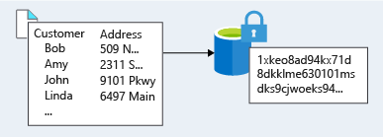

### **Encryption in transit**

Data in transit is the data actively moving from one location to another, such as across the internet or through a private network. Secure transfer can be handled by encrypting the data prior to sending it over a network, or setting up a secure channel to transmit unencrypted data between two systems. Encrypting data in transit protects the data from outside observers and provides a mechanism to transmit data while limiting risk of exposure.

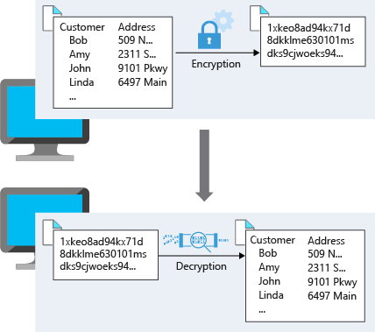

* For Lamna Healthcare, they are storing sensitive data that falls under the Health Insurance Portability and Accountability Act (HIPAA), which contains requirements on how to handle and store patient data.
* Most of the healthcare company follow HIPAA compliance rules.
* Other industries may fall under different regulatory requirements. A financial institution may store account information that falls within Payment Card Industry (PCI) standards. An organization doing business in the EU may fall under the General Data Protection Regulation (GDPR), which defines the handling of personal data in the EU. Business requirements may also dictate that any data that could put the organization at financial risk containing competitive information needs to be encrypted.
* Azure Storage Service Encryption (SSE) for data at rest helps you protect your data to meet your organizational security and compliance commitments. With this feature, the Azure storage platform automatically encrypts your data with 256-bit Advanced Encryption Standard (AES) encryption before persisting it to disk and decrypts the data during retrieval. This handling of encryption, encryption at rest, decryption, and key management in Storage Service Encryption is transparent to applications using the services - you don't need to add any code or turn on any features.
* You can use Microsoft-managed encryption keys with SSE, or you can use your own encryption keys by selecting the option in the Azure portal as shown below.

SSE automatically encrypts data in:

* All Azure Storage services including Azure Managed Disks, Azure Blob storage, Azure Files, Azure Queue storage, and Azure Table storage
* Both performance tiers (Standard and Premium)
* Both deployment models (Resource Manager and classic)

### **Encrypting virtual machines**

* Storage Service encryption provides low-level encryption protection for data written to physical disk, but how do you protect the virtual hard disks (VHD) of virtual machines? If a malicious attacker gained access to your Azure subscription and exfiltrated the VHDs of your virtual machines, how would you ensure they would be unable to access data stored on the VHD?
* **Azure Disk Encryption (ADE) is a capability that helps you encrypt your Windows and Linux IaaS virtual machine disks**. ADE leverages the industry standard **BitLocker feature of Windows and the DM-Crypt feature of Linux to provide volume encryption for the OS and data disks.** The solution is integrated with Azure Key Vault to help you control and manage the disk-encryption keys and secrets (and you can use managed identity for Azure services for accessing the key vault).

When you apply the Disk Encryption management solution, you can satisfy the following business needs:

* IaaS VMs are secured at rest by using industry-standard encryption technology to address organizational security and compliance requirements.
* IaaS VMs boot under customer-controlled keys and policies. You can audit their usage in your key vault.

### **Encrypting databases**

* Lamna Healthcare has several databases deployed that store data that needs additional protection. They've moved many databases to Azure SQL Database and want to ensure that their data is encrypted within their database. If the data files, log files, or backup files were stolen, they want to ensure they are unreadable without access to the encryption keys.
* Transparent data encryption (TDE) helps protect Azure SQL Database and Azure Data Warehouse against the threat of malicious activity. It performs real-time encryption and decryption of the database, associated backups, and transaction log files at rest without requiring changes to the application. By default, TDE is enabled for all newly deployed Azure SQL Databases.
* TDE encrypts the storage of an entire database by using a symmetric key called the database encryption key. By default, Azure provides a unique encryption key per logical SQL Server and handles all the details. Bring-your-own-key is also supported with keys stored in Azure Key Vault.
* Since TDE is enabled by default, Lamna Healthcare can be confident they have the proper protections in place for data stored in their databases.
* For their on-premises Microsoft SQL Server databases, Lamna Healthcare has turned on the SQL Server Always Encrypted feature. Always Encrypted is designed to protect sensitive data, such as client personal information or financial data. This feature protects column data at rest and in transit by having the client application handle the encryption and decryption outside the SQL Server database through an installed driver. This allows Lamna Healthcare to minimize exposure of data as the database never works with unencrypted data. The Always Encrypted client driver performs the actual encryption and decryption processes, rewriting the T-SQL queries as necessary to encrypt data passed to the DB and decrypt the results, while keeping these operations transparent to the application.

### **Encrypting secrets**

We've seen that the encryption services all use keys to encrypt and decrypt data, so how do we ensure that the keys themselves are secure? Lamna Healthcare may also have passwords, connection strings, or other sensitive pieces of information that they need to securely store.

Azure Key Vault is a cloud service that works as a secure secrets store. Key Vault allows you to create multiple secure containers, called vaults. These vaults are backed by hardware security modules (HSMs). Vaults help reduce the chances of accidental loss of security information by centralizing the storage of application secrets. Key Vaults also control and log the access to anything stored in them. Azure Key Vault can handle requesting and renewing Transport Layer Security (TLS) certificates, providing the features required for a robust certificate lifecycle management solution. Key Vault is designed to support any type of secret. These secrets could be passwords, database credentials, API keys and, certificates.

**Imp:** Because Azure AD identities can be granted access to use Azure Key Vault secrets, applications using managed identities for Azure services can automatically and seamlessly acquire the secrets they need.

### **Encrypting backups**

Encrypting all their data won't help Lamna Healthcare if the daily backups they take of their systems aren't also encrypted. Lamna Healthcare uses Azure Backup to backup data from their on-premises machines and Azure VMs. Azure Backup let's the IT department back up and recover data at a granular level, including backups of files, folders, machine system state, and app-aware data.

Luckily for our hard-working IT department, there's no work to do here as all our data is stored encrypted at rest. Azure Backup encrypts local backups using AES256 and a key created from the passphrase configured by the administrator. The data is securely transferred to Azure using HTTPS, and once there, the already-encrypted data is stored on disk. Azure VMs are also automatically encrypted at rest as they use Azure Storage for their disks.

Lamna healthcare have encrypted all virtual machines that are storing sensitive data, and are encrypting all sensitive patient information they are storing on blob storage.

* Blob storage is object storage.

**What is network security**

Network security is protecting the communication of resources within and outside of your network. The goal is to limit exposure at the network layer across your services and systems. By limiting this exposure, you decrease the likelihood that your resources can be attacked. In the focus on network security, efforts can be focused on the following areas:

* Securing traffic flow between applications and the internet
* Securing traffic flow amongst applications
* Securing traffic flow between users and the application

### **Internet protection**

If we start on the perimeter of the network, we're focused on limiting and eliminating attacks from the internet. A great first place to start is to assess the resources that are internet-facing, and only allow inbound and outbound communication where necessary. Identify all resources that are allowing inbound network traffic of any type, and ensure they are necessary and restricted to only the ports/protocols required. Azure Security Center is a great place to look for this information, as it will identify internet-facing resources that don't have network security groups (NSG) associated with them, as well as resources that are not secured behind a firewall.

* To provide inbound protection at the perimeter, there are a couple of ways to do this. Application Gateway is a Layer 7 load balancer that also includes a web application firewall (WAF) to provide advanced security for your HTTP-based services. **The WAF is based on rules from the OWASP 3.0 or 2.2.9** core rule sets, and provides protection from commonly-known vulnerabilities such as cross-site scripting and SQL injection.

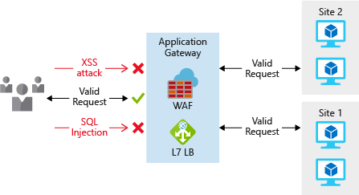

**For protection of non-HTTP-based services** or for increased customization, network virtual appliances (NVA) can be used to secure your network resources. NVAs are similar to firewall appliances you might find in on-premises networks, and are available from many of the most popular network security vendors. NVAs can provide greater customization of security for those applications that require it, but can come with increased complexity, so careful consideration of requirements is advised.

Any resource exposed to the internet is at risk of being attacked by a **denial-of-service attack.** These types of attacks attempt to overwhelm a network resource by sending so many requests that the resource becomes slow or unresponsive. To mitigate these attacks, Azure DDoS provides basic protection across all Azure services and enhanced protection for further customization for your resources. DDoS protection blocks attack traffic and forwards the remaining traffic to its intended destination. Within a few minutes of attack detection, you are notified using Azure Monitor metrics.

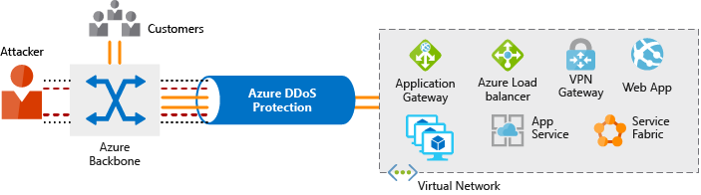

### **Virtual network security**

Once inside a virtual network (VNet), it's important to limit communication between resources to only what is required.

For communication between virtual machines, network security groups (NSG) are a critical piece to restrict unnecessary communication. NSGs operate at layers 3 & 4, and provide a list of allowed and denied communication to and from network interfaces and subnets. NSGs are fully customizable, and give you the ability to fully lock down network communication to and from your virtual machines. By using NSGs, you can isolate applications between environments, tiers, and services.

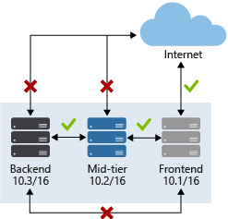

* Agar ham upar wale image mein dekhe toh ye pata chal raha hai ki.. outside internet se kewal Frontend accessible hai, Internet se agar koi direct backend call maarna chahe ya fir mid tier ko access karna chahe toh wo nai hoga, connection will be blocked.
* Aur even agar frontend se ham directly backend ko access karna chahe toh wo possible nai ha, kyunki u have to go through middle tier to access that.

**To isolate Azure services to only allow communication from virtual networks, use VNet service endpoints**. With service endpoints, Azure service resources can be secured to your virtual network. Securing service resources to a virtual network provides improved security by fully removing public internet access to resources, and allowing traffic only from your virtual network. This reduces the attack surface for your environment, reduces the administration required to limit communication between your VNet and Azure services, and provides optimal routing for this communication.

### **Network integration**

It's common to have existing network infrastructure that needs to be integrated to provide communication from on-premises networks, or to provide improved communication between services in Azure. There are a few key ways to handle this integration and improve the security of your network.

**Virtual private network (VPN) connections are a common way of establishing secure communication channels between networks**, and this is no different when working with virtual networking on Azure. Connection between Azure VNets and an on-premises VPN device is a great way to provide secure communication between your network and your virtual machines on Azure.

**To provide a dedicated, private connection between your network and Azure, you can use ExpressRoute.** ExpressRoute lets you extend your on-premises networks into the Microsoft cloud over a private connection facilitated by a connectivity provider. **With ExpressRoute, you can establish connections to Microsoft cloud services, such as Microsoft Azure, Office 365, and Dynamics 365. This improves the security of your on-premises communication by sending this traffic over the private circuit instead of over the internet.** You don't need to allow access to these services for your end users over the internet, and you can send this traffic through appliances for further traffic inspection.

**To easily integrate multiple VNets in Azure, VNet peering establishes a direct connection between designated VNets. Once established, you can use NSGs to provide isolation between resources in the same way you secure resources within a VNet.** This integration gives you the ability to provide the same fundamental layer of security across any peered VNets. Communication is only allowed between directly connected VNets.

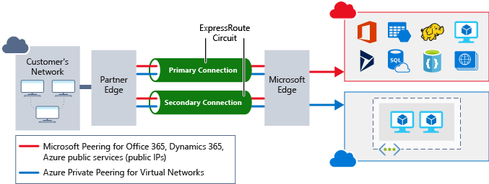

# **Application security**

Hosting applications on a cloud platform provides a number of advantages when compared to traditional on-premises deployments. The cloud's shared-responsibility model moves security at the physical network, building, and host levels under the control of the cloud provider. An attacker trying to compromise the platform at this level would see diminishing returns versus the considerable investment and insight providers make in securing and monitoring their infrastructure.

It's therefore far more effective for attackers to pursue vulnerabilities introduced at the application level by cloud-platform customers. Furthermore, by adopting Platform as a Service (PaaS) to host their applications, customers are able to free resources from managing operating system security and deploy them to harden application code and monitor the identity perimeter around the application. In this unit we will discuss some of the ways application security can be improved through design.

The primary areas that concern customer applications are:

* Secure application design
* Data security
* Identity and access management
* Endpoint security

## Security Development Lifecycle

Microsoft's [Security Development Lifecycle](https://www.microsoft.com/sdl) (SDL) process can be used during the application design stage to ensure security concerns are incorporated in the software development lifecycle. Security and compliance issues are far easier to address when designing an application and can mitigate many common errors that can lead to security flaws in the final product. Fixing issues early in the software development journey is also far less costly. The typical sequence of SDL steps a software project can use are as follows:

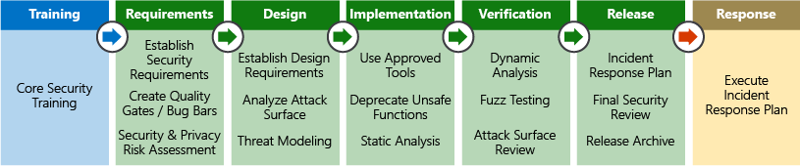

The SDL is as much a cultural aspect as it is a process or set of tools. Building a culture where security is a primary focus and requirement of any application development can make great strides in evolving an organization's capabilities around security.

## Operational security assessment

Once an application has been deployed, it's essential to continually evaluate its security posture, determine how to mitigate any issues that are discovered, and feed the knowledge back into the software development cycle. The depth to which this is performed is a factor of the maturity level of the software development and operational teams as well as the data privacy requirements.

Security vulnerability scanning software services are available to help automate this process and assess security concerns on a regular cadence, without burdening teams with costly manual processes, such as penetration testing.

**Azure Security Center** is a free service, now enabled by default for all Azure subscriptions, that is tightly integrated with other Azure application level services, such as Azure Application Gateway and Azure Web Application Firewall. By analyzing logs from these services, ASC can report on known vulnerabilities in real time, recommend responses to mitigate them, and even be configured to automatically execute playbooks in response to attacks.

* Transport Layer Security (TLS) is used to encrypt data exchanged between the web application and back-end SQL databases. Data is also encrypted at rest in SQL Server using Transparent Data Encryption (TDE), ensuring that even if the environment is compromised, data is effectively useless to anyone without the correct decryption keys.
* To encrypt data stored in blob storage, client-side encryption can be used to encrypt the data in memory before it's written to the storage service. Libraries supporting this encryption are available for .NET, Java, and Python, and enable the integration of data encryption directly into applications to enhance data integrity.
* Separating application secrets (connection strings, passwords, etc.) and encryption keys from the application used to access data is vital. Encryption keys and application secrets should never be stored in the application code or configuration files. Instead, a secure store such as Azure Key Vault should be used. Access to this sensitive data can then be limited to application identities through Managed Service Identities, and keys can be rotated on a regular basis to limit exposure in the case of encryption key leakage. Customers can also choose to use their own encryption keys generated by on-premises Hardware Security Modules (HSM) and even mandate that Azure Key Vault instances are implemented in single-tenant, discrete HSMs.

**Identity as a layer of security**

Digital identities are an integral part of today's business and social interactions on-premises and online. In the past, identity and access services were restricted to operating within a company's internal network, using protocols such as Kerberos and LDAP that were designed for this purpose. More recently, mobile devices have become the primary way people interact with digital services. Customers and employees alike expect to be able to access services from anywhere at any time, which has driven the development of identity protocols that can work at internet scale across many disparate devices and operating systems.

As they evaluate the capabilities their architecture has around identity, Lamna Healthcare is looking at ways they can bring the following capabilities into their application:

* Provide single-sign on to application users
* Enhance the legacy application to use modern authentication with minimal effort
* Enforce multi-factor authentication for all logins outside the company's network
* Develop an application to allow patients to enroll and securely manage their account data

### **SSO with Azure Active Directory**

Azure Active Directory (AD) is a cloud-based identity service. It has built-in support for synchronizing with your existing on-premises Active Directory or can be used stand-alone. This means that all your applications, whether on-premises, in the cloud (including Office 365), or even mobile can share the same credentials. Administrators and developers can control access to data and applications using centralized rules and policies configured in Azure AD.

By leveraging Azure AD for SSO you'll also have the ability to combine multiple data sources into an intelligent security graph. This security graph enables the ability to provide threat analysis and real-time identity protection to all accounts in Azure AD, including accounts that are synchronized from your on-premises AD. By using a centralized identity provider, you'll have centralized the security controls, reporting, alerting, and administration of your identity infrastructure.

### **Synchronize directories with AD Connect**

Azure AD Connect will integrate your on-premises directories with Azure Active Directory. Azure AD Connect provides the newest capabilities and replaces older versions of identity integration tools such as DirSync and Azure AD Sync.

It's a single tool to provide an easy deployment experience for synchronization and sign in.

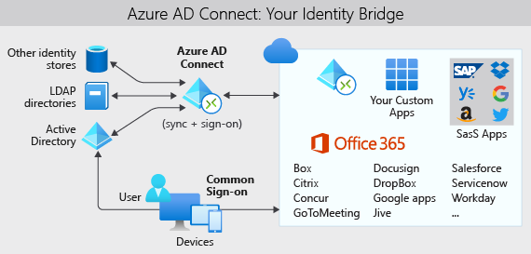

Lamna Healthcare has made the decision to move forward with the following configuration:

* Use Azure AD Connect to synchronize groups, user accounts, and password hashes stored in their on-premises Active Directory to Azure AD
  + This can be used as a backup if pass-through authentication is unavailable
* Configure pass-through authentication using an on-premises authentication agent installed on an on-premises Windows Server
* Use the seamless single sign-on feature of Azure AD to automatically sign in users from on-premises domain-joined PCs
  + Reduces user friction by suppressing multiple authentication requests

## Authentication & access

Lamna Healthcare's security policy requires that all logins occurring outside the company's perimeter network are authenticated with an additional factor of authentication. This requirement combines two aspects of the Azure AD service: multi-factor authentication and conditional access policies.

Azure AD has MFA capabilities built in, and will integrate with other third-party MFA providers. It's provided free of charge to any user who has the Global Administrator role in Azure AD, as these are highly sensitive accounts. All other accounts can have MFA enabled by purchasing licenses with this capability and assigning a license to the account.

### **Conditional access policies**

Along with MFA, ensuring that additional requirements are met before granting access can add another layer of protection. Blocking logins from a suspicious IP address, or denying access from devices without malware protection could limit access from risky sign ins.

Azure Active Directory provides a conditional access policies (CAP) feature that includes support for access policies based on group, location, or device state. The location feature allows Lamna to differentiate IP addresses that don't belong to their network, and satisfies their security policy to require multi-factor authentication from all such locations.

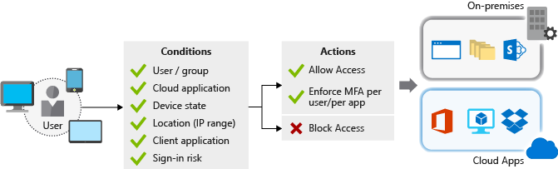

## Securing legacy applications

Lamna Healthcare employees require secure remote access to their administrative application hosted on-premises. Users currently authenticate to the application using Windows Integrated Authentication (WIA) from their domain-joined machines, behind the corporate firewall. Although a project to incorporate modern authentication mechanisms into the application has been planned, there's considerable business pressure to enable remote access capabilities as soon as possible. Azure Application Proxy can quickly, easily, and securely allow the application to be accessed remotely without any code changes.

Azure AD Application Proxy is:

* Simple
  + You don't need to change or update your applications to work with Application Proxy.
  + Your users get a consistent authentication experience. They can use the MyApps portal to get single sign-on to both SaaS apps in the cloud and your apps on-premises.
* Secure
  + When you publish your apps using Azure AD Application Proxy, you can take advantage of the rich authorization controls and security analytics in Azure. You get cloud-scale security and Azure security features like conditional access and two-step verification.
  + You don't have to open any inbound connections through your firewall to give your users remote access.
* Cost-effective
  + Application Proxy works in the cloud, so you can save time and money. On-premises solutions typically require you to set up and maintain DMZs, edge servers, or other complex infrastructures.

Azure AD Application Proxy is comprised of two components: a connector agent that sits on a Windows server within your corporate network and an external endpoint, either the MyApps portal or an external URL. When a user navigates to the endpoint, they authenticate with Azure AD and are routed to the on-premises application via the connector agent.

## Working with consumer identities

Since integrating modern authentication with their existing application, Lamna Healthcare has quickly acknowledged the power a managed identity system such as Azure AD can bring to their organization. The leadership team is now interested in exploring other ways Microsoft identity services can add business value. They have now focused their attention on external customers and how modernization of existing customer interactions could provide tight integration with third-party identity providers such as Google, Facebook, and LinkedIn.

Azure AD B2C is an identity management service built on the solid foundations of Azure Active Directory that enables you to customize and control how customers sign up, sign in, and manage their profiles when using your applications. This includes applications developed for iOS, Android, and .NET, among others. Azure AD B2C provides a social identity login experience, while at the same time protecting your customer identity profile information. Azure AD B2C directories are distinct from standard Azure AD directories and can be created in the Azure portal.

**DATABASE SCALING**

* Azure SQL Database is a platform as a service (PaaS) implementation of Microsoft SQL Server. You can scale up a database based upon the number of database transaction units (DTUs) or vCPUs. DTUs are an abstraction of underlying resources and are a blend of CPU, IO, and memory. For instance, you could scale your Azure SQL database from a size of P2 with 250 DTUs up to a P4 with 500 DTUs to give the database more throughput and capacity.
* For example, if you choose to scale up in Azure SQL Database, the service deals with scaling up individual nodes and continues the operation of your service. Changing the service tier and/or performance level of a database creates a replica of the original database at the new performance level, and then switches connections over to the replica. No data is lost during this process, and there's only a brief interruption (typically less than four seconds) when the service switches over to the replica.
* Alternatively, if you choose to scale up or down a virtual machine, you do so by selecting a different instance size. In most cases this requires a restart of the VM, so it's best to have the expectation that a reboot will be required and you'll need to account for when performing this activity.

Here are some examples of what scaling out or in means in the context of Azure resources:

* For the infrastructure layer, you would likely use virtual machine scale sets to automate the addition and removal of extra instances.
  + Virtual machine scale sets let you create and manage a group of identical, load balanced VMs.
  + The number of VM instances can automatically increase or decrease in response to demand or a defined schedule.
* In an Azure SQL Database implementation, you could share the load across database instances by sharding. *Sharding* is a technique to distribute large amounts of identically structured data across a number of independent databases.
* In Azure App Service, the App Service plan is the virtual web server farm hosting your application. Scaling out in this way means that you're increasing the number of virtual machines in the farm. As with virtual machine scale sets, the number of instances can be automatically raised or lowered in response to certain metrics or a schedule.

### **Considerations when scaling in and out**

When scaling out, the startup time of your application can impact how quickly your application can scale. If your web app takes two minutes to start up and be available for users, that means each of your instances will take two minutes until they are available to your users. You'll want to take this startup time into consideration when determining how fast you want to scale.

**Imp**

You'll also need to think about how your application handles state. When the application scales in, any state stored on the machine is no longer available. If a user connects to an instance that doesn't have its state, it could force them to sign in or re-select data, leading to a poor user experience. A common pattern is to externalize state to another service like Redis Cache or SQL Database, making your web servers stateless. Now that our web front ends are stateless, we don't need to worry about which individual instances are available. They are all doing the same job and are deployed in the same way.

## Throttling(Important)

We've established that the load on an application will vary over time. This may be due to the number of active or concurrent users and the activities being performed. While we could use autoscaling to add capacity, we could also use a throttling mechanism to limit the number of requests from a source. We can safeguard performance limits by putting known limits into place at the application level, preventing the application from breaking. Throttling is most frequently used in applications exposing API endpoints.

Once the application has identified that it would breach a limit, throttling could begin and ensure the overall system SLA isn't breached. For example, if we exposed an API for customers to get data, we could limit the number of requests to 100 per minute. If any single customer exceeded this limit, we could respond with an HTTP 429 status code, including the wait time before another request can successfully be submitted.

## Serverless

Serverless computing provides a cloud-hosted execution environment that runs your apps but completely abstracts the underlying environment. You create an instance of the service, and you add your code; no infrastructure management or maintenance is required, or even allowed.

You configure your serverless apps to respond to events. This could be a REST endpoint, a timer, or a message received from another Azure service. The serverless app runs only when it's triggered by an event.

Infrastructure isn't your responsibility. Scaling and performance are handled automatically, and you are billed only for the exact resources you use. There's no need to even reserve capacity. Azure Functions, Azure Container Instances, and Logic Apps are examples of serverless computing available on Azure.

Let's revisit the Lamna Healthcare example. There could be some potential for cost saving and ease of management. Consider an API endpoint. Instead of hosting the API in Azure App Service, where they must pay for reserved capacity, they could use an Azure Function App triggered by an HTTP request. Azure functions would enable the team to pay only for the resources required to process each transaction. The cost and scale would be directly in line with the number of transactions in the system.

## Scaling at Lamna Healthcare

Lamna Healthcare operates a patient management and booking system. The management system handles appointment bookings and patient records across dozens of hospitals and medical facilities. The local health service is running at full capacity, and no growth is expected at the moment. The system is running on a PHP website hosted in Azure App Service.

The load pattern of the application is predictable, as they primarily operate Monday to Friday between the hours of 9 to 5. From Tuesday through to Friday, the system averages 1,200 transactions per hour across the entire system. During the weekend, it handles 500 transactions per hour. After the quiet of the weekend, Mondays are busy with an average of 2,000 transactions per hour.

The application is hosted on an S1 App Service plan, but the operations team have noticed a high level of CPU utilization (over 95%) across all instances. The high usage is having an impact on the processing and loading times of the application. In a cloud environment, having highly utilized resources is not necessarily a bad thing. It means that they are getting value for their money, as the resources deployed are being well used.

The team decide to scale up the App Service plan level for the deployed instances from S1 (1 vCPU and 1.75 GB of RAM) to S2 (2 vCPUs and 3 GB of RAM). They easily achieve this using the Azure portal, but could have achieved the same thing using a single command in the Azure CLI, Azure PowerShell, or using Resource Manager templates.

The team decide that they want to automate the number of instances deployed based upon a schedule, as their load profile is predictable. They configure the App Service plan's autoscale schedule. Let's assume two instances sufficiently handle 500 transactions per hour. The team could then scale to six instances for Tuesday - Friday and eight instances for a Monday to meet the requirements (based upon insight and monitoring from load tests).

Autoscale also gives them an added benefit, preparing for those unforeseen scenarios. The site may suddenly take higher than expected load on the weekend (more appointments in the winter season because of colds and flu). The team can set up autoscale to increase by one instance when CPU percentage is above 70% and reduce by one instance when usage is below 15%.

The team have used the throttling pattern inside of the patient booking API they have exposed behind an Azure API Management instance. This helps prevent the system from performing poorly by only allowing a certain volume of throughput through the system.

We've talked about scaling up and down and scaling in and out, and how you can leverage these options in your architecture. We've also looked at how serverless technologies and containers can help evolve your scaling capabilities.

**Latency between Azure resources**

Imagine that Lamna Healthcare is piloting a new patient booking system running on several web servers and a database in the West Europe Azure region. This architecture minimizes the data time on the wire as resources are co-located inside an Azure region.

Suppose that the pilot of the system went well and has been expanded to users in Australia. Users in Australia will incur the round-trip time to the resources in West Europe to view the website, and their end-user experience will be poor due to the network latency.

The Lamna Healthcare team decide to host another front-end instance in the Australia East region to reduce user latency. While this design helps reduce the time for the web server to return content to end users, their experience is still poor since there's significant latency communicating between the front-end web servers in Australia East and the database in West Europe.

There are a few ways we could reduce the remaining latency:

* Create a read-replica of the database in Australia East. This would allow reads to perform well, but writes would still incur latency. Azure SQL Database geo-replication allows for read-replicas.
* Sync your data between regions with Azure SQL Data Sync.
* Use a globally distributed database such as Azure Cosmos DB. This would allow both reads and writes to occur regardless of location, but may require changes to the way your application stores and references data.
* Use caching technology such as Azure Cache for Redis to minimize high-latency calls to remote databases for frequently accessed data.

The goal here is to minimize the network latency between each layer of the application. How this is solved depends on your application and data architecture, but Azure provides mechanisms to solve this on several services.

## Latency between users and Azure resources

We've looked at the latency between our Azure resources, but we should also consider the latency between users and our cloud application. We're looking to optimize delivery of the front end-user interface to our users. Let's take a look at some ways to improve the network performance between end users and the application.

### Use a DNS load balancer for endpoint path optimization

In the Lamna Healthcare example, we saw that the team created an additional web front-end node in Australia East. However, end users have to explicitly specify which front-end endpoint they want to use. As the designer of a solution, Lamna Healthcare wants to make the experience as smooth as possible for their users.

**Traffic Manager**-Azure Traffic Manager could help. Traffic Manager is a DNS-based load balancer that enables you to distribute traffic within and across Azure regions. Rather than having the user browse to a specific instance of our web front end, Traffic Manager can route users based upon a set of characteristics:

* **Priority** - You specify an ordered list of front-end instances. If the one with the highest priority is unavailable, Traffic Manager will route the user to the next available instance.
* **Weighted** - You would set a weight against each front-end instance. Traffic Manager then distributes traffic according to those defined ratios.
* **Performance** - Traffic Manager routes users to the closest front-end instance based on network latency.
* **Geographic** - You could set up geographical regions for front-end deployments, routing your users based upon data sovereignty mandates or localization of content.

Traffic Manager profiles can also be nested. You could first route your users across different geographies (for example, Europe and Australia) using geographic routing and then route them to local front-end deployments using the performance routing method.

Consider that Lamna Healthcare has deployed a web front end in West Europe and Australia. Assume they have deployed Azure SQL Database with their primary deployment in West Europe, and a read replica in Australia East. Let's also assume the application can connect to the local SQL instance for read queries.

The team deploy a Traffic Manager instance in performance mode and add the two front-end instances as Traffic Manager profiles. As an end user, you navigate to a custom domain name (for example, lamnahealthcare.com) which routes to Traffic Manager. Traffic Manager then returns the DNS name of the West Europe or Australia East front end based on the best network latency performance.

It's important to note that this load balancing is only handled via DNS, there's no inline load balancing or caching that's happening here, Traffic Manager is simply returning the DNS name of the closest front end to the user.

### Use CDN to cache content close to users

The website will likely be using some form of static content (either whole pages or assets such as images and videos). This content could be delivered to users faster by using a content delivery network (CDN) such as Azure CDN.

When Lamna deploys content to Azure CDN, those items are copied to multiple servers around the globe. Let's say one of those items is a video served from blob storage: HowToCompleteYourBillingForms.MP4. The team then configure the website so that each user's link to the video will actually reference the CDN edge server nearest them, rather than referencing blob storage. This approach puts content closer to the destination, reducing latency and improving user experience. The following illustration shows how using Azure CDN puts content closer to the destination which reduces latency and improves the user experience.

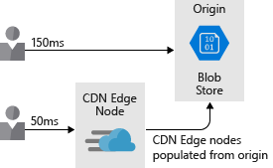

Content delivery networks *can* also be used to host cached dynamic content. Extra consideration is required, though, since cached content may be out of date compared with the source. Context expiration can be controlled by setting a time to live (TTL). If the TTL is too high, out-of-date content may be displayed and the cache would need to be purged.

One way to handle cached content is with a feature called **dynamic site acceleration**, which can increase performance of webpages with dynamic content. Dynamic site acceleration can also provide a low-latency path to additional services in your solution (for example, an API endpoint).

### Use ExpressRoute for connectivity from on-premises to Azure

Optimizing network connectivity from your on-premises environment to Azure is also important. For users connecting to applications, whether they're hosted on virtual machines or on PaaS offerings like Azure App Service, you'll want to ensure they have the best connection to your applications.

You can always use the public internet to connect users to your services, but internet performance can vary and may be impacted by outside issues. On top of that, you may not want to expose all of your services over the internet, and you may want a private connection to your Azure resources.

Site-to-site VPN over the internet is also an option, but for high throughput architectures, VPN overhead and internet variability can increase latency noticeably.

Azure ExpressRoute can help. ExpressRoute is a private, dedicated connection between your network and Azure, giving you guaranteed performance and ensuring that your end users have the best path to all of your Azure resources. The following illustration shows how ExpressRoute Circuit provides connectivity between on-premises applications and Azure resources.

By using a content delivery network, assets are cached at locations that are physically closer to end users and will reduce the amount of time to load them. This will cost-effectively improve network latency for users around the globe.

## Optimize virtual machine storage performance

Let's first look at optimizing storage for virtual machines. Disk storage plays a critical role in the performance of your virtual machines, and selecting the right disk type for your application is an important decision.

Different applications are going to have different storage requirements. Your application may be sensitive to latency of disk reads and writes or it may require the ability to handle a large number of input/output operations per second (IOPS) or greater overall disk throughput.

When building an IaaS workload, which type of disk should you use? There are four options:

* **Local SSD storage** - Each VM has a temporary disk that is backed by local SSD storage. The size of this disk varies depending on the size of the virtual machine. Since this disk is local SSD, the performance is high, but data may be lost during a maintenance event or a redeployment of the VM. This disk is only suitable for temporary storage of data that you do not need permanently. This disk is great for the page or swap file, and for things like tempdb in SQL Server. There is no charge for this storage. It's included in the cost of the VM.
* **Standard storage HDD** - This is spindle disk storage and may fit well where your application is not bound by inconsistent latency or lower levels of throughput. A dev/test workload where guaranteed performance isn't needed is a great use case for this disk type.
* **Standard storage SSD** - This is SSD backed storage and has the low latency of SSD but lower levels of throughput. A non-production web server would be a good use case for this disk type.
* **Premium storage SSD** - This SSD backed storage is well-suited for those workloads that are going into production, require the greatest reliability and demand consistent low latency, or need high levels of throughput and IOPS. Since these disks have greater performance and reliability capabilities, they are recommended for all production workloads.

Disks can be striped using a striping technology (such as Storage Spaces Direct on Windows or mdadm on Linux) to increase the throughput and IOPS by spreading disk activity across multiple disks. Using disk striping allows you to really push the limits of performance for disks, and is often seen in high-performance database systems and other systems with intensive storage requirements.

## Optimize storage performance for your application

While you can use differing storage technologies to improve the raw disk performance, you can also address the performance of access to data at the application layer. Let's take a look at a few ways you can do this.

### **Caching**

A common approach to improve application performance is to integrate a caching layer between your application and your data store. A cache typically stores data in memory and allows for fast retrieval. This data can be frequently accessed data, data you specify from a database, or temporary data such as user state. You'll have control over the type of data stored, how often it refreshes, and when it expires. By co-locating this cache in the same region as your application and database, you'll reduce the overall latency between the two. Pulling data out of the cache will almost always be faster than retrieving the same data from a database, so by using a caching layer you can substantially improve the overall performance of your application. The following illustration shows how an application retrieves data from a database, stores it in a cache, and uses the cached value as needed.

Azure Cache for Redis is a caching service on Azure that stores data in memory. It's based upon the open-source Redis cache and is a fully managed service offering by Microsoft. You select the performance tier that you require and configure your application to use the service.

### **Polyglot persistence**

Polyglot persistence is the usage of different data storage technologies to handle your storage requirements.

Consider an e-commerce example. You may store application assets in a blob store, product reviews and recommendations in a NoSQL store, and user profile or account data in a SQL database. The following illustration shows how an application might use multiple data storage techniques to store different types of data.

This is important, as different data stores are designed for certain use cases or may be more accessible because of cost. As an example, storing blobs in a SQL database may be costly and slower to access than directly from a blob store.

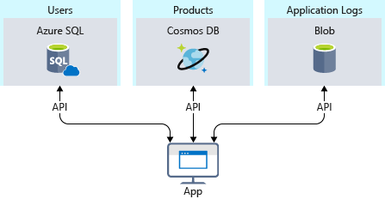

**ISSUES FACE ACROSS SCALABLE/DISTRIBUTED DATA STORAGE(PLACES HAVING REPLICAS)**

Maintaining data consistency across distributed data stores can be a significant challenge. The issue is that strategies such as serialization and locking only work well if all application instances share the same data store, and the application is designed to ensure that the locks are very short-lived. However, if data is partitioned or replicated across different data stores, locking and serializing data access to maintain consistency can become an expensive overhead that impacts the throughput, response time, and scalability of a system. Therefore, most modern distributed applications do not lock the data that they modify, and they take a rather more relaxed approach to consistency, known as eventual consistency.

Eventual consistency means that replica data stores will eventually converge if there are no further writes. If a write is made to one of the data stores, reads from another may provide slightly out-of-date data. Eventual consistency enables higher scale because there is a low latency for reads and writes, rather than waiting to check if information is consistent across all stores.

## DevOps and application performance

The idea behind DevOps is that we don't have development and infrastructure silos in our organization. Instead, they work together to effectively build, deploy, monitor, and maintain apps in streamlined process.

The planning, development, testing, and monitoring is carried out in an iterative approach. Performance and quality of our application become a part of our software development life cycle, rather than an afterthought as we deploy into a live environment. The following illustration shows where opportunities for collaboration exist in the software development lifecycle.

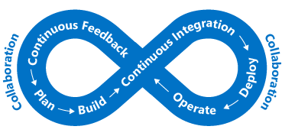

This approach aligns with a DevOps concept called "shifting left". In other words, bring your quality control checks earlier into your deployment and release process. This allows you to catch end-user impacting issues earlier in the process. As we operate in a continuous cycle, we limit the amount of manual interaction and automate as much as possible.

One way we make performance part of our DevOps process is to carry out performance or load tests to validate that the application meets the non-functional requirements prior to a deployment into production.

Ideally, we could carry out performance and load tests in an environment that is exactly like production while not impacting our actual production servers. When leveraging the cloud, you fully have this ability. You can automate the creation of a production-like environment, perform testing, and then destroy the environment to minimize cost. This approach to automation can provide reassurance that your application can handle the scale you require now, as well as respond to future growth.

Application performance monitoring becomes a core part of this. If we're running performance and load tests on our application or want to keep our production performance in check, we want to understand what parts of our application may be performing non-optimally. Let's take a look at some ways to do this.

The following diagram depicts a high-level view of Azure Monitor. At the center of the diagram are the data stores for metrics and logs, which are the two fundamental types of data that Azure Monitor uses. On the left side are the sources of monitoring data that populate these data stores. On the right side are the different functions that Azure Monitor performs with this collected data such as analysis, alerting, and streaming to external systems.

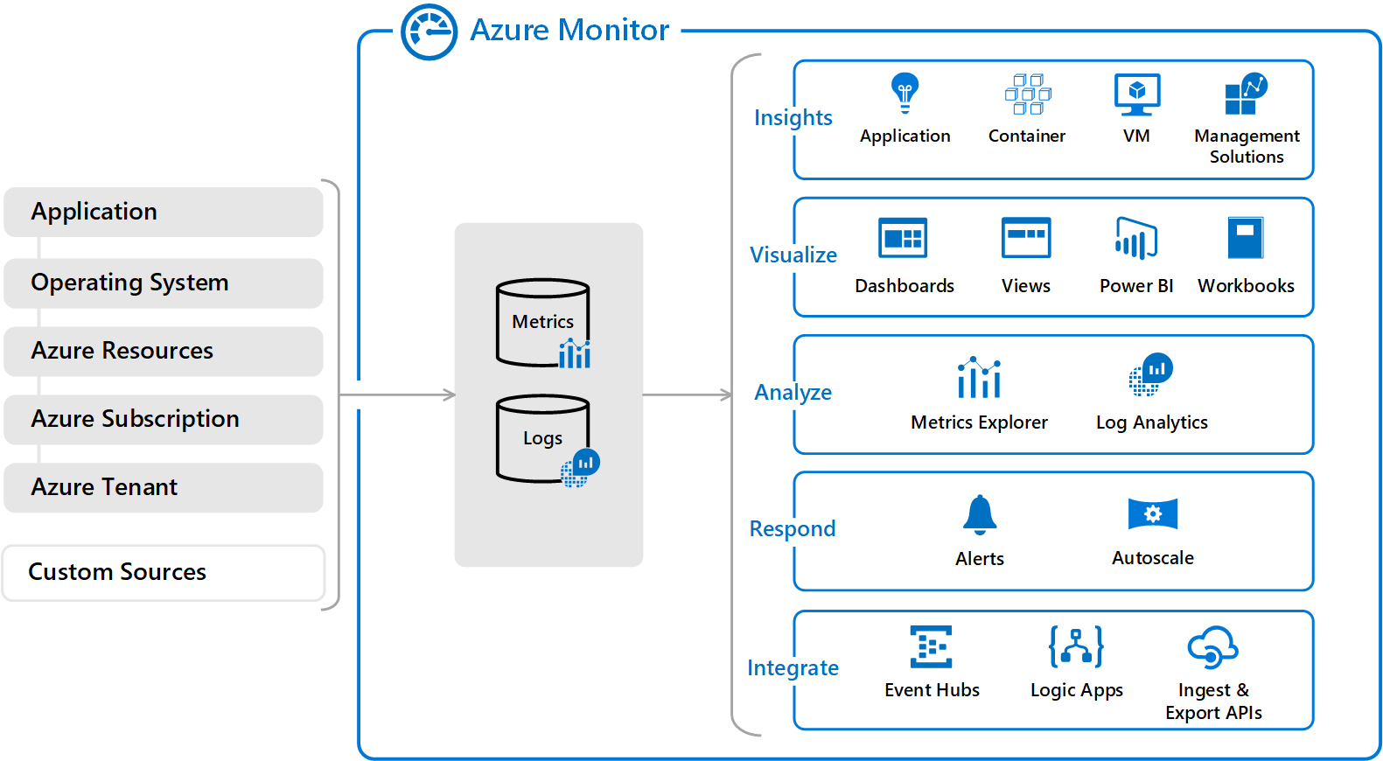

Azure Monitor can collect data from a variety of sources. You can think of monitoring data for your applications as occurring in tiers that range from your application to any OS and the services it relies on to the platform itself. Azure Monitor collects data from each of the following tiers:

* **Application monitoring data** - Data about the performance and functionality of the code you have written, regardless of its platform.
* **Guest OS monitoring data** - Data about the OS on which your application is running. It might be running in Azure, in another cloud, or on-premises.
* **Azure resource monitoring data** - Data about the operation of an Azure resource.
* **Azure subscription monitoring data** - Data about the operation and management of an Azure subscription and data about the health and operation of Azure itself.
* **Azure tenant monitoring data** - Data about the operation of tenant-level Azure services, such as Azure Active Directory (Azure AD).

### **Log Analytics**

Centralized logging can help you uncover hidden issues that may be difficult to track down. With Log Analytics you can query and aggregate data across logs. This cross-source correlation can help you identify issues or performance problems that may not be evident when looking at logs or metrics individually. The following illustration shows how Log Analytics acts as a central hub for monitoring data. Log Analytics receives monitoring data from your Azure resources and makes it available to consumers for analysis or visualization.

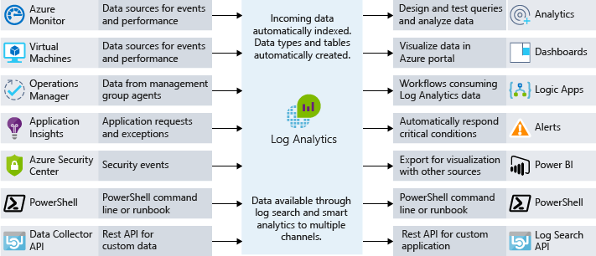

You can collate a wide range of data sources, security logs, Azure activity logs, server, network, and application logs. You can also push on-premises System Center Operations Manager data to Log Analytics in hybrid deployment scenarios and have Azure SQL Database send diagnostic information directly into Log Analytics for detailed performance monitoring.

Centralized logging can be massively beneficial for troubleshooting all types of scenarios, including performance issues. It's a key part of a good monitoring strategy for any architecture.

## Application performance management(New Relic jaisa)

Deep application issues are often tricky to track down. This is where integrating telemetry into an application by using an application performance management solution (APM) to track down low-level application performance and behavior can be beneficial. This telemetry can include individual page request times, exceptions within your application, and even custom metrics to track business logic. This telemetry can provide a wealth of insight into what is going on within your application.

On Azure, Application Insights is a service that provides this deep application performance management. You install a small instrumentation package in your application, and set up an Application Insights resource in the Microsoft Azure portal. The instrumentation monitors your app and sends telemetry data to the portal.

Telemetry from the host environments, such as performance counters, Azure diagnostics, and Docker logs, can be ingested. You can also set up web tests that periodically send synthetic requests to your web service. You could even configure your application to send custom events and metrics that you write yourself in the client or server code. For example, application-specific events such as items sold or games won.

Application Insights stores its data in a common repository, and metrics are shared with Azure Monitor. It can take advantage of shared functionality such as alerts, dashboards, and deep analysis with the Log Analytics query language.

A common pattern used in determining the availability of a web application is the health endpoint monitoring pattern. This pattern is used to monitor web applications and associated back-end services, to ensure that they're available and performing correctly. The pattern is implemented by querying a particular uri. The endpoint checks on the status of many components, including the back-end services that the app depends on, rather than just the availability of the front end itself. This acts as a service-level health check that returns an indication of the overall health of the service.

Use an APM solution such as Application Insights to gain a deep understanding of your application and correlate activity across your application. This can help you understand how a specific action works in the client browser, on the server, and through to downstream services. It will also provide insight into trends, provide notifications when there is a problem, and help identify where the problem is and how to fix it, before your users are aware.

## Scaling up and scaling out

* The difference between scaling up/down (the level of resource provisioned on an instance) and scaling in/out (increasing or decreasing the number of available instances). We also discussed examples in Azure of each.
* The considerations to be made when scaling in/out around state management and application startup times.
* Autoscale, and how it can help you scale the number of instances based on a schedule or the demand of an application.
* Discussed alternate technologies that may help with scalability, including serverless and containers.

## Optimize network performance

* Network latency is a measure in delay of data being sent from a sender to a receiver.
* In a cloud environment, chattier applications may see a performance impact compared to on-premises as resources are no longer immediately co-located.
* Co-locating APIs near to a database write endpoint could provide a performance benefit, as we are reducing the network latency between the two resources.
* Azure Traffic Manager could be used to route users to the deployed instance with the lowest network latency.
* Azure Content Delivery Networks (CDN) could be used to offload compute from the main application and speed up application load times by caching content on a CDN edge node near to a user.

## Optimize storage performance

* There are three main types of disks available for IaaS deployments. Standard HDD disks (inconsistent latency and lower levels of throughput), Standard SSD disks (consistent latency and lower levels of throughput), and Premium SSD disks (consistent latency and high levels of throughput).
* Caching could be used in the application layer to improve the load times of an application. Frequently requested information could be stored in a cache in front of the database, which could then optimize for data load times of the most requested information.
* Using the appropriate back-end data store for the job (polyglot persistence) should be considered when building out your solution.

## Identify performance bottlenecks

* Importance of understanding the expectations of the application before architecting or building any operations.
* Understanding how effective DevOps strategies can help build more robust and well-performing applications.
* Summarized the monitoring options available in Azure, including Azure Monitor (pane of glass for monitoring on Azure), Azure Log Analytics (log ingestion and IaaS monitoring), and Application Insights (application performance monitoring including availability, performance, and exception information).

### **Optimizing Azure SQL Database costs**

When creating an Azure SQL database, you have to select an Azure SQL Server and decide on a performance tier. Each tier provides a performance level either in database transaction units (DTUs) or virtual cores (vCores). For database loads that are steady, it's easy to optimize by selecting the properly sized tier for the needed performance. But what if your database has unpredictable bursts or spikes in activity? Elastic pools can reduce costs for unpredictable workloads.

SQL Database elastic pools are a simple, cost-effective solution for managing and scaling several databases that have varying and unpredictable usage demands. The databases in an elastic pool are on a single Azure SQL Database server and share a set number of resources at a set price. Pools are well suited for a large number of databases with specific utilization patterns. For a given database, this pattern is characterized by low average utilization with relatively infrequent utilization spikes. The more databases you can add to a pool, the greater your savings become. The following illustration shows the capabilities of the three types of Elastic Database Pools: basic, standard, and premium. Basic auto scales up to 5 eDTUs per DB, standard auto scales up to 100 eDTUs per DB, and Premium that auto scales up to 1000 eDTUs per DB.

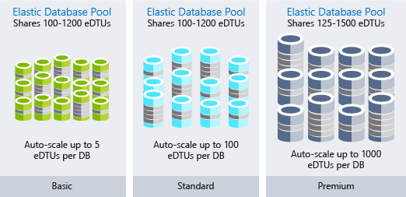

Elastic pools are a great way to spread costs across multiple databases and can make a significant impact on reducing your Azure SQL Database costs.

### **Optimizing Blob storage costs**

Blob storage is a cost-effective way to store data, but as the amount of data grows, your bill can benefit from optimizing how the data is stored.

Let's return to Lamna Healthcare. You have a medical-imaging application that stores images in blob storage. Due to the quantity and size of the images, the storage ends up being a notable cost for the application. When an image has been taken for a patient, it's likely that in the first week, that image will be viewed several times, and the performance of image retrieval is expected to be high. Conversely, an image taken two years ago may be accessed infrequently and has a lower retrieval performance expectation. You can use storage tiering to optimize the cost of image retrieval, given the reduced performance required as the image ages.

Azure Storage offers three storage tiers for blob object storage. The Azure hot storage tier is optimized for storing data that is accessed frequently. The Azure cool storage tier is optimized for storing data that is infrequently accessed and stored for at least 30 days. The Azure archive storage tier is optimized for storing data that is rarely accessed and stored for at least 180 days with flexible latency requirements.

* **Hot access tier** - Highest storage costs but the lowest access costs.
* **Cool access tier** - Lower storage costs and higher access costs compared to hot storage. This tier is intended for data that will stay in the cool tier for at least 30 days.
* **Archive access tier** - Lowest storage cost and highest data retrieval costs compared to hot and cool storage. This tier is intended for data that can tolerate several hours of retrieval latency and will stay in the archive tier for at least 180 days.

For Lamna Healthcare, keeping new images on the hot access tier for a month makes sense, so that viewing the most recent images performs as fast as possible. You could then move images over one year old to the archive tier since it is likely that these images will not be retrieved. This would reduce their costs associated with storing these images.

### **Leverage consumption pricing models**

Moving to PaaS services can also take the pay-as-you-go model even further into a true consumption pricing model. Services such as Azure Functions have the ability to use Consumption plans. When you're using a Consumption plan, instances of the Azure Functions host are dynamically added and removed based on the number of incoming events. This serverless plan scales automatically, and you're charged for compute resources only when your functions are running. On a Consumption plan, a function execution times out after a configurable period of time.

Billing is based on number of executions, execution time, and memory used. Billing is aggregated across all functions within a function app.

Moving to services that use a consumption pricing model can bring a new approach to cost savings into your architecture.

# **Use monitoring and analytics to gain operational insights**

When it comes to monitoring and analytics on Azure, we can bundle services into three specific areas of focus: deep application monitoring, deep infrastructure monitoring, and core monitoring. In this unit, we'll take a look through each of these bundles and how Azure services enable these capabilities for your architecture. Even though we've grouped these services together, there are several integration points between them, allowing for sharing of important monitoring data points between them. The following illustration shows the available monitoring services assembled into logical groups.

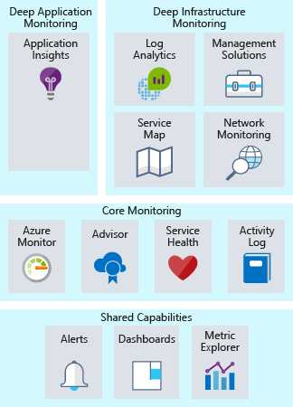

## Core monitoring

Core monitoring provides fundamental, required monitoring across Azure resources. When we talk about fundamental monitoring, you can think of this as monitoring what is happening with your resources at the Azure platform level. This area of focus gives you insight into things like the health of the Azure platform, insight into changes being made to your resources, and performance metrics. Using services from this area gives you the ability to monitor the basic pieces you need to keep your application running.

Azure provides services to give you visibility into four key core monitoring areas: activity logging, the health of services, metrics and diagnostics, and recommendations on best practices. These services are built in to Azure and take little to no configuration to enable and set up. Let's take a closer look.

### **Activity logging**

Activity logging is incredibly important to get information on what is happening with your resources at the Azure platform level. Every change submitted to the Azure platform is logged to the Azure Activity Log, giving you the ability to trace any action taken on your resources. Activity Log will contain detailed information on activities to help you answer questions like:

* Who has attached a disk to this virtual machine?
* When was this machine shut down?
* Who changed the load balancer configuration?
* Why did the autoscale operation on my virtual machine scale set fail?

Using Activity Log to answer these types of questions will help you troubleshoot issues, track changes, and provide auditing of what's happening in your Azure environment. Activity Log data is only retained for 90 days and can be archived to a storage account or sent to Azure Log Analytics for longer retention and further analysis.

### **Health of cloud services**

At some point, any system can have issues, and that's true for Azure services as well. Staying informed of the health of Azure services will help you understand if and when an issue impacting an Azure service is impacting your environment. What may seem like a localized issue could be the result of a more widespread issue, and Azure Service Health provides this insight. Azure Service Health identifies any issues with Azure services that might affect your application. Service Health also helps you plan for scheduled maintenance.

### **Metrics and diagnostics**

For issues that are more localized in nature, it's important to have visibility into what is happening on your system or service instance. The ability to view metrics and diagnostic information is critical to troubleshoot performance issues and stay notified when something goes wrong. To provide this visibility, Azure services have a common way of showing health, metric, or diagnostic information. Azure Monitor enables core monitoring for Azure services by allowing the collection, aggregation, and visualization of metrics, activity logs, and diagnostic logs.

## Deep infrastructure monitoring

While the monitoring components we've covered thus far are great at offering insights, they only give visibility to the Azure platform. For typical IaaS workloads, there's more metrics and diagnostic information to gather from the network or the actual operating systems. Pulling information from SQL Server to ensure it's properly configured, analyzing free disk space across all the servers in your environment, or visualizing the network dependencies between your systems and services are all examples where Log Analytics can provide deep insights.

When designing a monitoring strategy, it's important to include every component in the application chain, so you can correlate events across services and resources. For services that support Azure Monitor, they can be easily configured to send their data to a Log Analytics workspace. Virtual machines (both in the cloud and on-premises) can have an agent installed to send data to Log Analytics. You can submit custom data to Log Analytics through the Log Analytics API. The following illustration shows how Log Analytics acts as a central hub for monitoring data. Log Analytics receives monitoring data from your Azure resources and makes it available to consumers for analysis or visualization.

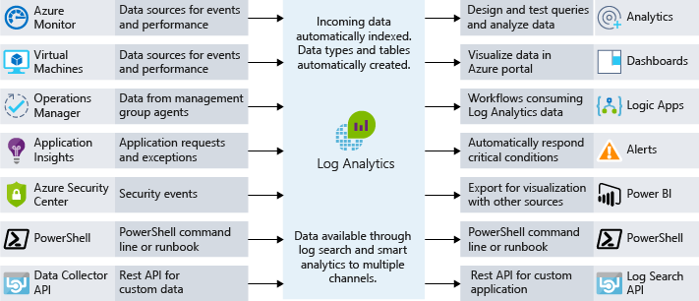

With this data in Log Analytics, you can query the raw data for troubleshooting, root cause identification, and auditing purposes. For several known services (SQL Server, Windows Server Active Directory), there are management solutions readily available that visualize monitoring data and uncover compliance with best practices.

Log Analytics allows you to create queries and interact with other systems based on those queries. The most common example is an alert. Maybe you want to receive an email when a system runs out of disk space or a best practice on SQL Server is no longer followed. Log Analytics can send alerts, kick off automation, and even hook into custom APIs for things like integration with IT service management (ITSM).

## Deep application monitoring

It's important to understand how core services and infrastructure are performing, but you can take your monitoring capabilities even further by looking deep into your applications to identify performance issues, usage trends, and overall availability of services you develop and depend on. By using an application performance management tool, you can better detect and diagnose issues that occur within your web apps and services.

Azure Application Insights allows you to do exactly that. Application Insights provides telemetry collection, query, and visualization capabilities. Little to no code changes are required. You only have to install a small instrumentation package into your application. Application Insights is cross platform, supporting .NET, Node.js, or Java.

For instance, the response time of the application might be complex to troubleshoot. Is it the web server being overloaded? Is it a specific SQL query that's not optimized? Is the API that you're calling performing slower than usual? Application performance monitoring solutions can help uncover the actual issues that basic metric monitoring can't expose. The following screenshot shows a graphical display of an application’s performance details provided by Azure Application Insights.

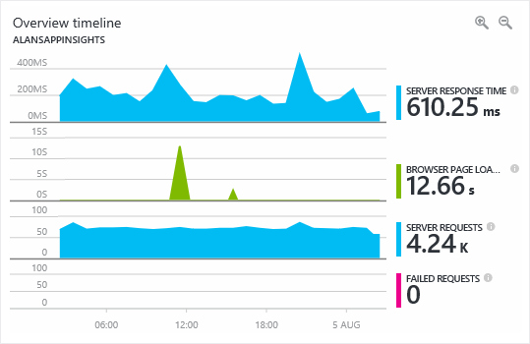

An application performance monitoring solution will help you monitor usage, performance, and availability, allowing you to respond to failure much faster, and should be included in any monitoring strategy.

# **Summary**

We started out by talking about how to ensure you are in control of your consumption as well as optimize it. Here are some of the key aspects that were covered:

* Tracking cloud spend: the importance of gathering and looking at cloud consumption data to understand your cloud spend.
* Organizing to optimize: the relevance of a subscription and resource group hierarchy and how tags can further help provide various dimensions.
* There are several possibilities to optimize IaaS costs: right-sizing, reducing runtime hours, and compute cost discounts.
* Some examples were shown to optimize PaaS costs: for example, using Azure SQL Database elastics pools to optimize Azure SQL costs or Azure Blob storage tiering to optimize Azure Storage costs.

Next, we covered the operational insights you could gain from understanding and implementing monitoring and analytics. We determined that there are various levels on which we can apply monitoring.

* Monitoring is the act of collecting and analyzing data to determine the performance, health, and availability of your business application and the resources that it depends on.
* There are various depths of monitoring. Core monitoring covers aspects close to the Azure platform such as activity logging, cloud services health, and metrics and diagnostics.
* Deep infrastructure monitoring allows you to gather information besides what the Azure fabric can provide. For typical IaaS workloads, we can monitor at the network or operating system level.
* Deep application monitoring takes it even further by gathering metrics and diagnostics information close to the application, allowing you to identity performance issues, usage trends, and overall availability information.

We wrapped up by discussing that there are various ways to automate tasks to improve your operational capabilities. Here are some of the key things we covered:

* **Automating the deployment of resources can take two different approaches:** imperative (scripting) or declarative (templates).
* **After the VM is deployed, we can look at how to customize it.** Either by using custom images and thus remove the need for customization in the first place. Or by running a script post deployment.
* **Automation of Azure tasks:** Azure Automation can help with installing updates or shutting down virtual machines on a schedule.
* **Automation lab environments:** Azure DevTest Labs takes automation one step further by providing an easy-to-use interface that allows you to use various automation capabilities like images or shutting down VMs without having to worry about the actual implementation of those tasks.

Four different products and services can use Azure Backup to create backups:

* **Azure Backup Agent** is a small Windows application that backs up files, folders, and system state from the Windows VM or server on which it's installed. It works in a way that's similar to many consumer cloud-based backup solutions, but requires configuration of an Azure Recovery vault. Once you download and install it onto a Windows server or VM, you can configure it to create backups up to three times a day.
* **System Center Data Protection Manager** is a robust, fully featured, enterprise-level backup and recovery system. Data Protection Manager is a Windows Server application that can back up filesystems and virtual machines (Windows and Linux), create bare-metal backups of physical servers, and perform application-aware backup of many Microsoft server products, such as SQL Server and Exchange. Data Protection Manager is part of the System Center family of products and is licensed and sold with System Center, but it's considered part of the Azure Backup family because it can store backups in an Azure Recovery vault.
* **Azure Backup Server** is similar to Data Protection Manager, but it's licensed as part of an Azure subscription and doesn't require a System Center license. Azure Backup Server supports the same functionality as Data Protection Manager except for local tape backup and integration with the other System Center products.
* **Azure IaaS VM Backup** is a turnkey backup and restore feature of Azure Virtual Machines. VM backup supports once-per-day backups for Windows and Linux virtual machines. It supports recovery of individual files, full disks, and entire VMs, and can also perform application-consistent backups. Individual applications can be made aware of backup operations and get their filesystem resources into a consistent state before the snapshot is taken.

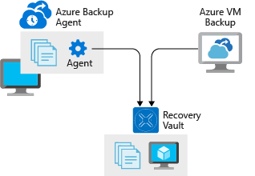

# **Summary**

* 3 minutes

We've discussed how to make your application available and recoverable by architecting for high availability, disaster recovery, and backups. Let's take a look at some of the key takeaways.

## High availability

* High availability is the ability to handle the loss or severe degradation of a component of a system.
* Evaluate your application for high availability by focusing on three key areas:
  + Your defined SLA.
  + The HA capabilities of your application.
  + The HA capabilities of dependent applications.
* Use availability sets and availability zones on Azure to provide HA for VM workloads.
* Use load balancing services such as Azure Traffic Manager, Azure Application Gateway, and Azure Load Balancer to distribute load across available systems.
* PaaS services have HA built in, so leverage these services in your architecture where possible.

## Disaster recovery

* Disaster recovery is about recovering from high-impact events that result in downtime and loss of data.
* Create a disaster recovery plan to define the procedures, responsibilities, and activities needed to recover from a disaster.
* Define the RPO and RTO for your application to help determine the DR requirements for your application.
* Use backup and replication to provide copies of your systems and data to recover to.
* Use Azure Site Recovery for DR process recovery capabilities for your application.
* Test your disaster recovery plan to identify gaps and relevance of steps.

## Backup and restore

* Use backups to restore your data as part of your DR strategy or for more isolated data loss scenarios.
* Use Azure Backup for full VM backup, file and folder backup, and backup of systems in an on-premises environment.
* Backup capabilities are often built into PaaS services, such as Azure SQL Database and Azure App Service. Take advantage of these backup capabilities when possible, understand their default configuration and overall capabilities.
* Test your restoration processes and procedures regularly to ensure they are valid and sufficient.

# **Architect network infrastructure in Azure**

Learn how to architect a secure, flexible, network infrastructure in Azure and connect on-premises networks to your Azure resources.

**Prerequisites**

* Familiarity with network concepts, such as IP addressing and routing
* Familiarity with network connectivity methods, such as VPN

# **Connect your on-premises network to Azure with VPN Gateway**

VPN Gateway in Azure provides secure connectivity between your on-premises networks and clients.

In this module, you will:

* Learn the features and use cases of VPN gateways
* Learn the requirements for provisioning VPN gateways
* Provision site-to-site VPN gateways

# Introduction

Suppose you're the network architect at a regional healthcare provider. The organization has migrated much of its infrastructure to Azure. You'd like to connect your datacenter and larger regional facilities to Azure. You need secure connectivity so that patient health information is protected while it's crossing the network. You don't currently have the bandwidth requirements for a dedicated circuit, and you're looking for a way to integrate these networks in a cost-effective way.

The virtual private network (VPN) gateway options in Azure can help your company meet these connectivity requirements. You'll see how this is done by creating and testing VPNs to securely connect sites to Azure.

# Connect on-premises networks to Azure by using site-to-site VPN gateways

* A virtual private network (VPN) is a type of private interconnected network. VPNs use an encrypted tunnel within another network. They're typically deployed to connect two or more trusted private networks to one another over an untrusted network (typically the public Internet). Traffic is encrypted while traveling over the untrusted network to prevent eavesdropping or other attacks.
* For the healthcare provider in our scenario, VPNs can enable health professionals to share sensitive information between locations. For example, say a patient requires surgery at a specialist facility. The surgical team needs to be able to see the details of the patient's medical history. This medical data is stored on a system in Azure. A VPN that connects the facility to Azure allows the surgical team to securely access this information.

**Azure VPN gateways**

A VPN gateway is a type of Virtual Network Gateway. VPN gateways are deployed in Azure virtual networks and enable the following connectivity:

* *Connect* ***on-premises datacenters*** *to Azure virtual networks through a site-to-site connection.*
* *Connect* ***individual devices*** *to Azure virtual networks through a point-to-site connection.*
* *Connect Azure virtual networks to other Azure virtual networks through a network-to-network connection.*

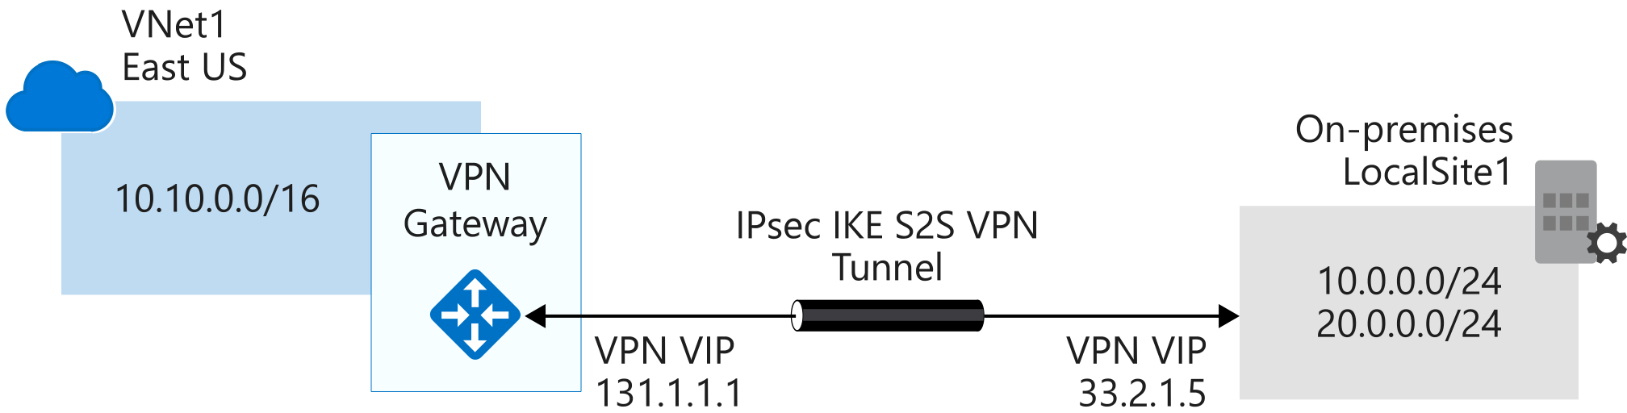

**Imp**

* All transferred data is encrypted in a private tunnel as it crosses the internet. You can deploy only one VPN gateway in each virtual network, but you can use one gateway to connect to multiple locations, including other Azure virtual networks or on-premises datacenters.
* When you deploy a VPN gateway, you specify the VPN type: either policy-based or route-based. The main difference of these two types of VPNs is how traffic to be encrypted is specified

### **Policy-based VPNs**

Policy-based VPN gateways specify statically the IP address of packets that should be encrypted through each tunnel. This type of device evaluates every data packet against those sets of IP addresses to choose the tunnel where that packet is going to be sent through. Key features of policy-based VPN gateways in Azure include:

* Support for IKEv1 only.
* Use of static routing, where combinations of address prefixes from both networks control how traffic is encrypted and decrypted through the VPN tunnel. The source and destination of the tunneled networks are declared in the policy and don't need to be declared in routing tables.
* Policy-based VPNs must be used in specific scenarios that require them, such as for compatibility with legacy on-premises VPN devices.

### Route-based VPNs

If defining which IP addresses are behind each tunnel is too cumbersome, route-based gateways can be used. In this devices IPSec tunnels are modeled as a network interface or VTI (virtual tunnel interface), and IP routing (static routes or dynamic routing protocols) will decide across which one of these tunnel interfaces to send each packet. Route-based VPNs are the preferred connection method for on-premises devices, since they are more resilient to topology changes such as the creation of new subnets, for example. Use a route-based VPN gateway if you need any of the following types of connectivity:

* Connections between virtual networks
* Point-to-site connections
* Multisite connections
* Coexistence with an Azure ExpressRoute gateway

Key features of route-based VPNs gateways in Azure include:

* Supports IKEv2.
* Uses any-to-any (wildcard) traffic selectors.
* Can use *dynamic routing protocols*, where routing/forwarding tables direct traffic to different IPSec tunnels. In this case, the source and destination networks are not statically defined as they are in policy-based VPNs or even in route-based VPNs with static routing. Instead, data packets are encrypted based on network routing tables that are created dynamically using routing protocols such as BGP (Border Gateway Protocol).

Both types of VPN gateways (route-based and policy-based) in Azure use pre-shared key as the only method of authentication. Both types also rely on Internet Key Exchange (IKE) in either version 1 or version 2 and Internet Protocol Security (IPSec). IKE is used to set up a security association (an agreement of the encryption) between two endpoints. This association is then passed to the IPSec suite, which encrypts and decrypts data packets encapsulated in the VPN tunnel.

## VPN gateway sizes

The capabilities of your VPN gateway are determined by the SKU or size that you deploy. This table shows the main capabilities of each available SKU:

| **SKU** | **Site-to-site/VNet-to-VNet tunnels** | **Aggregate throughput benchmark** | **Border Gateway Protocol (BGP) support** |
| --- | --- | --- | --- |
| Basic* | Maximum: 10 | 100 Mbps | Not supported |
| VpnGw1/Az | Maximum: 30 | 650 Mbps | Supported |
| VpnGw2/Az | Maximum: 30 | 1 Gbps | Supported |
| VpnGw3/Az | Maximum: 30 | 1.25 Gbps | Supported |

Basic VPN Gateway should only be used for Dev/Test workloads. In addition, it is unsupported to migrate from Basic to the VpnGW1/2/3/Az skus at a later time without having to remove the gateway and redeploy.

## Deploying VPN gateways

Before you can deploy a VPN gateway, you'll need some Azure and on-premises resources.

### Required Azure resources

You'll need these Azure resources before you can deploy an operational VPN gateway:

* **Virtual network**. Deploy an Azure virtual network with enough address space for the additional subnet that you'll need for the VPN gateway. The address space for this virtual network must not overlap with the on-premises network that you'll be connecting to. Remember that you can deploy only one VPN gateway within a virtual network.
* **GatewaySubnet**. Deploy a subnet called GatewaySubnet for the VPN gateway. Use at least a **/27** address mask to make sure you have enough IP addresses in the subnet for future growth. You can't use this subnet for any other services.
* **Public IP address**. Create a Basic-SKU dynamic public IP address if using a non-zone-aware gateway. This address provides a public-routable IP address as the target for your on-premises VPN device. This IP address is dynamic, but it won't change unless you delete and re-create the VPN gateway.
* **Local network gateway**. Create a local network gateway to define the on-premises network's configuration: where the VPN gateway will connect and what it will connect to. This configuration includes the on-premises VPN device's public IPv4 address and the on-premises routable networks. This information is used by the VPN gateway to route packets that are destined for on-premises networks through the IPSec tunnel.
* **Virtual network gateway**. Create the virtual network gateway to route traffic between the virtual network and the on-premises datacenter or other virtual networks. The virtual network gateway can be either a VPN or ExpressRoute gateway, but this module deals only with VPN virtual network gateways.
* **Connection**. Create a Connection resource to create a logical connection between the VPN gateway and the local network gateway.
  + The connection is made to the on-premises VPN device's IPv4 address as defined by the local network gateway.
  + The connection is made from the virtual network gateway and its associated public IP address.

You can create multiple connections.

The following diagram shows this combination of resources and their relationships to help you better understand what's required to deploy a VPN gateway:

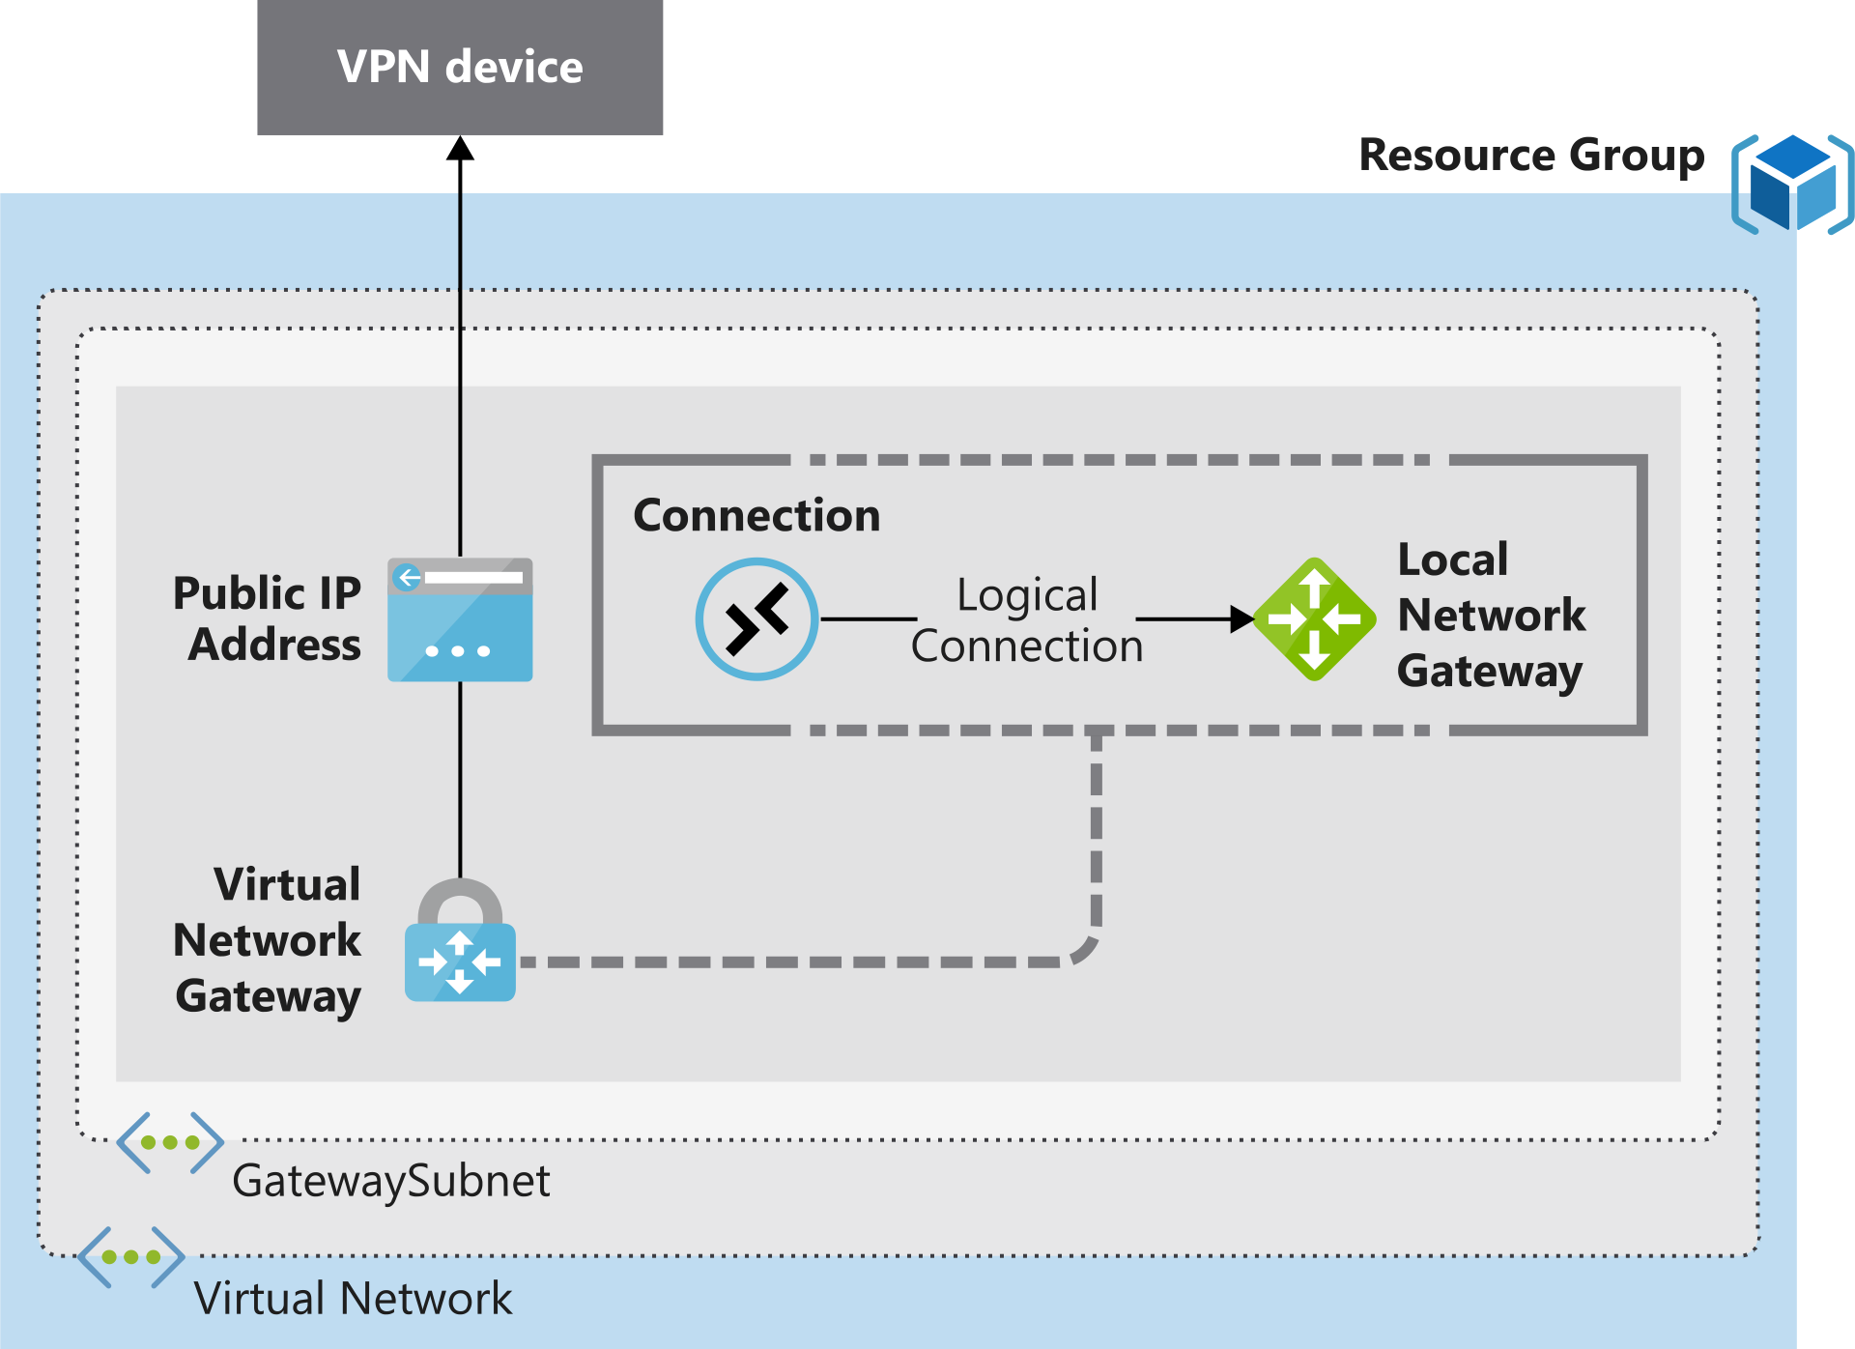

### Required on-premises resources

To connect your datacenter to a VPN gateway, you'll need these on-premises resources:

* A VPN device that supports policy-based or route-based VPN gateways
* A public-facing (internet-routable) IPv4 address

## High availability scenarios

There are several ways to ensure you have a fault-tolerant configuration.

Active/standby

By default, VPN gateways are deployed as two instances in an active/standby configuration, even if you only see one VPN gateway resource in Azure. When planned maintenance or unplanned disruption affects the active instance, the standby instance automatically assumes responsibility for connections without any user intervention. Connections are interrupted during this failover, but they're typically restored within a few seconds for planned maintenance and within 90 seconds for unplanned disruptions. 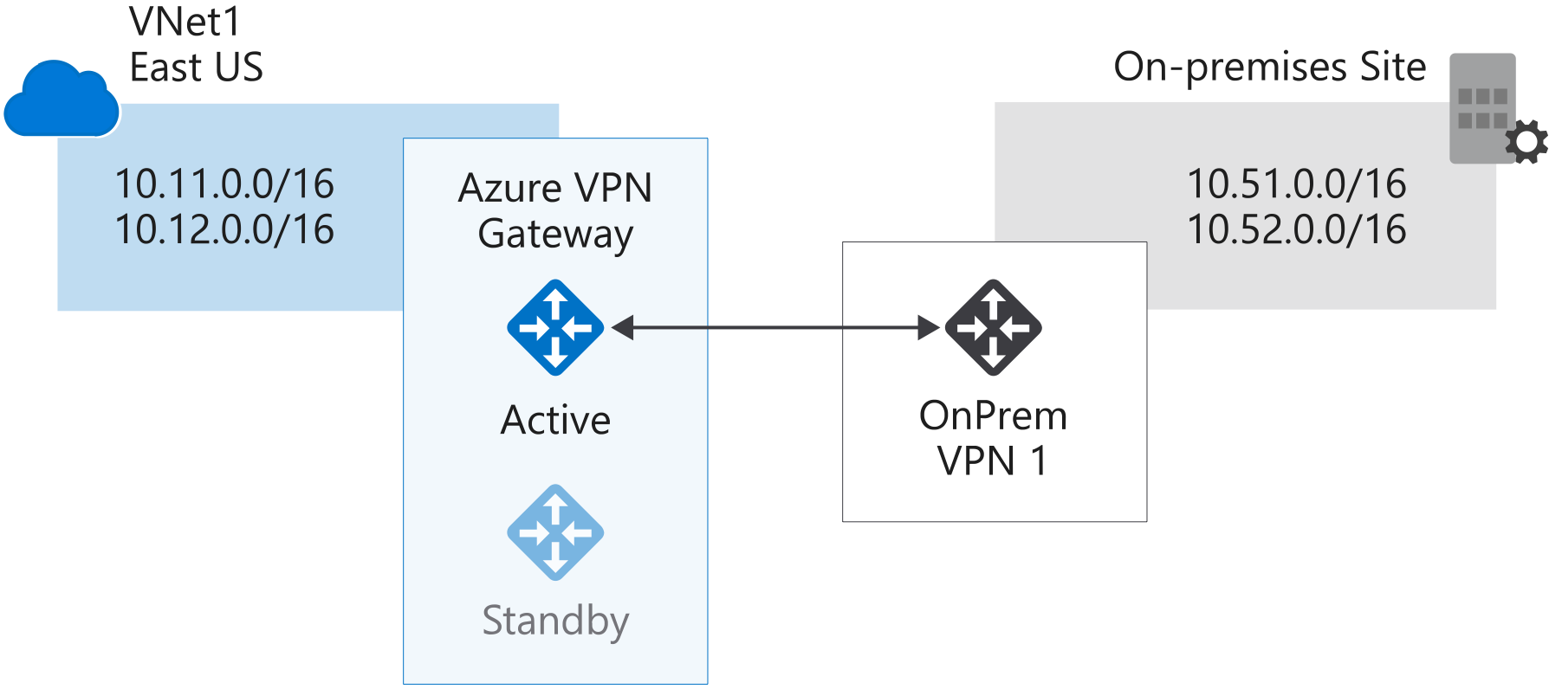

### Active/active

With the introduction of support for the BGP routing protocol, you can also deploy VPN gateways in an active/active configuration. In this configuration, you assign a unique public IP address to each instance. You then create separate tunnels from the on-premises device to each IP address. You can extend the high availability by deploying an additional VPN device on-premises.

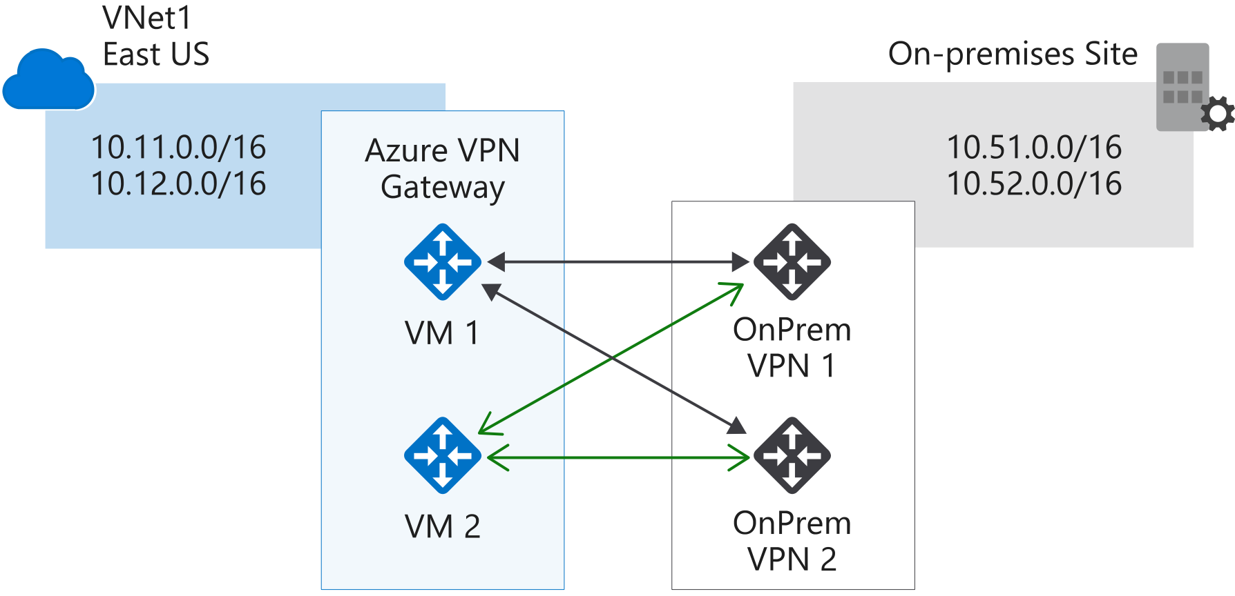

### **ExpressRoute failover**

Another high availability option is to configure a VPN gateway as a secure failover path for ExpressRoute connections. ExpressRoute circuits have resiliency built in but aren't immune to physical problems that affect the cables delivering connectivity or outages affecting the complete ExpressRoute location. In high availability scenarios, where there's risk associated with an outage of an ExpressRoute circuit, you can also provision a VPN gateway which uses the internet as an alternative method of connectivity, thus ensuring there's always a connection to the Azure virtual networks.

### **Zone-redundant gateways**

In regions that support availability zones, VPN and ExpressRoute gateways can be deployed in a zone-redundant configuration. This brings resiliency, scalability, and higher availability to virtual network gateways. Deploying gateways in Azure Availability Zones physically and logically separates gateways within a region, while protecting your on-premises network connectivity to Azure from zone-level failures. These require different gateway SKUs and leverage Standard public IP addresses instead of Basic public IP addresses.

# **Exercise - Prepare Azure and on-premises virtual networks by using Azure CLI commands**

Your company is now ready to deploy a site-to-site VPN. This VPN will allow your on-premises servers to connect to resources in Azure. You can then start to securely share data from each of your sites, and you can use resources hosted in Azure across your organization.

You'll start by creating your Azure-side resources and on-premises network resources. For this deployment, you'll use this network topology:

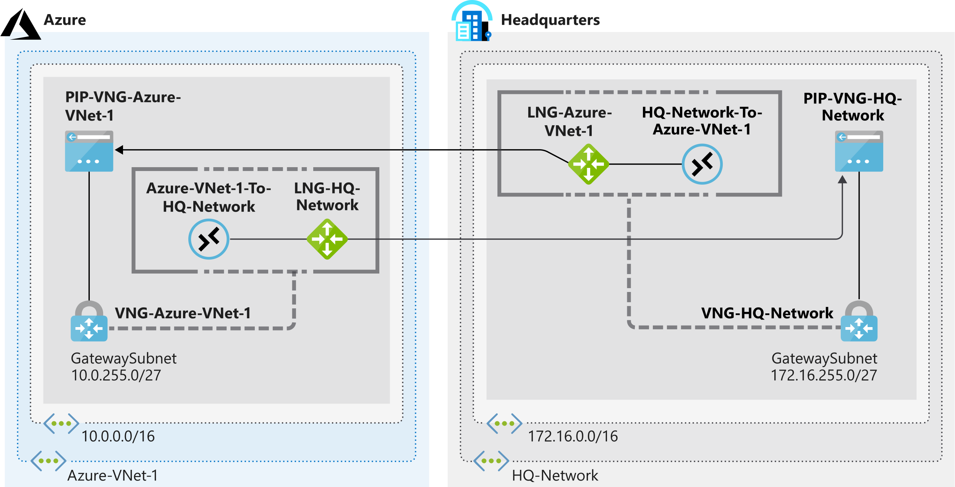

In this exercise, you'll simulate an on-premises datacenter (HQ-Network) by using an additional Azure virtual network. There are many makes and models of on-premises VPN devices, and it won't be possible to describe their configuration in this unit. The logical method of configuration is the same for a VPN device. You just need to replace the steps for HQ-Network with steps tailored to your on-premises device.

In the diagram, notice that the local network gateway names in each location reflect the *target* networks rather than the *source* network. This is a good practice. It clarifies that the local network gateway refers to the *other* network that you're connecting to.

In this unit, you'll configure the virtual networks with a subnet, add a gateway subnet, and then create the local network gateway by using the Azure CLI.

**Q: Try to understand the difference between subnet and gateway subnet?**

You're now ready to complete your site-to-site VPN gateway by creating the public IP addresses, virtual network gateways, and connections. Remember that you used placeholders for the public IP address references when you created your local network gateways. So one of your tasks now is to update these gateways with the actual public IP addresses assigned to your virtual network gateways.

Ideally, the public IP addresses and virtual network gateways should be created *before* the local network gateways. In this exercise, you'll see how to update the local network gateways. You can use the same commands to update any configuration elements in the local network gateways, like remote network address spaces.

**Create the Azure-side VPN gateway**

First, you'll create the VPN gateway for the Azure end of the connection. It can take up to 45 minutes to create a virtual network gateway. To save time, you'll use Azure CLI commands with the --no-wait parameter. This parameter lets you create both virtual network gateways simultaneously to minimize the overall time required to create these resources.

1. Run this command in Cloud Shell to create the **PIP-VNG-Azure-VNet-1** public IP address.

Azure CLICopy

az network public-ip create \

--resource-group learn-04abb970-9cb7-45cf-a6e4-870baec61f2e \

--name PIP-VNG-Azure-VNet-1 \

--allocation-method Dynamic

1. Run this command in Cloud Shell to create the **VNG-Azure-VNet-1** virtual network gateway.

Azure CLICopy

az network vnet-gateway create \

--resource-group learn-04abb970-9cb7-45cf-a6e4-870baec61f2e \

--name VNG-Azure-VNet-1 \

--public-ip-address PIP-VNG-Azure-VNet-1 \

--vnet Azure-VNet-1 \

--gateway-type Vpn \

--vpn-type RouteBased \

--sku VpnGw1 \

--no-wait

**Create the on-premises VPN gateway**

Next, you'll create a VPN gateway to simulate an on-premises VPN device.

1. Run this command in Cloud Shell to create the **PIP-VNG-HQ-Network** public IP address.

Azure CLICopy

az network public-ip create \

--resource-group learn-04abb970-9cb7-45cf-a6e4-870baec61f2e \

--name PIP-VNG-HQ-Network \

--allocation-method Dynamic

1. Run these commands in Cloud Shell to create the **VNG-HQ-Network** virtual network gateway.

Azure CLICopy

az network vnet-gateway create \

--resource-group learn-04abb970-9cb7-45cf-a6e4-870baec61f2e \

--name VNG-HQ-Network \

--public-ip-address PIP-VNG-HQ-Network \

--vnet HQ-Network \

--gateway-type Vpn \

--vpn-type RouteBased \

--sku VpnGw1 \

--no-wait

1. To monitor the progress of the gateway creation, run the following command. We're using the Linux watch command to run the az network vnet-gateway list command periodically, which allows you to monitor the progress.

bashCopy

watch -d -n 5 az network vnet-gateway list \

--resource-group learn-04abb970-9cb7-45cf-a6e4-870baec61f2e \

--output table

After each VPN gateway shows a **ProvisioningState** of **Succeeded**, you're ready to continue. Press Ctrl+C to halt the command after the gateway is created.

outputCopy

ActiveActive EnableBgp GatewayType Location Name ProvisioningState ResourceGroup ResourceGuid VpnType

-------------- ----------- ------------- -------------- ---------------- ------------------- ----------------------------- ------------------------------------ ----------

False False Vpn southcentralus VNG-Azure-VNet-1 Succeeded learn-04abb970-9cb7-45cf-a6e4-870baec61f2e 48dc714e-a700-42ad-810f-a8163ee8e001 RouteBased

False False Vpn southcentralus VNG-HQ-Network Succeeded learn-04abb970-9cb7-45cf-a6e4-870baec61f2e 49b3041d-e878-40d9-a135-58e0ecb7e48b RouteBased

**Update the local network gateway IP references**

**Important**

Your virtual network gateways must be successfully deployed before you start the next exercise.

In this section, you'll update the remote gateway IP address references that are defined in the local network gateways. You can't update the local network gateways until you've created the VPN gateways and an IPv4 address is assigned to and associated with them. You can use this Azure CLI command to check whether both virtual network gateways have been created:

Azure CLICopy

az network vnet-gateway list \

--resource-group learn-04abb970-9cb7-45cf-a6e4-870baec61f2e \

--query "[?provisioningState=='Succeeded']" \

--output table

Remember to wait until the lists of gateways are successfully returned. Also, remember that the local network gateway resources define the settings of the *remote* gateway and network that they're named after. For example, the **LNG-Azure-VNet-1** local network gateway contains information like the IP address and networks for **Azure-VNet-1**.

1. Run this command in Cloud Shell to retrieve the IPv4 address assigned to **PIP-VNG-Azure-VNet-1**.

bashCopy

PIPVNGAZUREVNET1="$(az network public-ip show \

--resource-group learn-04abb970-9cb7-45cf-a6e4-870baec61f2e \

--name PIP-VNG-Azure-VNet-1 \

--query "[ipAddress]" \

--output tsv)"

1. Run this command in Cloud Shell to update the **LNG-Azure-VNet-1** local network gateway so that it points to the public IP address attached to the **VNG-Azure-VNet-1** virtual network gateway.

Azure CLICopy

az network local-gateway update \

--resource-group learn-04abb970-9cb7-45cf-a6e4-870baec61f2e \

--name LNG-Azure-VNet-1 \

--gateway-ip-address $PIPVNGAZUREVNET1

1. Run this command in Cloud Shell to retrieve the IPv4 address assigned to **PIP-VNG-HQ-Network**.

bashCopy

PIPVNGHQNETWORK="$(az network public-ip show \

--resource-group learn-04abb970-9cb7-45cf-a6e4-870baec61f2e \

--name PIP-VNG-HQ-Network \

--query "[ipAddress]" \

--output tsv)"

1. Run this command in Cloud Shell to update the **LNG-HQ-Network** local network gateway so that it points to the public IP address attached to the **VNG-HQ-Network** virtual network gateway.

Azure CLICopy

az network local-gateway update \

--resource-group learn-04abb970-9cb7-45cf-a6e4-870baec61f2e \

--name LNG-HQ-Network \

--gateway-ip-address $PIPVNGHQNETWORK

**Create the connections**

You'll now complete the configuration by creating the connections from each VPN gateway to the local network gateway that contains the public IP address references for that gateway's remote network.

1. Create the shared key to use for the connections. In the following command, replace <shared key> with a text string to use for the IPSec pre-shared key. The pre-shared key is a string of printable ASCII characters no longer than 128 characters. You'll use this pre-shared key on both connections.

bashCopy

SHAREDKEY=<shared key>

1. Remember that **LNG-HQ-Network** contains a reference to the IP address on your simulated on-premises VPN device. Run this command in Cloud Shell to create a connection from **VNG-Azure-VNet-1** to **LNG-HQ-Network**.

Azure CLICopy

az network vpn-connection create \

--resource-group learn-04abb970-9cb7-45cf-a6e4-870baec61f2e \

--name Azure-VNet-1-To-HQ-Network \

--vnet-gateway1 VNG-Azure-VNet-1 \

--shared-key $SHAREDKEY \

--local-gateway2 LNG-HQ-Network

1. Remember that **LNG-Azure-VNet-1** contains a reference to the public IP address associated with the **VNG-Azure-VNet-1** VPN gateway. This connection would normally be created from your on-premises device. Run this command in Cloud Shell to create a connection from **VNG-HQ-Network** to **LNG-Azure-VNet-1**.

Azure CLICopy

az network vpn-connection create \

--resource-group learn-04abb970-9cb7-45cf-a6e4-870baec61f2e \

--name HQ-Network-To-Azure-VNet-1 \

--vnet-gateway1 VNG-HQ-Network \

--shared-key $SHAREDKEY \

--local-gateway2 LNG-Azure-VNet-1

You've now finished the configuration of the site-to-site connection. This may take a few minutes, but the tunnels should automatically connect and become active.

**Verification steps**

Let's confirm that the VPN tunnels are connected.

1. Run the following command to confirm that **Azure-VNet-1-To-HQ-Network** is connected.

Azure CLICopy

az network vpn-connection show \

--resource-group learn-04abb970-9cb7-45cf-a6e4-870baec61f2e \

--name Azure-VNet-1-To-HQ-Network \

--output table \

--query '{Name:name,ConnectionStatus:connectionStatus}'

You should see output like below indicating the connection is successful. If the ConnectionStatus shows as Connecting, wait a minute or two and rerun the command. The connections can take a few minutes to fully connect.

outputCopy

Name ConnectionStatus

-------------------------- ------------------

Azure-VNet-1-To-HQ-Network Connected

1. Now lets confirm the corresponding **HQ-Network-To-Azure-VNet-1** connection is also established.

Azure CLICopy

az network vpn-connection show \

--resource-group learn-04abb970-9cb7-45cf-a6e4-870baec61f2e \

--name HQ-Network-To-Azure-VNet-1 \

--output table \

--query '{Name:name,ConnectionStatus:connectionStatus}'

You should see the following output indicating this connection is also successful.

outputCopy

Name ConnectionStatus

-------------------------- ------------------

HQ-Network-To-Azure-VNet-1 Connected

The site-to-site configuration is now complete. Your final topology, including the subnets, and connections, with logical connection points, is shown in this diagram. Virtual machines deployed in the **Services** and **Applications** subnets can now communicate with each other, now that the VPN connections have been successfully established.

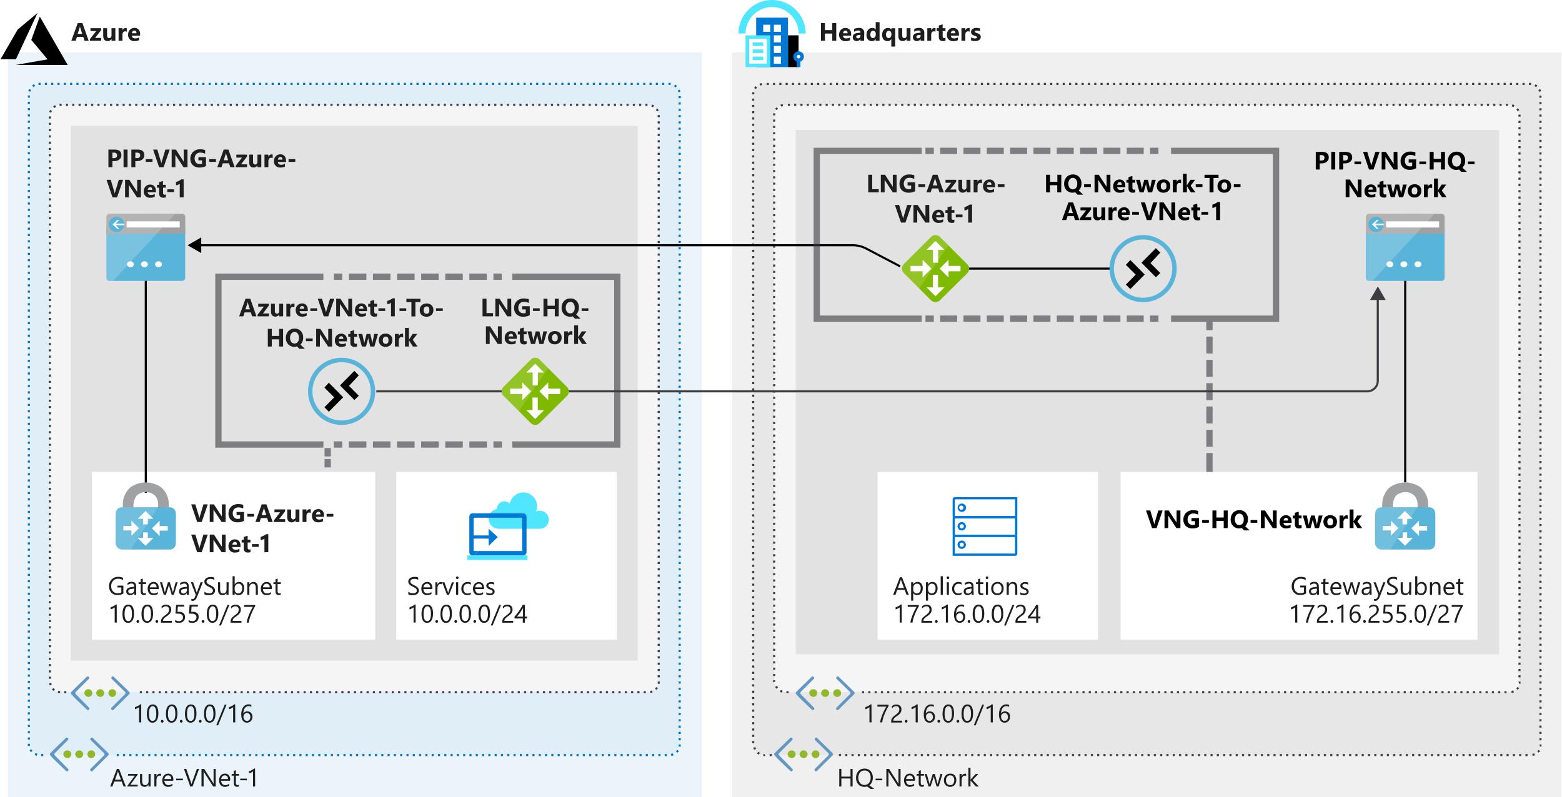

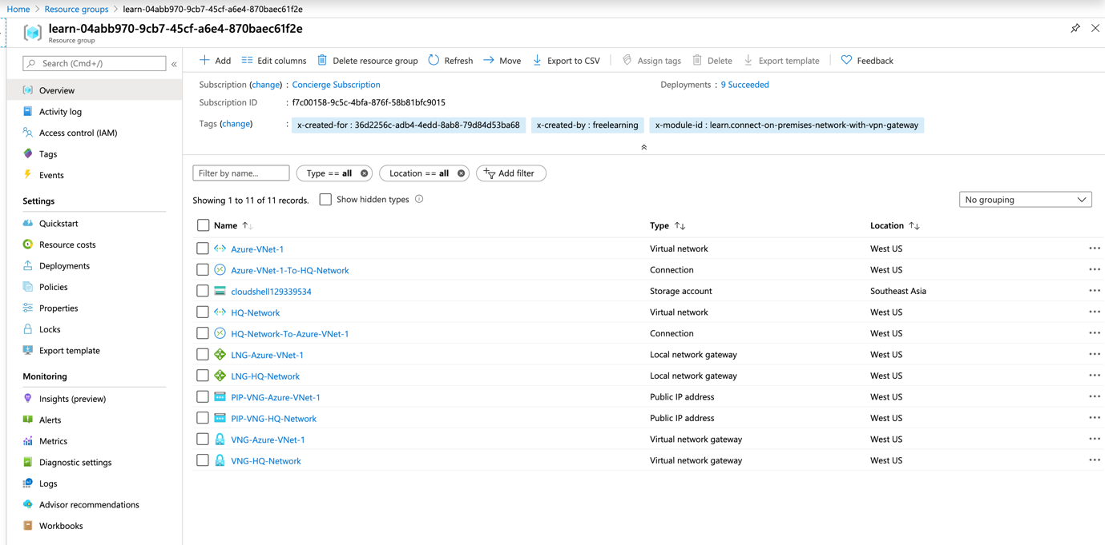

**Summary**

It's critical that healthcare providers have secure connectivity for passing patient healthcare information between datacenters and regional facilities. To achieve the goals of secure connectivity in a cost-effective way, you used VPN gateway options in Azure to connect on-premises networks to virtual networks in Azure. You learned about the resources you need to create VPN gateways and the limitations that apply to different VPN Gateway SKUs. You also learned how to create and configure site-to-site virtual network gateways.

### **Connect your on-premises network to the Microsoft global network by using ExpressRoute**

Connect your on-premises systems and users to Azure and Office 365 by using ExpressRoute for private, dedicated, and guaranteed throughput connectivity.

In this module, you will:

* Describe the features and capabilities of ExpressRoute
* Describe the use cases for using ExpressRoute to integrate traditional networks with Azure

# Introduction

* 5 minutes

You can use the Azure ExpressRoute service to extend your on-premises networks into the Microsoft cloud. Connections are made over a private high-bandwidth connection. The ExpressRoute service provides a secure and reliable way to connect your on-premises network directly to Azure.

Imagine you're the solution architect for a financial organization that has begun migrating resources to Azure. The organization has systems that need to communicate between an on-premises network and Azure, and it doesn't want this traffic traversing the internet. These applications have higher bandwidth requirements and need to have consistent network performance.

The organization also uses Office 365. It wants to reduce traffic over the internet and send this traffic over a dedicated connection to Azure. The organization believes ExpressRoute meets its needs, but it wants to understand more about the service and whether it should include the service in the infrastructure.

# **What is the Azure ExpressRoute service?**

* 10 minutes

As part of the project for the finance company, you need to understand:

* What Azure ExpressRoute is.
* How ExpressRoute integrates with on-premises and Azure networks.
* The benefits that ExpressRoute provides compared to other site-to-site connectivity options.
* Whether ExpressRoute can provide the finance company with the best possible network performance.

## ExpressRoute overview

Azure ExpressRoute lets you seamlessly extend your on-premises networks into the Microsoft cloud. This connection between your organization and Azure is dedicated and private. Establishing an ExpressRoute connection enables you to connect to Microsoft cloud services like Azure, Office 365, and Dynamics 365. Security is enhanced, connections are more reliable, latency is minimal, and throughput is greatly increased.

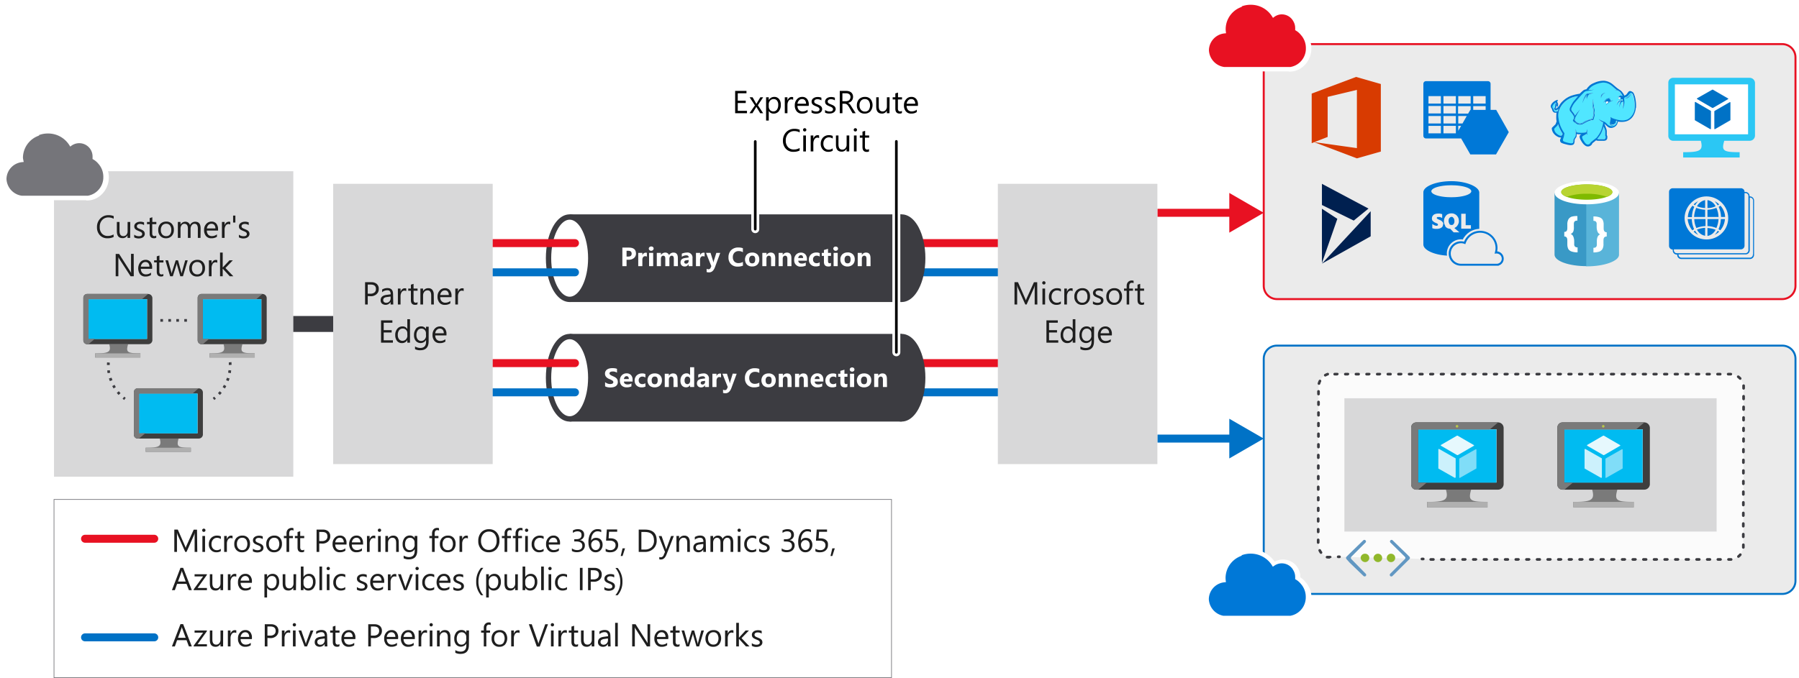

## Features and benefits of ExpressRoute

There are several benefits to using ExpressRoute as the connection service between Azure and on-premises networks.

### **Layer 3 connectivity**

ExpressRoute provides Layer 3 (address-level) connectivity between your on-premises network and the Microsoft cloud through connectivity partners. These connections can be from a point-to-point, any-to-any network, or they can be virtual cross-connections through an exchange.

### **Built-in redundancy**

Each connectivity provider uses redundant devices to ensure that connections established with Microsoft are highly available. You can configure multiple circuits to complement this feature. All redundant connections are configured with Layer 3 connectivity to meet SLAs.

### Connectivity to Microsoft cloud services

ExpressRoute enables direct access to the following services in all regions:

* Microsoft Office 365
* Microsoft Dynamics 365
* Azure compute services, such as Azure Virtual Machines
* Azure cloud services, such as Azure Cosmos DB and Azure Storage

Office 365 was created to be accessed securely and reliably via the internet. Because of this, we recommend ExpressRoute for specific scenarios. The "Learn more" section at the end of this module includes a link about using ExpressRoute to access Office 365.

### **Across on-premises connectivity with ExpressRoute Global Reach**

You can enable ExpressRoute Global Reach to exchange data across your on-premises sites by connecting your ExpressRoute circuits. For example, assume that you have a private datacenter in California connected to ExpressRoute in Silicon Valley. You have another private datacenter in Texas connected to ExpressRoute in Dallas. With ExpressRoute Global Reach, you can connect your private datacenters through two ExpressRoute circuits. Your cross-datacenter traffic will travel through the Microsoft network.

### **Dynamic routing**

ExpressRoute uses the Border Gateway Protocol (BGP) routing protocol. BGP is used to exchange routes between on-premises networks and resources running in Azure. This protocol enables dynamic routing between your on-premises network and services running in the Microsoft cloud.

**ExpressRoute connectivity models**

ExpressRoute supports three models that you can use to connect your on-premises network to the Microsoft cloud:

* CloudExchange co-location
* Point-to-point Ethernet connection
* Any-to-any connection

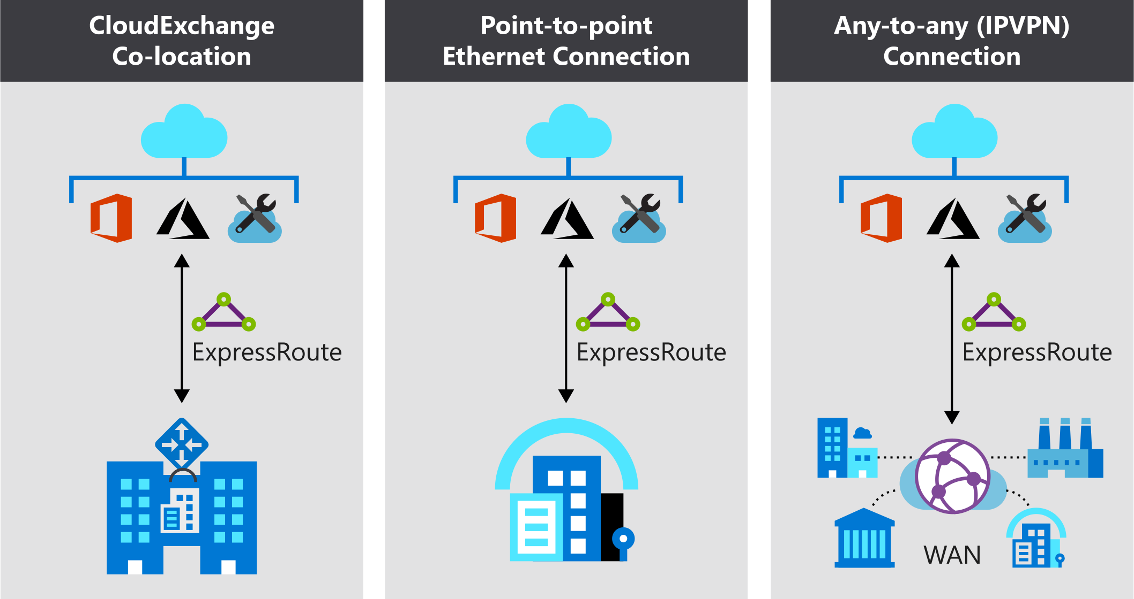

### **Co-location at a cloud exchange**

Co-located providers can normally offer both Layer 2 and Layer 3 connections between your infrastructure, which might be located in the co-location facility, and the Microsoft cloud. For example, if your datacenter is co-located at a cloud exchange such as an internet service provider (ISP), you can request a virtual cross-connection to the Microsoft cloud.

### **Point-point Ethernet connection**

Point-to-point connections provide Layer 2 and Layer 3 connectivity between your on-premises site and Microsoft Azure. You can connect your offices or datacenters to Azure by using the point-to-point links. For example, if you have an on-premises datacenter, you can use a point-to-point Ethernet link to connect to Microsoft.

### **Any-to-any networks**

With point-to-point connectivity, you can integrate your wide area network (WAN) with Microsoft Azure by providing connections to your offices and datacenters. Azure will integrate with your WAN connection to provide a seamless connection, just like you would have between your datacenter and any branch offices.

With point-to-point connections, all WAN providers offer Layer 3 connectivity. For example, if you already use Multiprotocol Label Switching (MPLS) to connect to your branch offices or other sites in your organization, an ExpressRoute connection to Microsoft will behave just like another location on your private WAN.

## Security considerations

With ExpressRoute, your data doesn’t travel over the public internet, so it's not exposed to the potential risks associated with internet communications. ExpressRoute is a private connection from your on-premises infrastructure to your Azure infrastructure. Even if you have an ExpressRoute connection, DNS queries, certificate revocation list checking, and Azure Content Delivery Network requests are still sent over the public internet.

# **How Azure ExpressRoute works**

* You've learned about the purpose of the Azure ExpressRoute service, and the services for which you can use it. Now you're ready to start learning about how the service works. You'll see how it interacts with Azure and on-premises networks to help create a secure and reliable connection between your on-premises datacenter and the Microsoft cloud.
* In this unit, you'll learn how to create and use Azure circuits to connect your on-premises networks to the cloud. You'll see the steps that you need to take to create a circuit. You'll also learn about the other components of an ExpressRoute connection, which work together to form a connection from your on-premises datacenter to the Microsoft cloud.

## Architecture of ExpressRoute

* ExpressRoute is supported across all regions and locations. To implement ExpressRoute, you need to work with an ExpressRoute partner. The partner provides the edge service: an authorized and authenticated connection that operates through a partner-controlled router. The edge service is responsible for extending your network to the Microsoft cloud.
* The partner sets up connections to an endpoint in an ExpressRoute location (implemented by a Microsoft edge router). These connections enable you to peer your on-premises networks with the virtual networks available through the endpoint. These connections are called circuits.
* A circuit provides a physical connection for transmitting data through the ExpressRoute provider's edge routers to the Microsoft edge routers. A circuit is established across a private wire rather than the public internet. Your on-premises network is connected to the ExpressRoute provider's edge routers. The Microsoft edge routers provide the entry point to the Microsoft cloud.

## Prerequisites for ExpressRoute

Before you can connect to Microsoft cloud services by using ExpressRoute, you need to have:

* An ExpressRoute connectivity partner or cloud exchange provider that can set up a connection from your on-premises networks to the Microsoft cloud.
* An Azure subscription that is registered with your chosen ExpressRoute connectivity partner.
* An active Microsoft Azure account that can be used to request an ExpressRoute circuit.
* An active Office 365 subscription, if you want to connect to the Microsoft cloud and access Office 365 services.

ExpressRoute works by peering your on-premises networks with networks running in the Microsoft cloud. Resources on your networks can communicate directly with resources hosted by Microsoft. To support these peerings, ExpressRoute has a number of network and routing requirements:

* Ensure that BGP sessions for routing domains have been configured. Depending on your partner, this might be their or your responsibility. Additionally, for each ExpressRoute circuit, Microsoft requires redundant BGP sessions between Microsoft’s routers and your peering routers.
* You or your providers need to translate the private IP addresses used on-premises to public IP addresses by using a NAT service. Microsoft will reject anything except public IP addresses through Microsoft peering.
* Reserve several blocks of IP addresses in your network for routing traffic to the Microsoft cloud. You configure these blocks as either a /29 subnet or two /30 subnets in your IP address space. One of these subnets is used to configure the primary circuit to the Microsoft cloud, and the other implements a secondary circuit. You use the first address in these subnets to communicate with services in the Microsoft cloud. Microsoft uses the second address to establish a BGP session.

ExpressRoute supports two peering schemes:

* Use private peering to connect to Azure IaaS and PaaS services deployed inside Azure virtual networks. The resources that you access must all be located in one or more Azure virtual networks with private IP addresses. You can't access resources through their public IP address over a private peering.
* Use Microsoft peering to connect to Azure PaaS services, Office 365 services, and Dynamics 365.

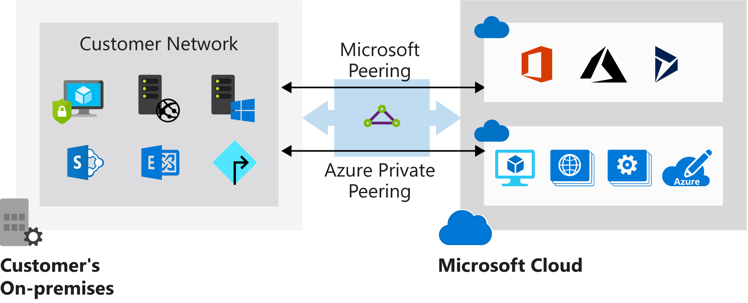

## Create an ExpressRoute circuit and peering

Establishing a connection to Azure through ExpressRoute is a multistep process. You can perform many of these steps either by using the Azure portal, or from the command line by using PowerShell or the Azure CLI. This section describes the process of using the Azure portal. For PowerShell and CLI instructions, see the "Learn more" section at the end of this module.

### **Create a circuit**

When you're using the Azure portal, select **Create a resource** > **Networking** > **ExpressRoute**. The **Create ExpressRoute circuit** page requires you to complete the following fields:

| **Property** | **Value** |
| --- | --- |
| **Circuit name** | A meaningful name for your circuit, without any white space or special characters. |
| **Provider** | The ExpressRoute provider with which you've registered your subscription. |
| **Peering location** | A location enabled by the ExpressRoute provider in which to create your circuit. |
| **Bandwidth** | Select your bandwidth, from 50 Mbps up to 10 Gbps. Start with a low value. You can increase it later with no interruption to service. However, you can't reduce the bandwidth if you set it too high initially. |
| **SKU** | Select **Standard** if you have up to 10 virtual networks and only need to connect to resources in the same geopolitical region. Otherwise, select **Premium**. |
| **Billing model** | Select **Unlimited** to pay a flat fee regardless of usage. Or select **Metered** to pay according to the volume of traffic that enters and exits the circuit. |
| **Subscription** | The subscription you've registered with your ExpressRoute provider. |
| **Resource group** | The Azure resource group in which to create the circuit. |
| **Location** | The Azure location in which to create the circuit. |

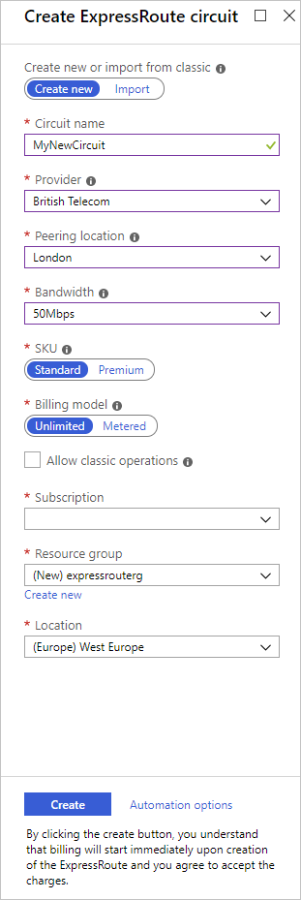

Circuit creation can take several minutes. After the circuit has been provisioned, you can use the Azure portal to view the properties. You'll see that **Circuit status** is enabled, meaning that the Microsoft side of the circuit is ready to accept connections. **Provider status** will be **Not provisioned** initially. This is because the provider hasn't configured their side of the circuit for connecting to your network.

You send the provider the value in the **Service key** field to enable them to configure the connection. This can take several days. You can revisit this page to check the provider status.

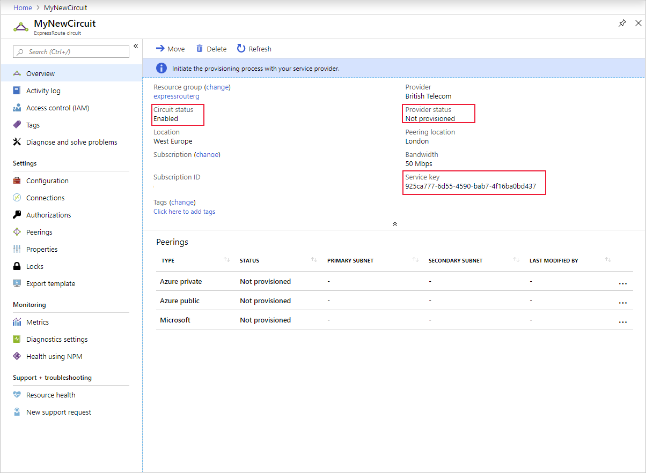

### **Create a peering configuration**

After the provider status is reported as **Provisioned**, you can configure the routing for the peerings. These steps apply only to circuits that are created with service providers who offer Layer 2 connectivity. For any circuits that operate at Layer 3, the provider might be able to configure the routing for you.

The **ExpressRoute circuit** page (shown earlier) lists each peering and its properties. You can select a peering to configure these properties.

### Configure private peering

You use private peering to connect your network to your virtual networks running in Azure. To configure private peering, you must provide the following information:

* **Peer ASN**. The autonomous system number for your side of the peering. This ASN can be public or private, and 16 bits or 32 bits.
* **Primary subnet**. This is the address range of the primary /30 subnet that you created in your network. You'll use the first IP address in this subnet for your router. Microsoft uses the second for its router.
* **Secondary subnet**. This is the address range of your secondary /30 subnet. This subnet provides a secondary link to Microsoft. The first two addresses are used to hold the IP address of your router and the Microsoft router.
* **VLAN ID**. This is the VLAN on which to establish the peering. The primary and secondary links will both use this VLAN ID.
* **Shared key**. This is an optional MD5 hash that's used to encode messages passing over the circuit.

### **Configure Microsoft peering**

You use Microsoft peering to connect to Office 365 and its associated services. To configure Microsoft peering, you provide a peer ASN, a primary subnet address range, a secondary subnet address range, a VLAN ID, and an optional shared key as described for a private peering. You must also provide the following information:

* **Advertised public prefixes**. This is a list of the address prefixes that you use over the BGP session. These prefixes must be registered to you, and must be prefixes for public address ranges.
* **Customer ASN**. This is optional. It's the client-side autonomous system number to use if you are advertising prefixes that aren't registered to the peer ASN.
* **Routing registry name**. This name identifies the registry in which the customer ASN and public prefixes are registered.

## Connect a virtual network to an ExpressRoute circuit

After the ExpressRoute circuit has been established, Azure private peering is configured for your circuit, and the BGP session between your network and Microsoft is active, you can enable connectivity from your on-premises network to Azure.

Before you can connect to a private circuit, you must create an Azure virtual network gateway by using a subnet on one of your Azure virtual networks. The virtual network gateway provides the entry point to network traffic that enters from your on-premises network. It directs incoming traffic through the virtual network to your Azure resources.

You can configure network security groups and firewall rules to control the traffic that's routed from your on-premises network. You can also block requests from unauthorized addresses in your on-premises network.

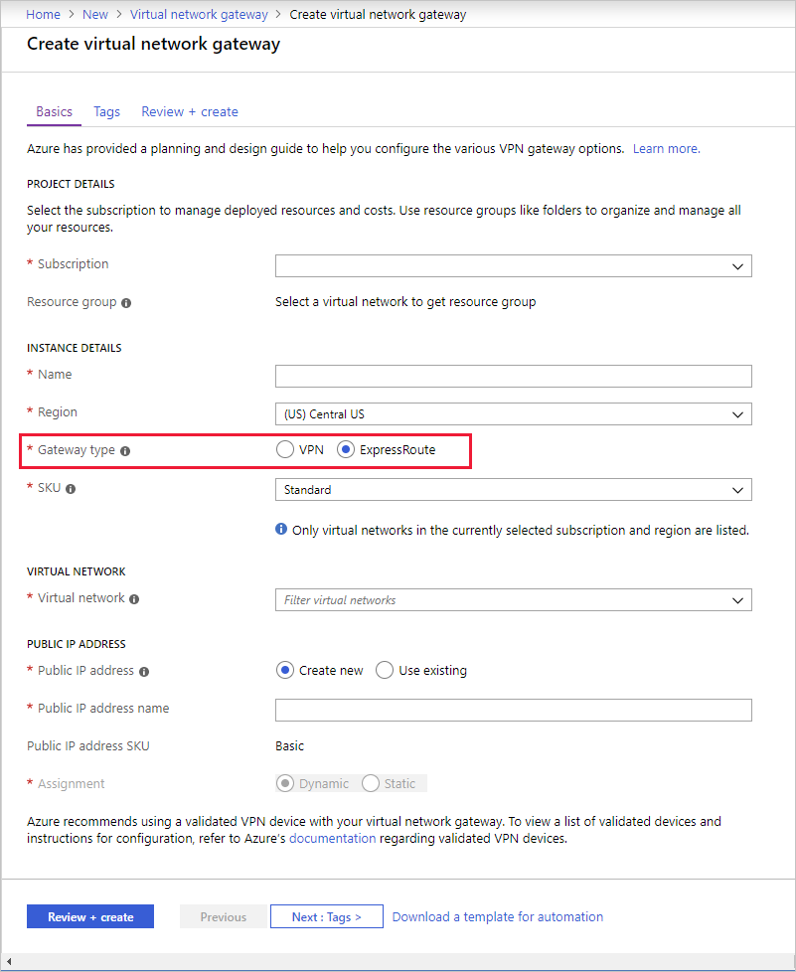

Up to 10 virtual networks can be linked to an ExpressRoute circuit, but these virtual networks must be in the same geopolitical region as the ExpressRoute circuit. You can link a single virtual network to four ExpressRoute circuits if necessary. The ExpressRoute circuit can be in the same subscription to the virtual network, or in a different one.

If you're using the Azure portal, you connect a peering to a virtual network gateway as follows:

1. On the **ExpressRoute circuit** page for your circuit, select **Connections**.
2. On the **Connections** page, select **Add**.
3. On the **Add connection** page, give your connection a name, and then select your virtual network gateway. When the operation has finished, your on-premises network will be connected through the virtual network gateway to your virtual network in Azure. The connection will be made across the ExpressRoute connection.

## High availability and failover with ExpressRoute

In each ExpressRoute circuit, there are two connections from the connectivity provider to two different Microsoft edge routers. This configuration occurs automatically. It provides a degree of availability within a single location.

Consider setting up ExpressRoute circuits in different peering locations to provide high availability and help protect against a regional outage. For example, you might create circuits in the US East and US Central regions and connect these circuits to your virtual network. This way, if one ExpressRoute circuit goes down, you won't lose connectivity to your resource and you can fail over the connection to another ExpressRoute circuit.

You can also have multiple circuits across different providers to ensure that your network stays available even if an outage affects all circuits from a single approved provider. You can set the **Connection Weight** property to prefer one circuit to another.

## ExpressRoute Direct and FastPath

Microsoft also provides an ultra-high-speed option called ExpressRoute Direct. This service enables dual 100-Gbps connectivity. It's suitable for scenarios that involve massive and frequent data ingestion. It's also suitable for solutions that require extreme scalability, such as banking, government, and retail.

You enroll your subscription with Microsoft to activate ExpressRoute Direct. For more information, visit the ExpressRoute article in the "Learn more" section at the end of this module.

ExpressRoute Direct supports FastPath. When FastPath is enabled, it sends network traffic directly to a virtual machine that's the intended destination. The traffic bypasses the virtual network gateway, improving the performance between Azure virtual networks and on-premises networks.

FastPath doesn't support virtual network peering (where you have virtual networks connected together). It also doesn't support user-defined routes on the gateway subnet.

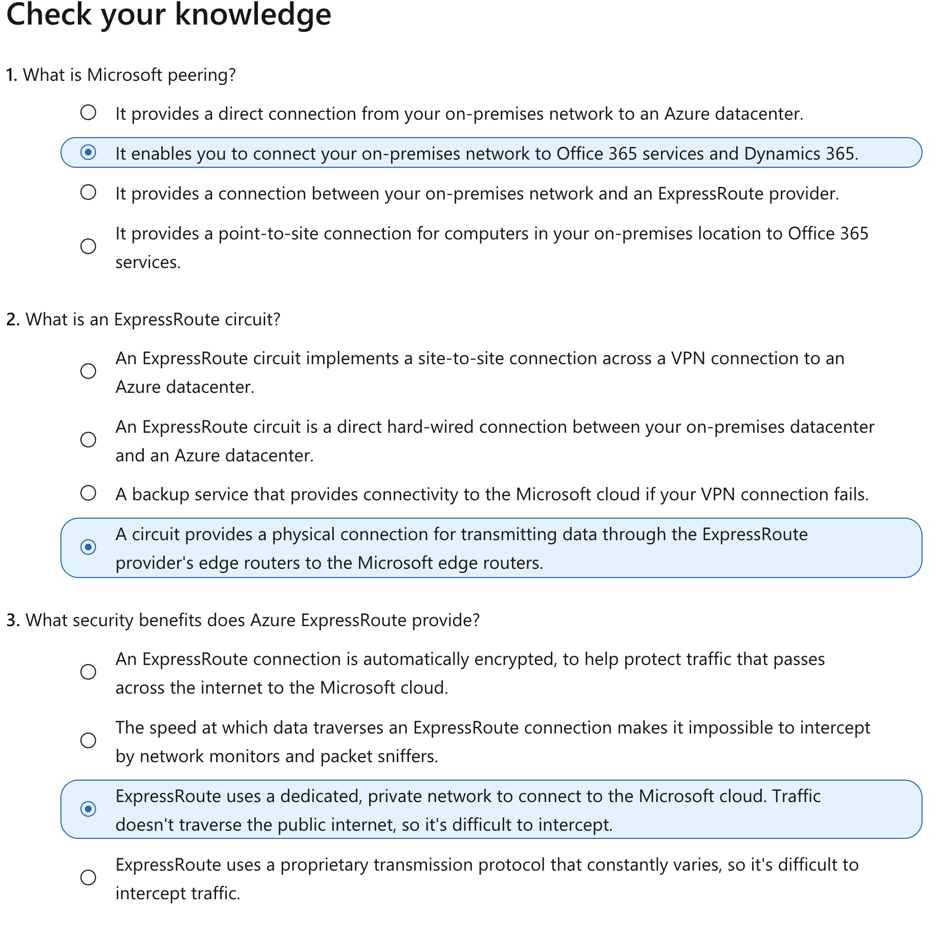

# When to choose Azure ExpressRoute

* 10 minutes

You've learned how the Azure ExpressRoute service works, and how to connect your on-premises networks to the Microsoft cloud by using an ExpressRoute circuit. You've also learned about the different peering options available, and how to use a virtual network gateway to route requests between your on-premises network and the Microsoft cloud.

In this unit, you'll learn about the most common use cases for deploying ExpressRoute. You'll compare ExpressRoute to other connection options available for Azure, like site-to-site and point-to-site through a virtual network gateway. This information will to help you determine whether ExpressRoute is the most appropriate solution for your organization.

## When to use Azure ExpressRoute

Consider using the Azure ExpressRoute service in the following scenarios:

* Low-latency connectivity to services in the cloud. In these situations, eliminating or reducing the network overhead will have a significant impact on the performance of your applications.
* Accessing high-volume systems in the cloud that consume or produce massive volumes of data quickly. ExpressRoute can move data around rapidly, with high reliability.
* Consuming Microsoft Cloud Services, such as Office 365 and Dynamics 365. ExpressRoute is especially useful if your organization has a large number of users who need to access these services concurrently.
* Organizations that have migrated large-scale on-premises systems to Azure. Using ExpressRoute helps ensure that the results of the migrations are seamless for on-premises clients. They should notice no drop in performance. They might even experience some improvement if the previous on-premises systems were restricted by network bandwidth.
* Situations where data should not traverse the public internet for security reasons.
* Large datacenters, with a high number of users and systems accessing SaaS offerings.

## Benefits of using ExpressRoute

ExpressRoute offers several advantages for building highly scalable, cloud-based solutions.

### **Predictable performance**

Having a dedicated connection to the Microsoft cloud guarantees performance. There are no concerns over internet provider outages or spikes in internet traffic. With ExpressRoute, your providers are accountable to provide the necessary throughput and latency SLA.

### **Data privacy for your traffic**

Traffic that's sent over ExpressRoute connection is as secure as using MPLS WAN links. There's no risk of internet monitoring or packet capture by malicious users.

### **High-throughput, low-latency connections**

With ExpressRoute, you can obtain speeds of up to 10 Gbps when connecting to the Microsoft cloud. If you're using ExpressRoute Direct, you can achieve up to 100 Gbps. Latency is minimal, so your systems are highly responsive.

### **Availability and connectivity**

Microsoft guarantees a minimum of 99.95 percent availability for an ExpressRoute dedicated circuit.

With ExpressRoute enabled, you can connect to Microsoft through one of several peering connections and have access to regions within the same geopolitical region. For example, if you connect to Microsoft through ExpressRoute in France, you'll have access to all Microsoft services hosted in Western Europe.

You can also enable ExpressRoute Premium, which provides cross-region accessibility. For example, if you access Microsoft through ExpressRoute in Germany, you'll have access to all Microsoft cloud services in all regions globally.

You can also take advantage of a feature called ExpressRoute Global Reach. It allows you to exchange data across all of your on-premises datacenters by connecting all of your ExpressRoute circuits.

## Alternatives to ExpressRoute

ExpressRoute is one of three solutions that you can use to connect your on-premises network to Azure. The others are a virtual network site-to-site connection and a virtual network point-to-site connection.

### **Site-to-site VPN**

An Azure site-to-site VPN connection enables you to connect your on-premises network to Azure over an IPsec tunnel to build a hybrid network solution. You configure an on-premises VPN device with a public IP address. You connect this device to an Azure virtual network through an Azure virtual network gateway.

### **Point-to-site VPN**

With point-to-site VPN, you can establish a secure connection to a network from individual computers located on-premises. This solution is useful for someone who wants to connect to Azure from remote locations such as a home or customer site. Point-to-site is useful if you have only a few clients that need to connect to a virtual network.

### **Azure ExpressRoute vs. site-to-site and point-to-site VPN connections**

The following table shows a comparison between ExpressRoute, point-to-site, and site-to-site networks with Azure.

| **Connection** | **Azure services supported** | **Bandwidth** | **Protocols** | **Typical use case** |
| --- | --- | --- | --- | --- |
| Virtual network, point-to-site | Azure IaaS services, Azure Virtual Machines | Based on the gateway SKU | Active/passive | Dev, test, and lab environments for cloud services and virtual machines. |
| Virtual network, site-to-site | Azure IaaS services, Azure Virtual Machines | Typically < 1 Gbps aggregate | Active/passive | Dev, test, and lab environments. Small-scale production workloads and virtual machines. |
| ExpressRoute | Azure IaaS and PaaS services, Microsoft Office 365 services | 50 Mbps up to 10 Gbps (100 Gbps for ExpressRoute Direct) | Active/active | Enterprise-class and mission-critical workloads. Big data solutions. |

# **Secure and isolate access to Azure resources by using network security groups and service endpoints**

Network security groups and service endpoints help you secure your virtual machines and Azure services from unauthorized network access.

In this module, you will:

* Identify the capabilities and features of network security groups.
* Identify the capabilities and features of virtual network service endpoints.
* Use network security groups to restrict network connectivity.
* Use virtual network service endpoints to control network traffic to and from Azure services.

# **Introduction**

* 3 minutes

Imagine you are the solution architect for a manufacturing company. Your company has several sites, and users throughout the company will need to use an enterprise resource planning (ERP) application to migrate to Azure. The company will only consider moving key systems onto the platform if stringent security requirements can be met, including tight control over which computers have network access to the servers running the application. You want to secure both virtual machine networking and Azure services networking as part of your company's network security strategy. Your goal is to prevent unwanted or unsecured network traffic from being able to reach key systems.

You'll use network security groups to secure network traffic for virtual machines running on Azure. You'll learn to use virtual network service endpoints to control network traffic to and from Azure services, such as storage or database services.

## Learning objectives

In this module, you will:

* Identify the capabilities and features of network security groups.
* Identify the capabilities and features of virtual network service endpoints.
* Use network security groups to restrict network connectivity.
* Use virtual network service endpoints to control network traffic to and from Azure services.

## Prerequisites

* Knowledge of basic networking concepts, including subnets and IP addressing.
* Basic familiarity with Azure services, specifically Azure SQL Database and Azure Storage.
* Familiarity with Azure virtual machines and virtual networking.

# **Use network security groups to control network access**

* 8 minutes

As part of the project to move your ERP system to Azure, you need to ensure that servers have proper isolation, so that only allowed systems can make network connections. For example, you have database servers that store data for your ERP application. You want to block prohibited systems from communicating with the servers over the network, while allowing application servers to communicate with the database servers.

## Network security groups

Network security groups filter network traffic to and from Azure resources. Network security groups contain security rules that you configure to allow or deny inbound and outbound traffic. You can use network security groups to filter traffic between virtual machines or subnets, both within a virtual network and from the internet.

### **Network security group assignment and evaluation**

Network security groups are assigned to a network interface or a subnet. When you assign a network security group to a subnet, the rules apply to all network interfaces in that subnet. You can restrict traffic further by associating a network security group to the network interface of a virtual machine.

### **Network security group assignment and evaluation**

Network security group , same aws k security group ki tarah hai. Neeche ye bataane ki koshish ki gayi hai ki maan lo ek vm ko hamne ek subnet k andar launch kiya toh, jab bhi koi request ayegi jayegi toh wo do security groups ko cross karegi, ek pahla vm level ke security group ko doosra subnet level ke security group ko.

Neeche network interface ke baare mein baat kiya hai, wo VM ka part hota hai.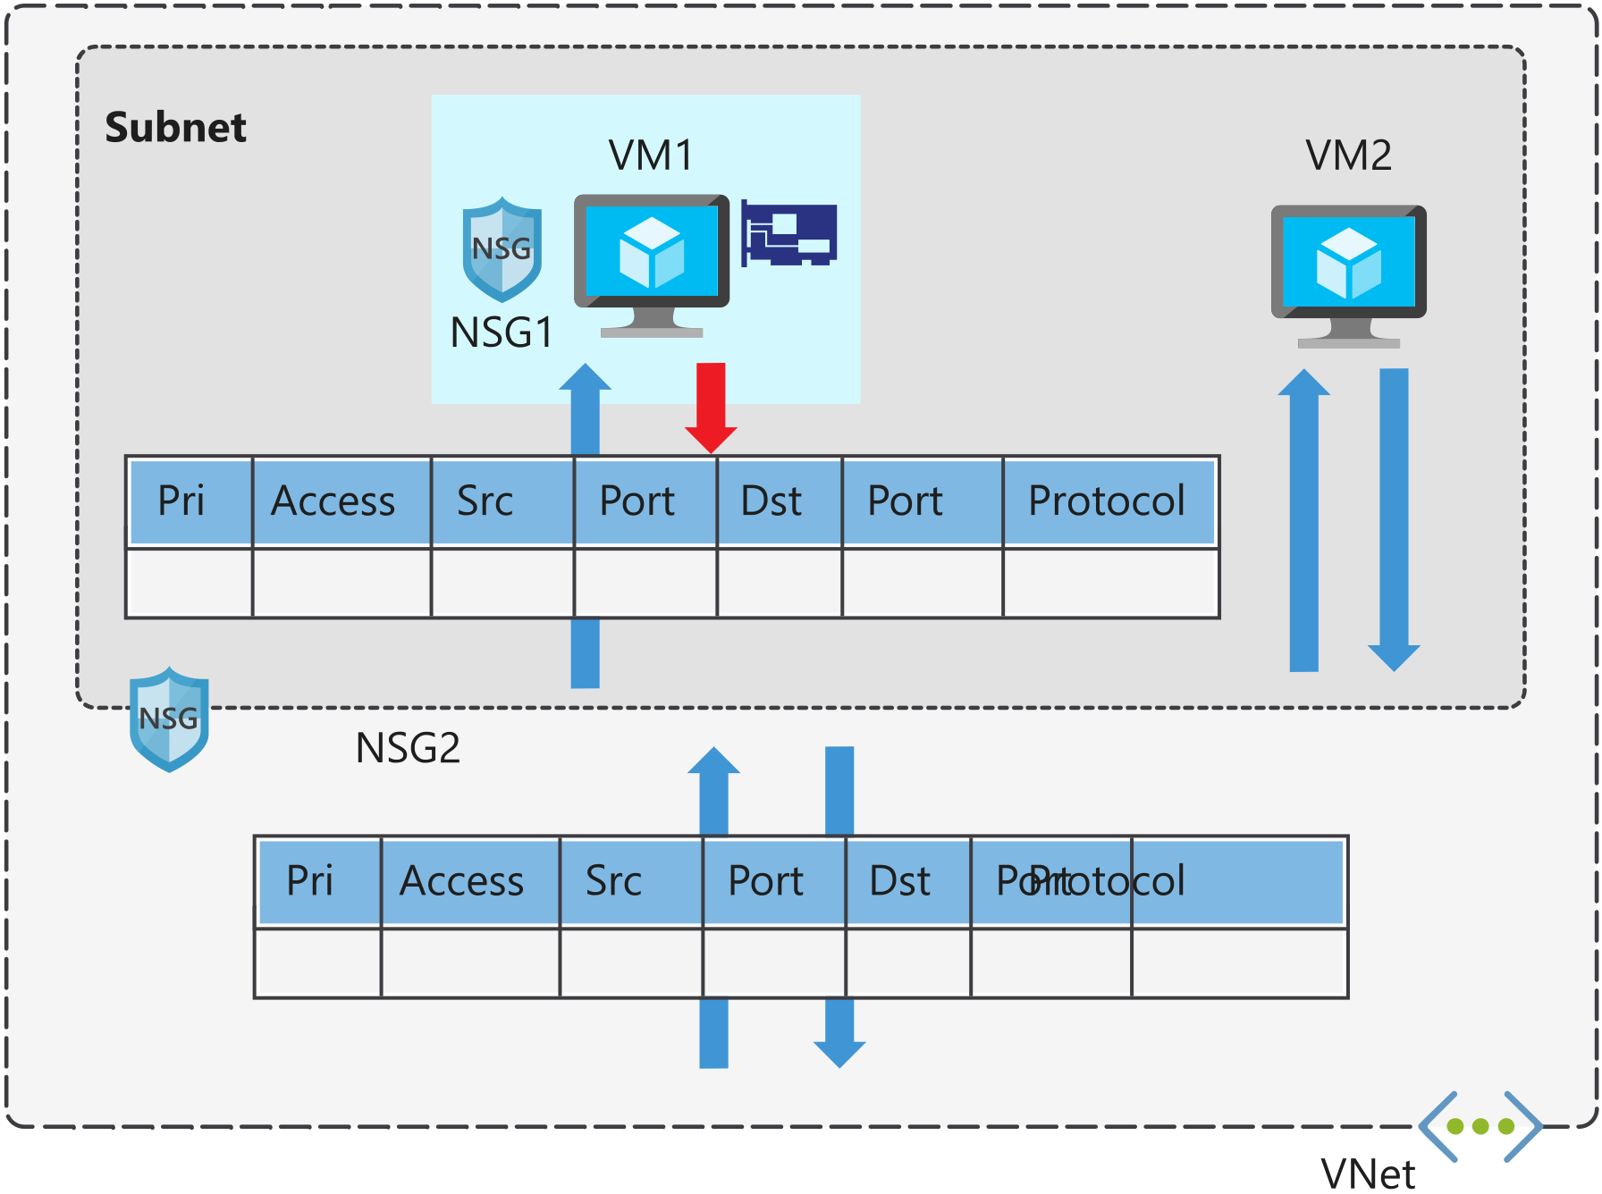

* Network security groups are assigned to a network interface or a subnet. When you assign a network security group to a subnet, the rules apply to all network interfaces in that subnet. You can restrict traffic further by associating a network security group to the network interface of a virtual machine.
* When you apply network security groups to both a subnet and a network interface, each network security group is evaluated independently. Inbound traffic is first evaluated by the network security group applied to the subnet, and then by the network security group applied to the network interface. Conversely, outbound traffic from a virtual machine is first evaluated by the network security group applied to the network interface, and then by the network security group applied to the subnet.
* Applying a network security group to a subnet instead of individual network interfaces can reduce administration and management efforts. This approach also ensures that all virtual machines within the specified subnet are secured with the same set of rules.
* Each subnet and network interface can have one network security group applied to it. Network security groups support TCP, UDP, and ICMP, and operate at Layer 4 of the OSI model.
* In our manufacturing company scenario, network security groups can help you secure the network. You can control which computers can connect to your application servers. You configure the network security group so that only a specific range of IP addresses can connect to the servers. You can lock this down even more by only allowing access to or from specific ports, or from individual IP addresses. These rules can be applied to devices that are connecting remotely from on-premises networks, or between resources within Azure.

## Security rules

A network security group contains one or more security rules. Configure security rules to either allow or deny traffic.

Rules have several properties:

| **Property** | **Explanation** |
| --- | --- |
| Name | A unique name within the network security group. |
| Priority | A number between 100 and 4096. |
| Source or destination | Any, or an individual IP address, classless inter-domain routing (CIDR) block (10.0.0.0/24, for example), service tag, or application security group. |
| Protocol | TCP, UDP, or Any. |
| Direction | Whether the rule applies to inbound, or outbound traffic. |
| Port range | An individual port or range of ports. |
| Action | Allow or deny the traffic. |

Network security group security rules are evaluated by priority, using the 5-tuple information (source, source port, destination, destination port, and protocol) to allow or deny the traffic. When the conditions for a rule match the device configuration, rule processing stops.

For example, suppose your company has created a security rule to allow inbound traffic on port 3389 (RDP) to your web servers, with a priority of 200. Then suppose that another administrator has created a rule to deny inbound traffic on port 3389, with a priority of 150. The deny rule takes precedence, because it's processed first. The rule with priority 150 is processed before the rule with priority 200.

With network security groups, the connections are stateful. Return traffic is automatically allowed for the same TCP/UDP session. For example, an inbound rule allowing traffic on port 80 also allows the virtual machine to respond to the request (typically on an ephemeral port). You don't need a corresponding outbound rule.

With regard to the ERP system, the web servers for the ERP application connect to database servers that are in their own subnets. You can apply security rules to state that the only allowed communication from the web servers to the database servers is port 1433 for SQL Server database communications. All other traffic to the database servers will be denied.

### **Default security rules**

When you create a network security group, Azure creates several default rules. These default rules can't be changed, but can be overridden with your own rules. These default rules allow connectivity within a virtual network and from Azure load balancers. They also allow outbound communication to the internet, and deny inbound traffic from the internet.

The default rules for inbound traffic are:

| **Priority** | **Rule name** | **Description** |
| --- | --- | --- |
| 65000 | AllowVnetInbound | Allow inbound coming from any VM to any VM within the subnet. |
| 65001 | AllowAzureLoadBalancerInbound | Allow traffic from the default load balancer to any VM within the subnet. |
| 65500 | DenyAllInBound | Deny traffic from any external source to any of the VMs. |

The default rules for outbound traffic are:

| **Priority** | **Rule name** | **Description** |
| --- | --- | --- |
| 65000 | AllowVnetOutbound | Allow outbound going from any VM to any VM within the subnet. |
| 65001 | AllowInternetOutbound | Allow outbound traffic going to the internet from any VM. |
| 65500 | DenyAllOutBound | Deny traffic from any internal VM to a system outside the virtual network. |

### **Augmented security rules**

You use augmented security rules for network security groups to simplify the management of large numbers of rules. Augmented security rules also help when you need to implement more complex network sets of rules. Augmented rules let you add the following options into a single security rule:

* multiple IP addresses
* multiple ports
* service tags
* application security groups

Suppose your company wants to restrict access to resources in your datacenter, spread across several network address ranges. With augmented rules, you can add all these ranges into a single rule, reducing the administrative overhead and complexity in your network security groups.

### **Service tags**

You use service tags to simplify network security group security even further. You can allow or deny traffic to a specific Azure service, either globally or per region.

Service tags simplify security for virtual machines and Azure virtual networks, by allowing you to restrict access by resources or services. Service tags represent a group of IP addresses, and help simplify the configuration of your security rules. For resources that you can specify by using a tag, you don't need to know the IP address or port details.

You can restrict access to many services. Microsoft manages the service tags (you can't create your own). Some examples of the tags are:

* **VirtualNetwork** - This tag represents all virtual network addresses anywhere in Azure, and in your on-premises network if you're using hybrid connectivity.
* **AzureLoadBalancer** - This tag denotes Azure's infrastructure load balancer. The tag translates to the virtual IP address of the host (168.63.129.16) where Azure health probes originate.
* **Internet** - This tag represents anything outside the virtual network address that is publicly reachable, including resources that have public IP addresses. One such resource is the Web Apps feature of Azure App Service.
* **AzureTrafficManager** - This tag represents the IP address for Azure Traffic Manager.
* **Storage** - This tag represents the IP address space for Azure Storage. You can specify whether traffic is allowed or denied. You can also specify if access is allowed only to a specific region, but you can't select individual storage accounts.
* **SQL** - This tag represents the address for Azure SQL Database, Azure Database for MySQL, Azure Database for PostgreSQL, and Azure SQL Data Warehouse services. You can specify whether traffic is allowed or denied, and you can limit to a specific region.
* **AppService** - This tag represents address prefixes for Azure App Service.

## Application security groups

Application security groups let you configure network security for resources used by specific applications. You can group virtual machines logically, no matter what their IP address or subnet assignment.

Use application security groups within a network security group to apply a security rule to a group of resources. It's easier to deploy and scale up specific application workloads. You just add a new virtual machine deployment to one or more application security groups, and that virtual machine automatically picks up your security rules for that workload.

An application security group allows you to group network interfaces together. You can then use that application security group as a source or destination rule within a network security group.

For example, your company has a number of front-end servers in a virtual network. The web servers must be accessible over ports 80 and 8080. Database servers must be accessible over port 1433. You assign the network interfaces for the web servers to one application security group, and the network interfaces for the database servers to another application security group. You then create two inbound rules in your network security group. One rule allows HTTP traffic to all servers in the web server application security group. The other rule allows SQL traffic to all servers in the database server application security group.

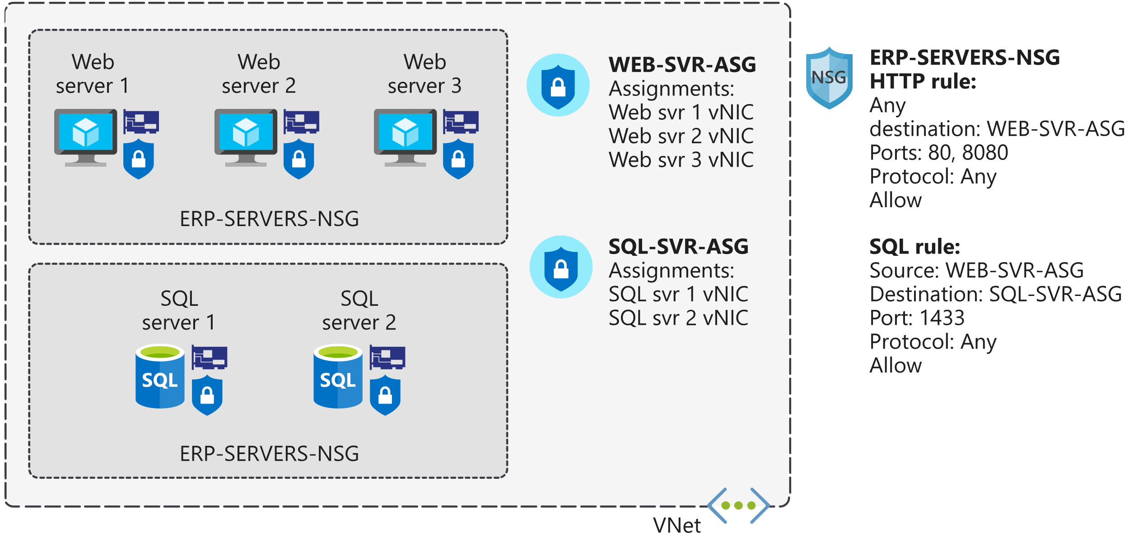

Without application security groups, you'd need to create a separate rule for each virtual machine.

The key benefit of application security groups is that it makes administration easier. You can easily add and remove network interfaces to an application security group as you deploy or redeploy application servers. You can also dynamically apply new rules to an application security group, which are then automatically applied to all the virtual machines in that application security group.

## When to use network security groups

As a best practice, you should always use network security groups to help protect your networked assets against unwanted traffic. Network security groups give you granular control access over the network layer, without the potential complexity of setting security rules for every virtual machine or virtual network.

# **Exercise - Create and manage network security groups**

As the solution architect for the manufacturing company, you now want to start moving the ERP application and database servers to Azure. As a first step, you're going to test out your network security plan, using two of your servers.

In this unit, you'll configure a network security group and security rules to restrict network traffic to specific servers. You want your application server to be able to connect to your database server over HTTP. You don't want the database server to be able to use HTTP to connect to the application server.

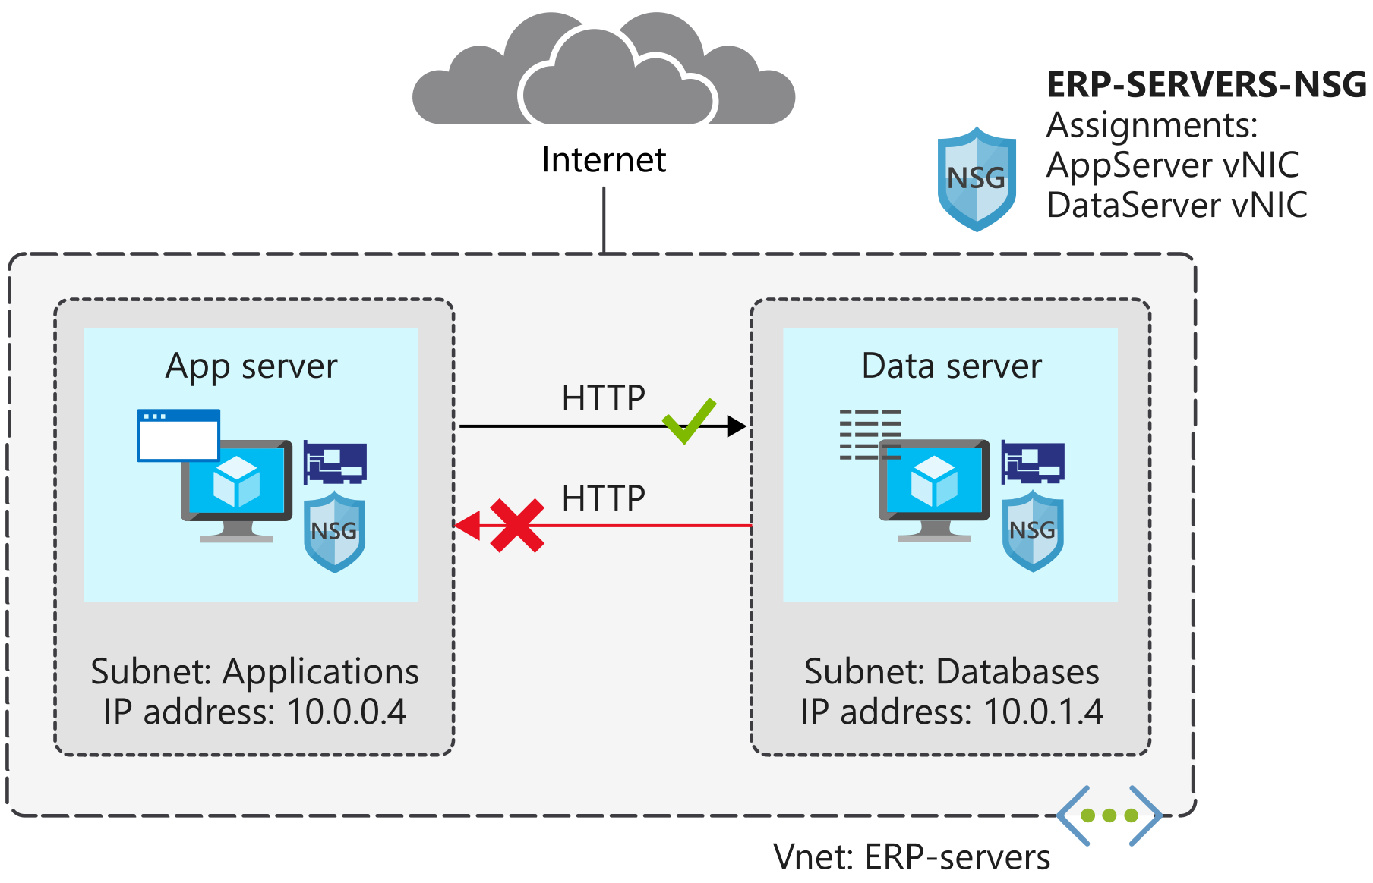

**Deploy an application security group**

Next, create an application security group for database servers, so that all servers in this group can be assigned the same settings. You're planning to deploy more database servers, and want to prevent these servers from accessing application servers over HTTP. By assigning sources in the application security group, you don't need to manually maintain a list of IP addresses in the network security group. Instead, you assign the network interfaces of the virtual machines you want to manage to the application security group.

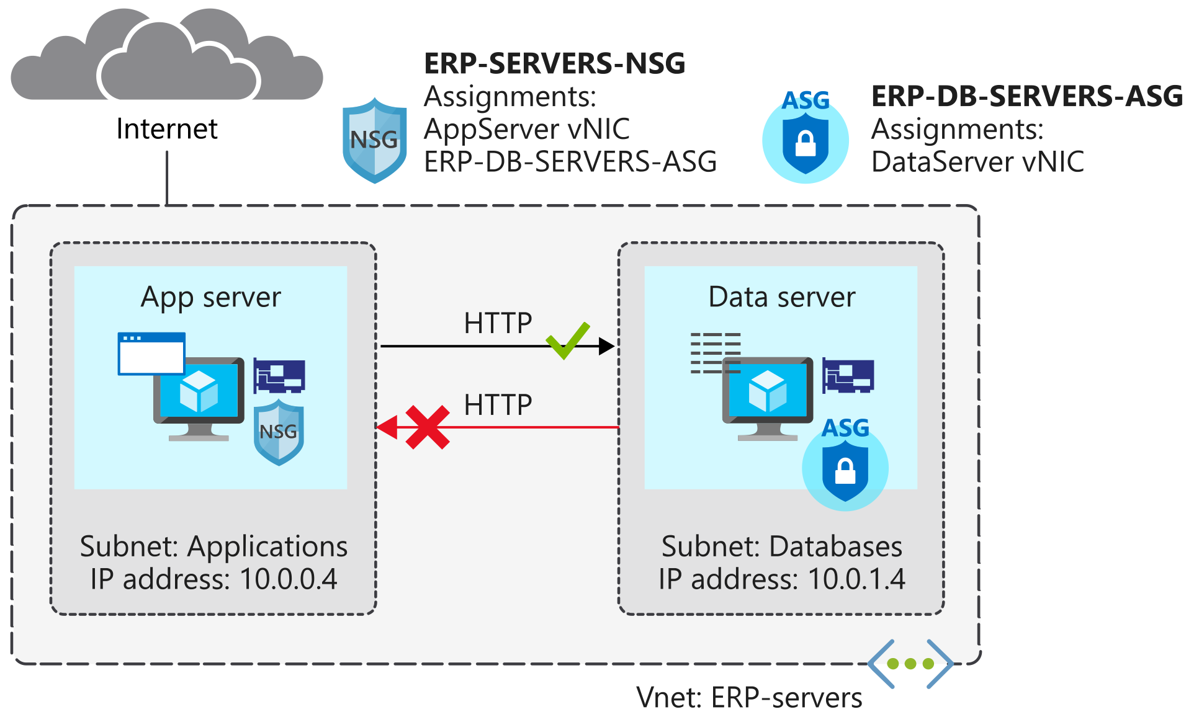

# **Secure network access to PaaS services with virtual network service endpoints**

You've migrated your existing application and database servers for your ERP system to Azure as virtual machines. Now you're considering using some Azure platform as a service (PaaS) services to reduce your costs and administrative requirements. Storage services will hold certain large file assets, such as engineering diagrams. These engineering diagrams have proprietary information in them, and must remain secure from unauthorized access. These files must only be accessible from specific systems.

In this unit, you'll look at how to use virtual network service endpoints for securing supported Azure services.

## Virtual network service endpoints

Use virtual network service endpoints to extend your private address space in Azure by providing a direct connection to your Azure services. Service endpoints let you secure your Azure resources to only your virtual network. Service traffic will remain on the Azure backbone, and doesn't go out to the internet.

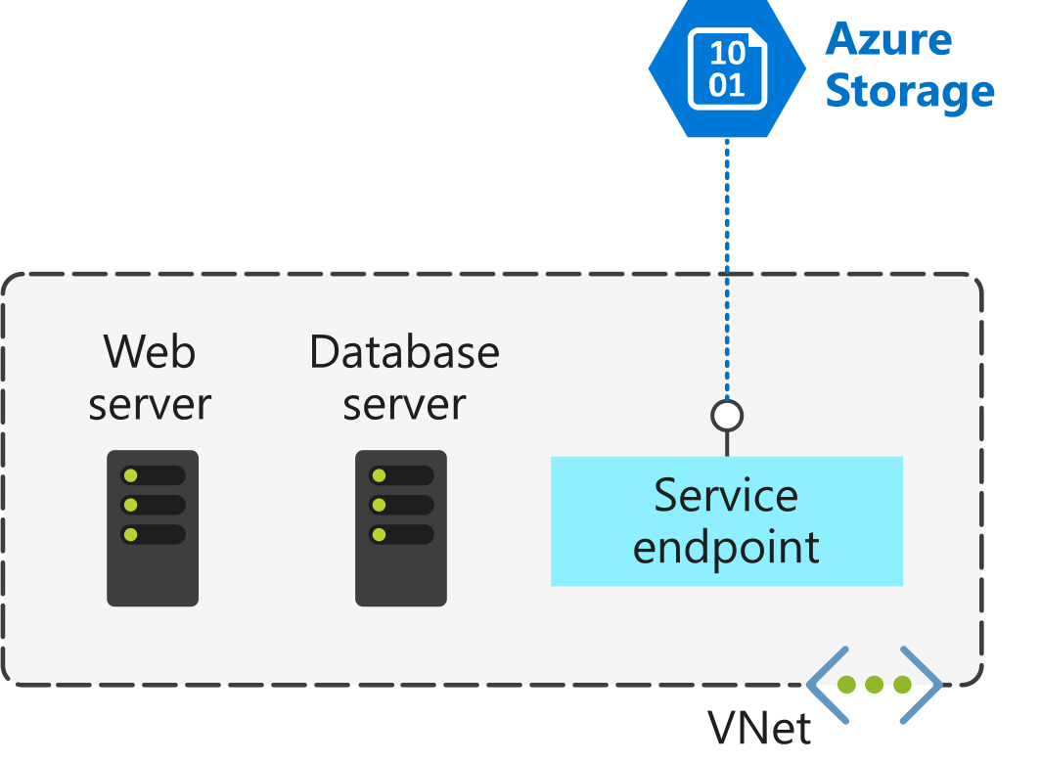

* By default, Azure services are all designed for direct internet access. All Azure resources have public IP addresses, including PaaS services such as Azure SQL Database and Azure Storage. Because these services are exposed to the internet, anyone can potentially access your Azure services.
* Service endpoints can connect certain PaaS Services directly to your private address space in Azure, so they act like they’re on the same virtual network. You use your private address space to access the PaaS services directly. Adding service endpoints doesn't remove the public endpoint. It simply provides a redirection of traffic.

Azure service endpoints are available for many services, such as:

* Azure Storage
* Azure SQL Database
* Azure Cosmos DB
* Azure Key Vault
* Azure Service Bus
* Azure Data Lake

For a service like SQL Database, which can't be accessed until you add IP addresses to its firewall, service endpoints should still be considered. Using a service endpoint for SQL Database restricts access to specific virtual networks, providing greater isolation and reducing the attack surface.

**How service endpoints work**

To enable a service endpoint, you must do two things:

1. Turn off public access to the service.
2. Add the service endpoint to a virtual network.

When you enable a service endpoint, you restrict the flow of traffic, and allow your Azure virtual machines to access the service directly from your private address space. Devices cannot access the service from a public network. On a deployed virtual machine vNIC, if you look at **Effective routes**, you'll notice the service endpoint as the **Next Hop Type**.

This is an example route table, before enabling a service endpoint:

| **SOURCE** | **STATE** | **ADDRESS PREFIXES** | **NEXT HOP TYPE** |
| --- | --- | --- | --- |
| Default | Active | 10.1.1.0/24 | VNet |
| Default | Active | 0.0.0.0./0 | Internet |
| Default | Active | 10.0.0.0/8 | None |
| Default | Active | 100.64.0.0./10 | None |
| Default | Active | 192.168.0.0/16 | None |

And here's an example route table after you've added two service endpoints to the virtual network:

| **SOURCE** | **STATE** | **ADDRESS PREFIXES** | **NEXT HOP TYPE** |
| --- | --- | --- | --- |
| Default | Active | 10.1.1.0/24 | VNet |
| Default | Active | 0.0.0.0./0 | Internet |
| Default | Active | 10.0.0.0/8 | None |
| Default | Active | 100.64.0.0./10 | None |
| Default | Active | 192.168.0.0/16 | None |
| Default | Active | 20.38.106.0/23, 10 more | VirtualNetworkServiceEndpoint |
| Default | Active | 20.150.2.0/23, 9 more | VirtualNetworkServiceEndpoint |

All traffic for the service now is routed to the **VirtualNetworkServiceEndpoint**, and remains internal to Azure.

## Service endpoints and hybrid networks

Service resources that you've secured by using virtual network service endpoints are not, by default, accessible from on-premises networks. To access resources from an on-premises network, use NAT IPs. If you use ExpressRoute for connectivity from on-premises to Azure, you have to identify the NAT IP addresses that are used by ExpressRoute. By default, each circuit uses two NAT IP addresses to connect to the Azure backbone network. You then need to add these IP addresses into the IP firewall configuration of the Azure service resource (for example, Azure Storage).

This diagram shows how you can use a service endpoint and firewall configuration to enable on-premises devices to access Azure Storage resources.

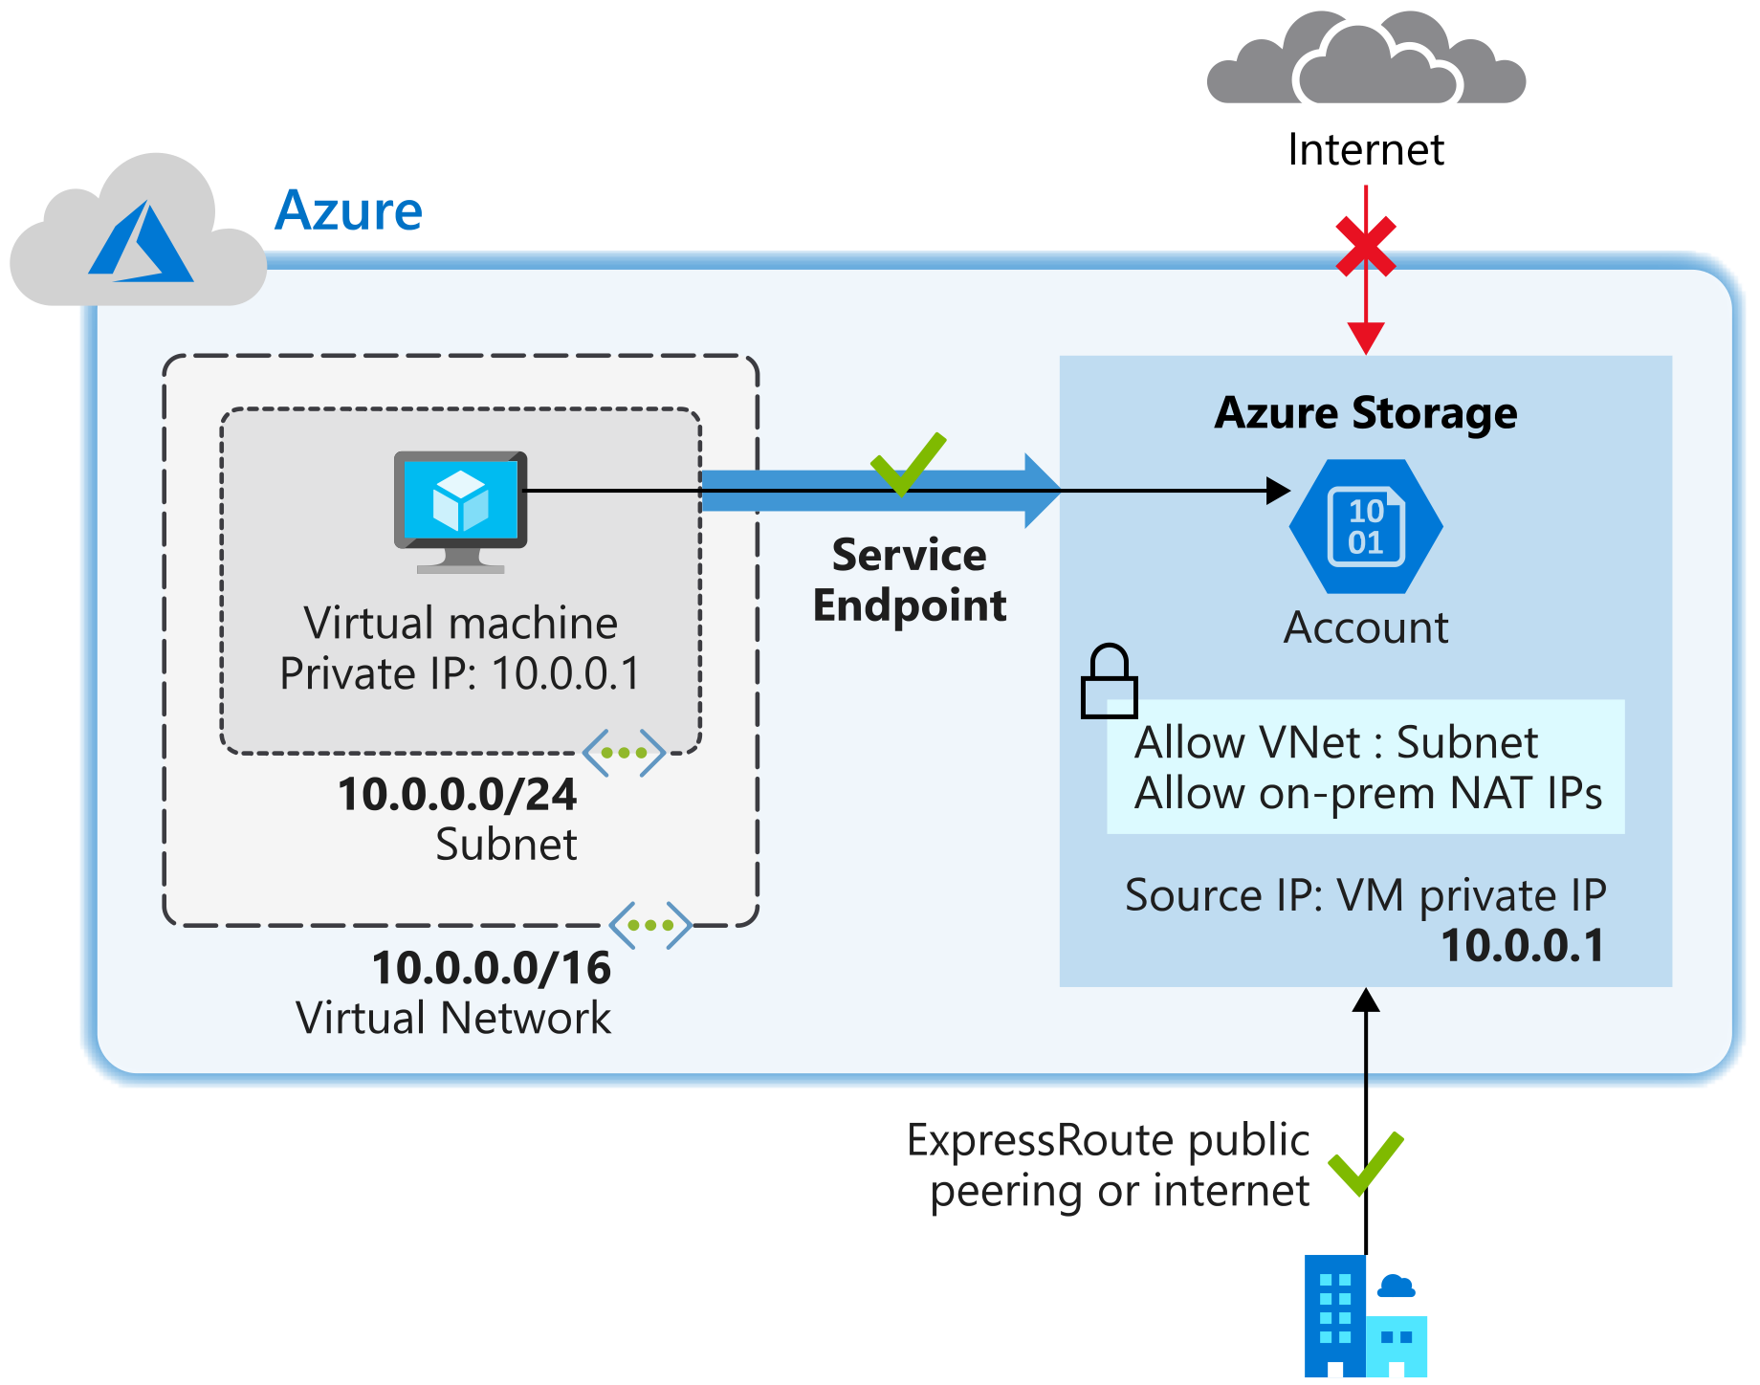

# **Exercise - Restrict access to Azure Storage by using service endpoints**

* As the solution architect, you're planning to move sensitive engineering diagram files into Azure Storage. The files must only be accessible from computers inside the corporate network. You want to create a virtual network service endpoint for Azure Storage to secure the connectivity to your storage accounts.

In this unit, you'll create a service endpoint, and use network rules to restrict access to Azure Storage. You'll create a virtual network service endpoint for Azure Storage on the **Databases** subnet. You'll then verify that your **DataServer** virtual machine can access Azure Storage. Finally, you'll check that the **AppServer** virtual machine, which is on a different subnet, can't access storage.

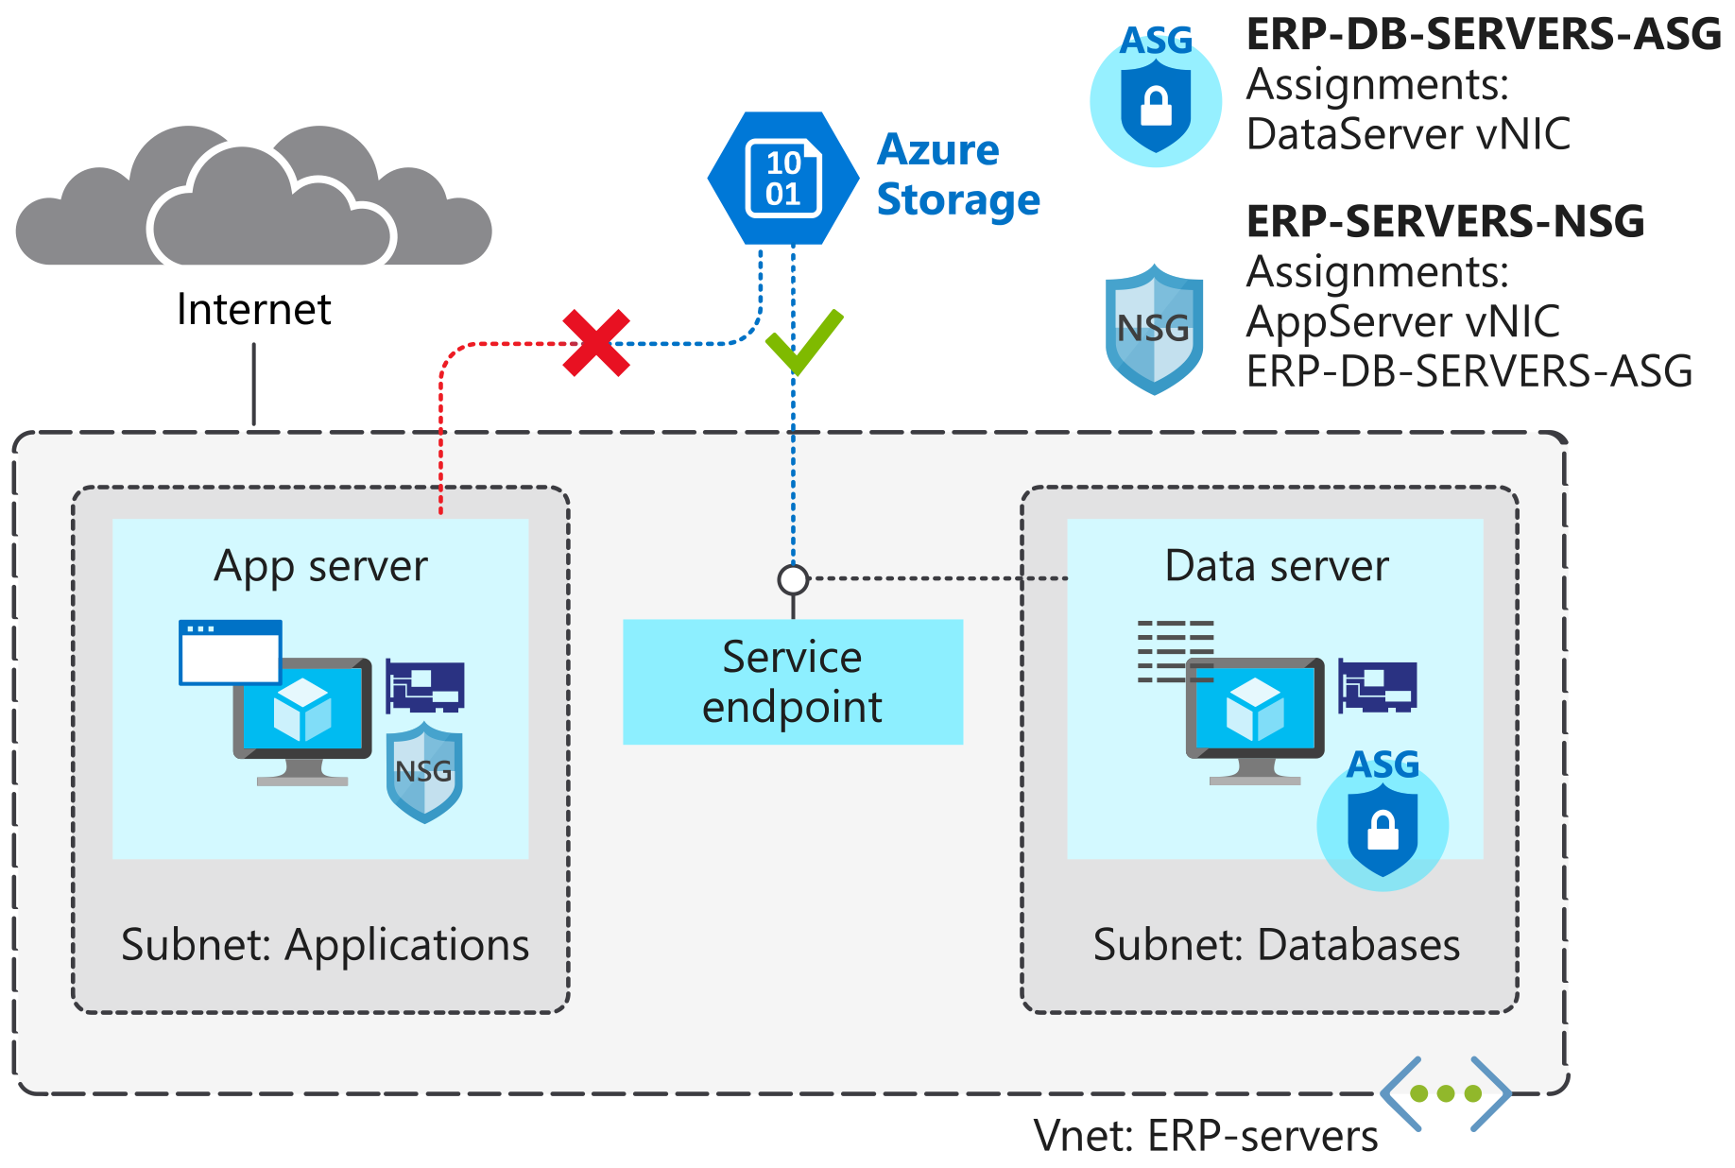

**Distribute your services across Azure virtual networks and integrate them by using virtual network peering**

# Imagine you're the solution architect for an engineering company that has been migrating services into Azure. The company has deployed services into separate virtual networks. It hasn't configured private connectivity between the virtual networks.

Several business units have identified services in these virtual networks that need to communicate with each other. You need to enable this connectivity, but you don't want to expose these services to the internet. You also want to keep the integration as simple as possible.

In this module, you'll learn about virtual network connection options and why virtual network peering is suited to this scenario. You'll create three virtual networks and configure virtual network peering between them. You'll then test your configuration to make sure it meets your connectivity goals.

# **Connect services by using virtual network peering**

You can use virtual network peering to directly connect Azure virtual networks. When you use peering to connect virtual networks, virtual machines (VMs) in these networks can communicate with each other as if they were in the same network.

In peered virtual networks, traffic between virtual machines is routed through the Azure network. The traffic uses only private IP addresses. It doesn't rely on internet connectivity, gateways, or encrypted connections. The traffic is always private, and it takes advantage of the high bandwidth and low latency of the Azure backbone network.

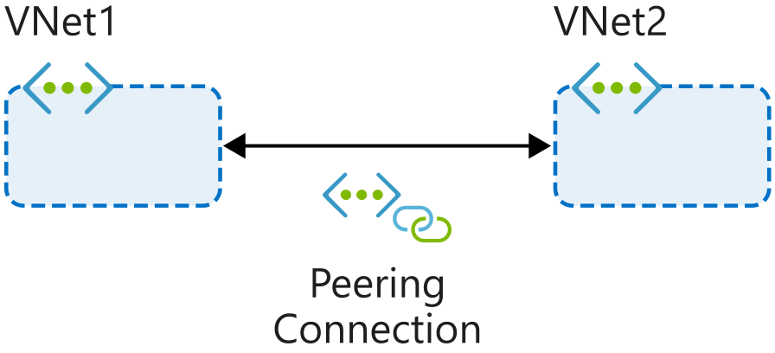

The two types of peering connections are created in the same way:

* **Virtual network peering** connects virtual networks in the same Azure region, such as two virtual networks in North Europe.
* **Global virtual network peering** connects virtual networks that are in different Azure regions, such as a virtual network in North Europe and a virtual network in West Europe.

Virtual network peering doesn't affect or disrupt any resources that you've already deployed to the virtual networks. But when you use virtual network peering, consider the key features that the following sections define.

## Reciprocal connections

When you create a virtual network peering connection in only one virtual network to connect to a peer in another network, you're not connecting the networks together. To connect the networks by using virtual network peering, you have to create connections in each virtual network.

Think of how you connect two network switches together. You connect a cable to each switch and maybe configure some settings so that the switches can communicate. Virtual network peering requires similar connections in each virtual network. Reciprocal connections provide this functionality.

## Cross-subscription virtual network peering

You can use virtual network peering even when both virtual networks are in different subscriptions. This might be necessary for mergers and acquisitions or to connect virtual networks in subscriptions that different departments manage. Virtual networks can be in different subscriptions, and the subscriptions can use the same or different Azure Active Directory tenants.

When you use virtual network peering across subscriptions, you might find that an administrator of one subscription doesn't administer the peer network's subscription. The administrator might not be able to configure both ends of the connection. To peer the virtual networks when both subscriptions are in different Azure Active Directory tenants, the administrators of each subscription must grant the peer subscription's administrator the Network Contributor role on their virtual network.

## Transitivity

Virtual network peering is nontransitive. Only virtual networks that are directly peered can communicate with each other. The virtual networks can't communicate with the peers of their peers.

Suppose, for example, that your three virtual networks (A, B, C) are peered like this: A <-> B <-> C. Resources in A can't communicate with resources in C because that traffic can't transit through virtual network B. If you need communication between virtual network A and virtual network C, you must explicitly peer these two virtual networks.

## Overlapping address spaces

IP address spaces of connected networks within Azure and between Azure and your on-premises system can't overlap. This is also true for peered virtual networks. Keep this rule in mind when you're planning your network design. In any networks you connect through virtual network peering, VPN, or ExpressRoute, assign different address spaces that don't overlap.

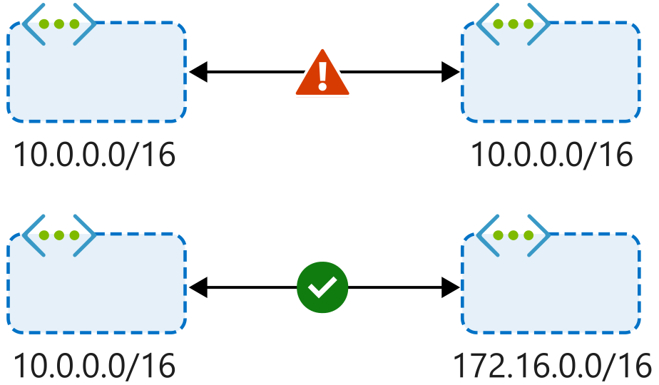

## Alternative connectivity methods

Virtual network peering is the least complex way to connect virtual networks. Other methods focus primarily on connectivity between on-premises and Azure networks rather than connections between virtual networks.

You can also connect virtual networks together through the ExpressRoute circuit. ExpressRoute is a dedicated, private connection between an on-premises datacenter and the Azure backbone network. The virtual networks that connect to an ExpressRoute circuit are part of the same routing domain and can communicate with each other. ExpressRoute connections don't go over the public internet, so your communications with Azure services are as secure as possible.

VPNs use the internet to connect your on-premises datacenter to the Azure backbone through an encrypted tunnel. You can use a site-to-site configuration to connect virtual networks together through VPN gateways. VPN gateways have higher latency than virtual network peering setups. They're more complex to manage, and they can cost more.

When virtual networks are connected through both a gateway and virtual network peering, traffic flows through the peering configuration.

## When to choose virtual network peering

Virtual network peering can be a great way to enable network connectivity between services that are in different virtual networks. Because it's easy to implement and deploy, and it works well across regions and subscriptions, virtual network peering should be your first choice when you need to integrate Azure virtual networks.

Peering might not be your best option if you have existing VPN or ExpressRoute connections or services behind Azure Basic Load Balancers that would be accessed from a peered virtual network. In these cases, you should research alternatives.

# Summary

In this module, you learned how to use peering to connect virtual networks in a hub and spoke topology. You used VMs and SSH to verify connectivity between virtual networks. The peering connections will enable communication for services that run on the VMs.

Now that you understand how to peer virtual networks together, you can use this cost-effective and minimally complex method in your Azure network infrastructure. The method enables low-latency communication between resources in virtual networks. It supports scenarios where resources are in different regions or subscriptions. Virtual network peering should be your first choice when you need to connect virtual networks.

1. Peering ka use karne se ham alag alag vnet k vm’s mein ssh kar sakte hain using just the private i.p

# **Enhance your service availability and data locality by using Azure Traffic Manager**

Azure Traffic Manager provides DNS load balancing to your application, so you improve your ability to distribute your application around the world. Use Traffic Manager to improve the performance and availability of your application.

In this module, you will:

* Learn how to use Traffic Manager to dynamically distribute network traffic
* Set up Traffic Manager for automatic failover to a secondary region
* Set up Traffic Manager to redirect client requests to the nearest endpoint

# **Introduction**

Suppose you're the lead architect for a company that provides a global music streaming web application. You want your customers, wherever they are in the world, to experience near-zero downtime. The application needs to be responsive. You know that poor performance might drive your customers to your competitors. You'd also like to have customized experiences for customers who are in specific regions for user interface, legal, and operational reasons.

Azure Traffic Manager is a DNS-based traffic load balancer that you can use to distribute traffic optimally to services across Azure regions globally. You can use Traffic Manager to distribute traffic to different regions while providing high availability, resilience, and responsiveness in your app.

# **Route network traffic by using Traffic Manager**

Your customers require 24x7 availability of your company's streaming music application. Cloud services in one region might become unavailable because of technical issues, such as planned maintenance or scheduled security updates. In these scenarios, your company wants to have a failover endpoint so your customers can continue to access its services. To manage routing traffic and to handle these situations, you've decided to implement Azure Traffic Manager.

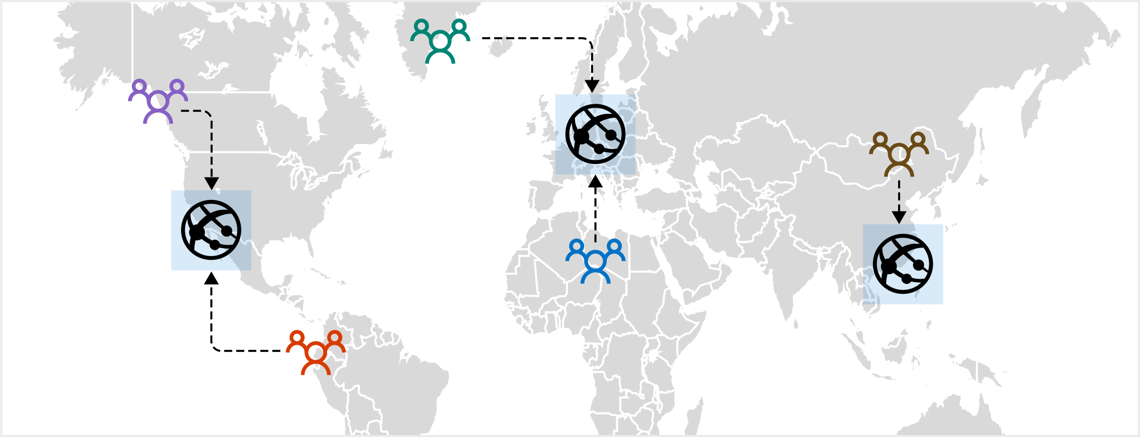

## How Traffic Manager works

When a client attempts to connect to a service, first it resolves the DNS name of the service as an IP address. The client then connects to that IP address to access the service.

Traffic Manager uses DNS to direct clients to a specific service endpoint IP address based on the rules of the traffic routing method that's used. Clients connect directly to the selected endpoint. Traffic Manager isn't a proxy or gateway. Traffic Manager doesn't see the traffic that passes between the clients and the service; it just gives clients the IP address of where they need to go.

## Traffic Manager endpoints

Endpoints are the destination location that is returned to the client. You configure each application deployment as an 'endpoint' in Traffic Manager. When Traffic Manager receives a DNS request, it chooses an available endpoint to return in the DNS response. There are three types of endpoint supported by Traffic Manager:

* **Azure endpoints** are used for services hosted in Azure. These can be services like Azure App Service, as well as public IP resources that are associated with load balancers or virtual machines.
* **External endpoints** are used for IPv4/IPv6 addresses, FQDNs, or for services hosted outside Azure that can either be on-premises or with a different hosting provider.
* **Nested endpoints** are used to combine Traffic Manager profiles to create more flexible traffic-routing schemes to support the needs of larger, more complex deployments.

There is no restriction on how endpoints of different types are combined in a single Traffic Manager profile. Each profile can contain any mix of endpoint types.

### **Weighted routing**

Choose weighted when you want to distribute traffic across a set of endpoints, either evenly or based on different weights. The weight is an integer from 1 to 1,000. For each DNS query received, Traffic Manager randomly chooses an available endpoint. The probability of choosing an endpoint is based on the weights assigned to all available endpoints.

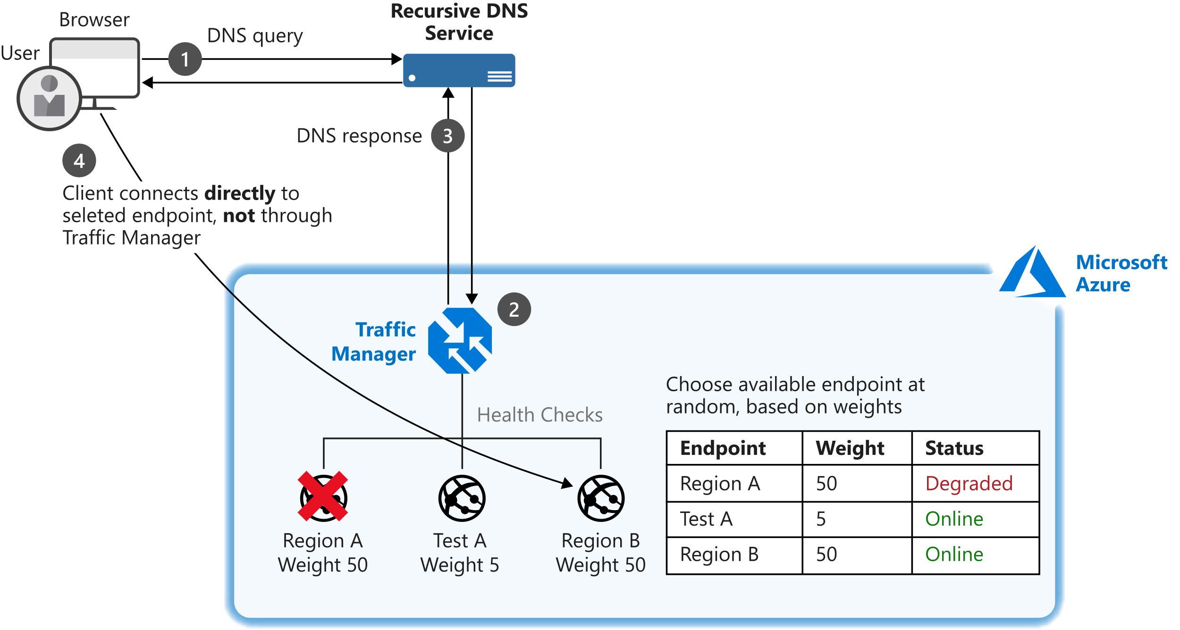

### **Performance routing**

If you have endpoints in different geographic locations, you can use performance routing to send users to the endpoint that has the best performance for the user. To choose the best endpoint to use, this routing method uses an internet latency table, which actively tracks network latencies to the endpoints from locations around the globe. When a user makes a request, Traffic Manager returns the best performing endpoint based on the location of the request.

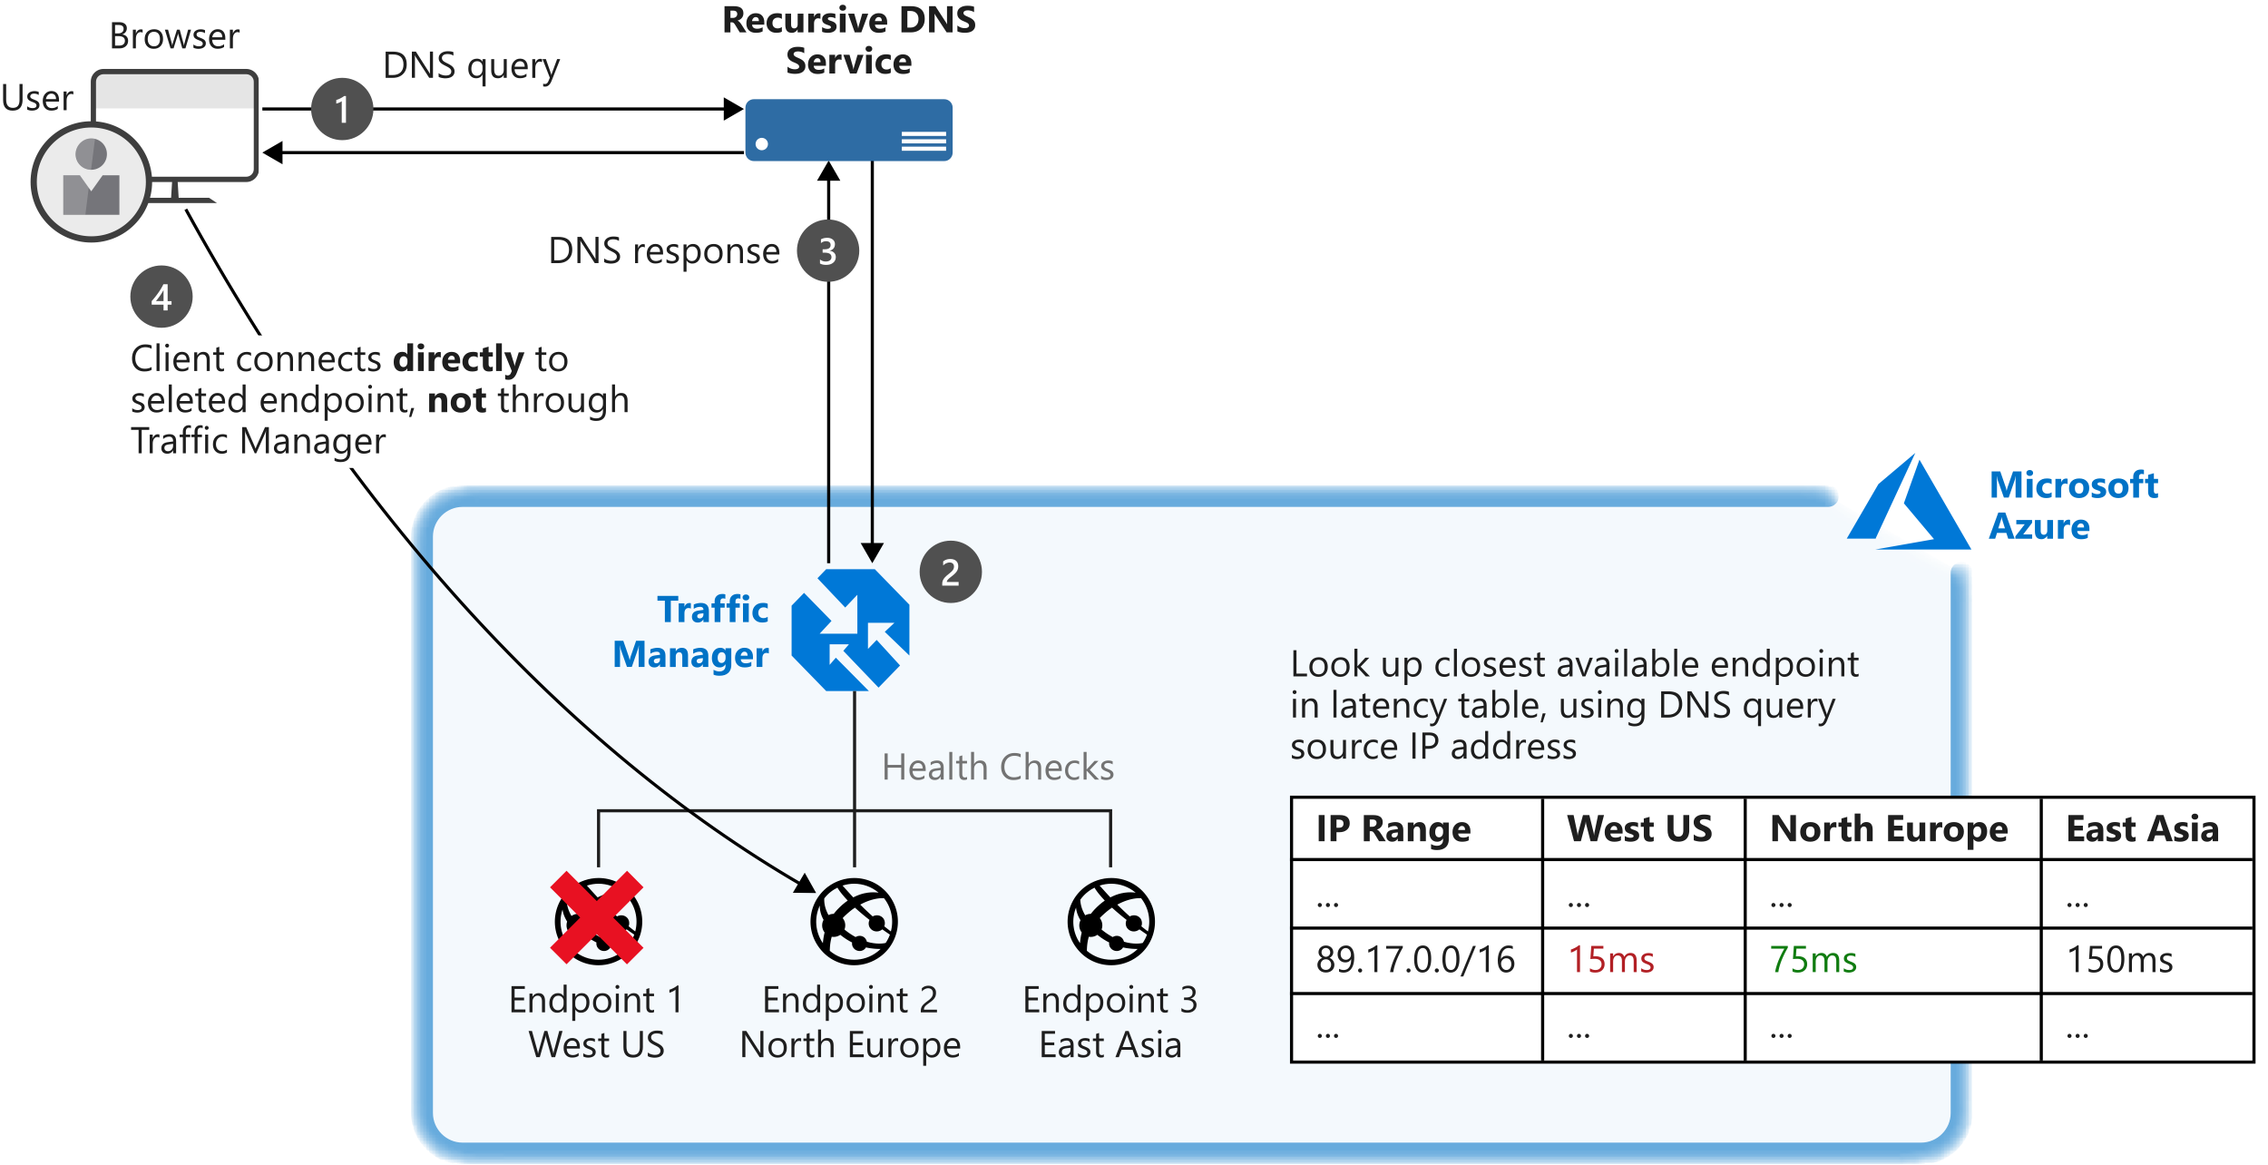**Geographic routing**

With the geographic routing method, users are directed to specific endpoints based on where their DNS query originates. Using this method allows you to geo-fence content to specific user regions. For example, European users can be directed to an endpoint in Europe that has specific terms and conditions for regional compliance. Users in China can be directed to an endpoint that has been localized in Mandarin.

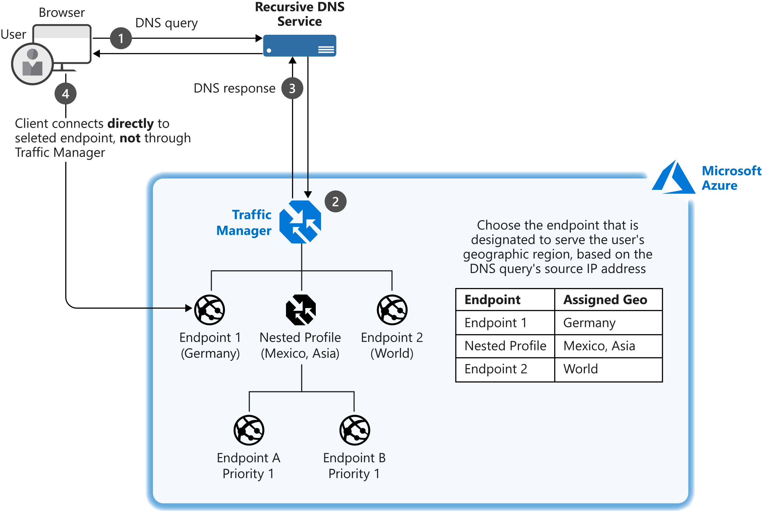

### **Multivalue routing**

You can use the multivalue routing method to get multiple healthy endpoints in a single DNS query response. The caller can make client-side retries with other endpoints if an endpoint is unresponsive. This pattern can increase the availability of a service and reduce the latency associated with a new DNS query to obtain a healthy endpoint.

### **Subnet routing**

This method maps the set of user IP address ranges to specific endpoints within a Traffic Manager profile. When a request is received, the endpoint returned will be the one mapped for that request's source IP address. For example, using subnet routing, a customer can route all requests from their corporate office to a different endpoint, where they might be testing an internal-only version of the app. Another scenario is if you want to provide a different experience to users who connect from a specific ISP (for example, to block users from a specific ISP).

### **Priority routing**

The Traffic Manager profile contains a prioritized list of service endpoints. By default, Traffic Manager sends all traffic to the primary (highest-priority) endpoint. If the primary endpoint isn't available, Traffic Manager routes the traffic to the second endpoint. If both the primary and secondary endpoints are not available, the traffic goes to the third endpoint, and so on. Availability of the endpoint is based on the configured status (enabled or disabled) and the ongoing endpoint monitoring that is set up.

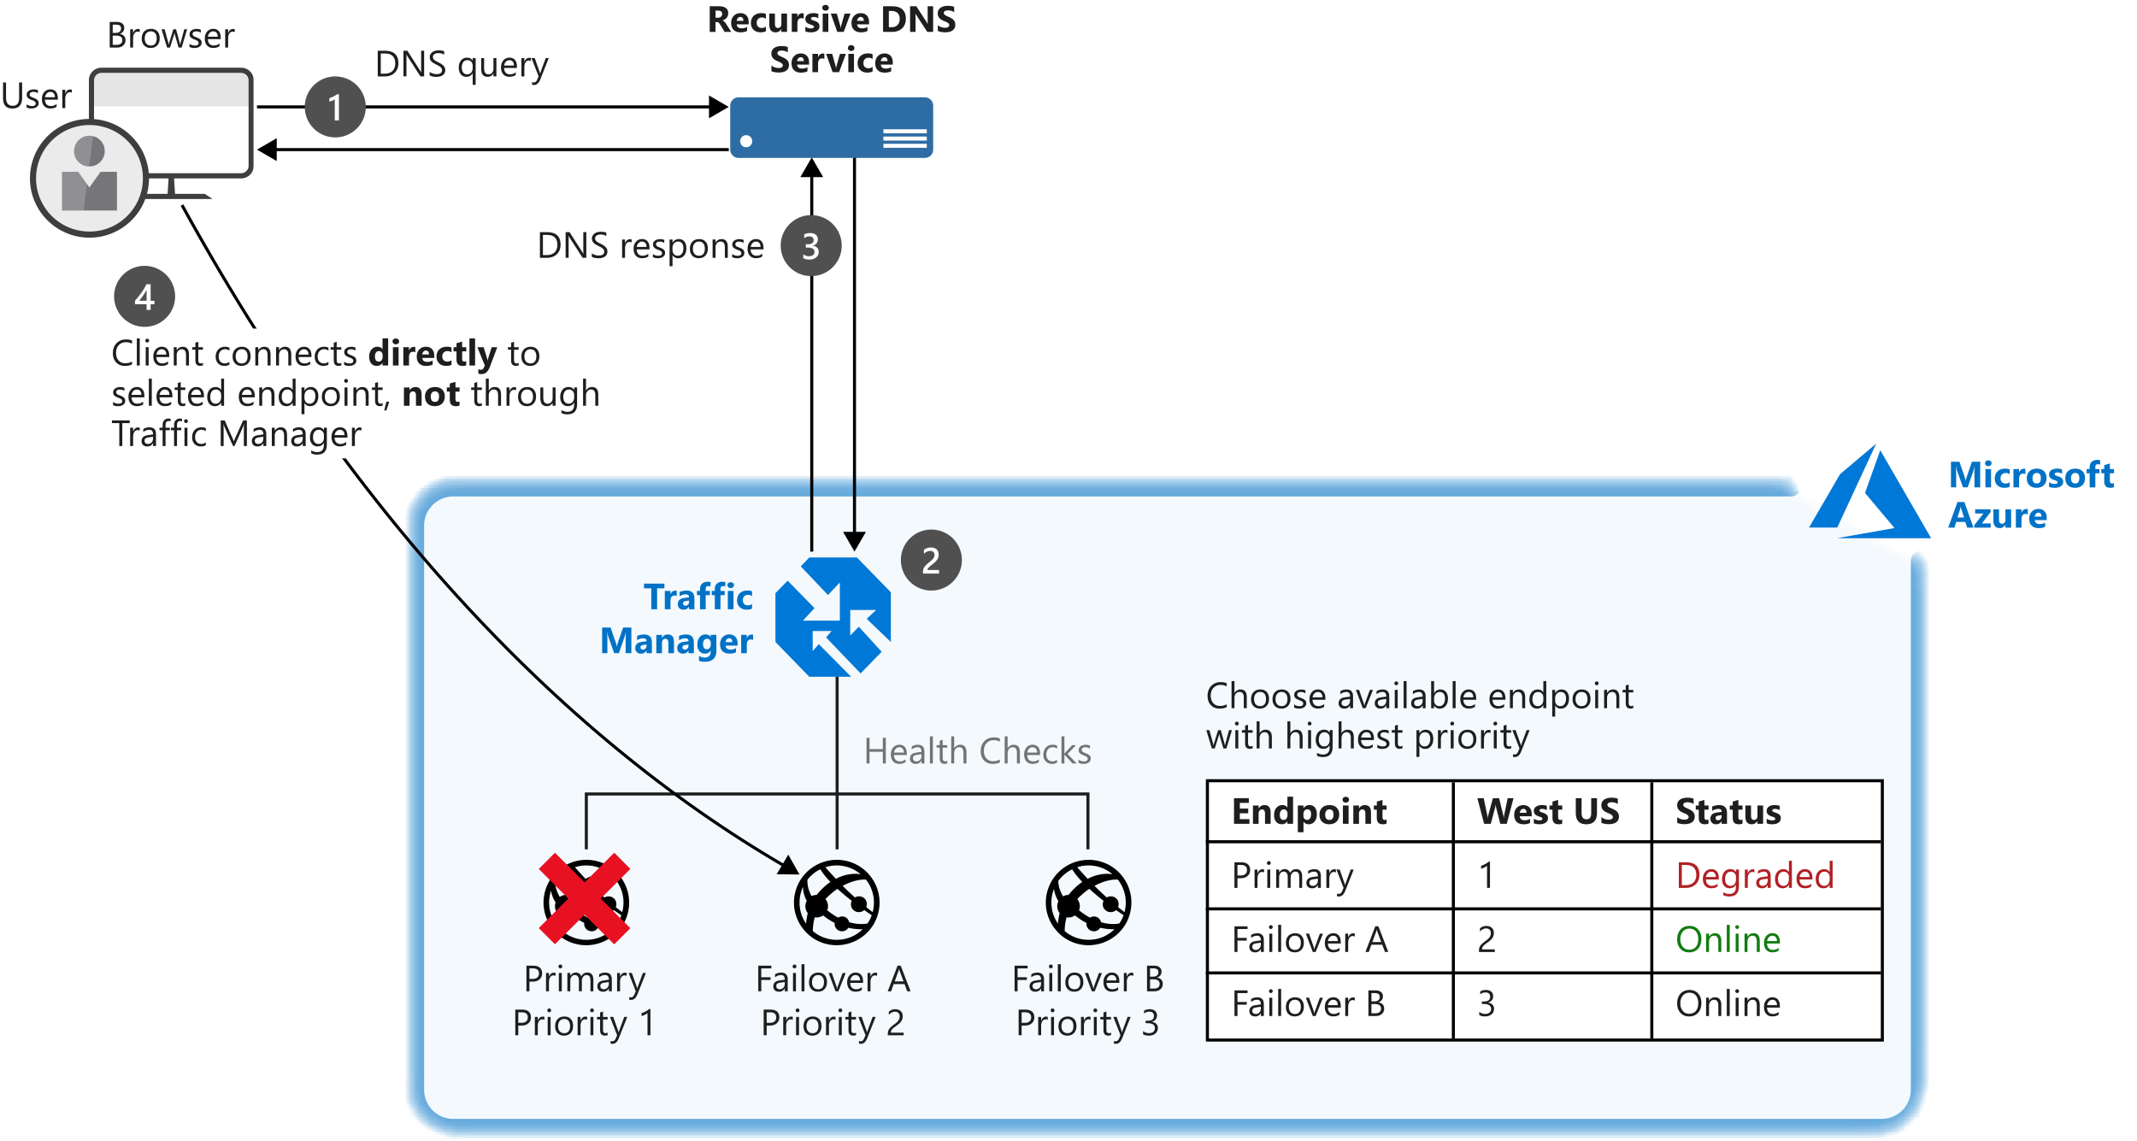

# **Optimize applications across regions by using performance routing**

The music streaming app has users in different regions around the world. Some users are located far from where the application is deployed. Streaming performance is partially dependent on the distance between a user's device and the host. To offer the best possible performance to your users, you deploy your application in multiple regions. As you add regions, you'd like Traffic Manager to automatically direct the traffic to the best performing endpoint.

The performance traffic routing method connects users with the server that performs best for the user. It might be better performing because it's physically closer to the user, but it might also be due to congestion on internet network connectivity. Azure stores historical DNS query latency for connecting clients in an internet latency table. Azure can use this information to direct traffic to the fastest responding server, which is the server with the lowest latency. Traffic Manager maintains the internet latency table by tracking the roundtrip time between IP address ranges and each Azure datacenter. If an endpoint becomes unavailable, Traffic Manager doesn't include it in DNS query responses.

You don't have to do anything more than configure a Traffic Manager profile and select **performance** as the routing method. Endpoints don't need to be prioritized, Traffic Manager will route all the traffic automatically to the fastest responding server.

In the following example, if endpoint A stopped performing as efficiently as endpoint B, customer traffic is automatically routed to endpoint B.

Client traffic is routed consistently. A client will be directed to the same endpoint for each request it makes if nothing changes in the underlying servers and networking. If you need more granular control, for example, to choose a preferred failover within a region, you can use Traffic Manager in a nested configuration.

# **Optimize applications across regions by using performance routing**

Your network architect would like to ensure customers have the best performance. By using the performance routing method in Traffic Manager, you can ensure that users access the location closest to them. Let's configure an instance of Traffic Manager to use performance routing.

# **Summary**

In this module, you learned how to use Traffic Manager as a DNS load balancer to distribute traffic to different web apps deployed in different regions to:

* Improve performance by serving requests from the closest deployment.
* Direct traffic to specific endpoints through priority routing.
* Improve application resilience by detecting failures and routing customers to available endpoints.
* Perform maintenance or updates without any downtime.
* Serve requests from specific geographic locations from specific deployments.

You can now use Traffic manager to improve your availability and global distribution of your application, which improves customer experience.

**RESOURCE CREATED FOR TRAFFIC MANAGER EXERCISE**

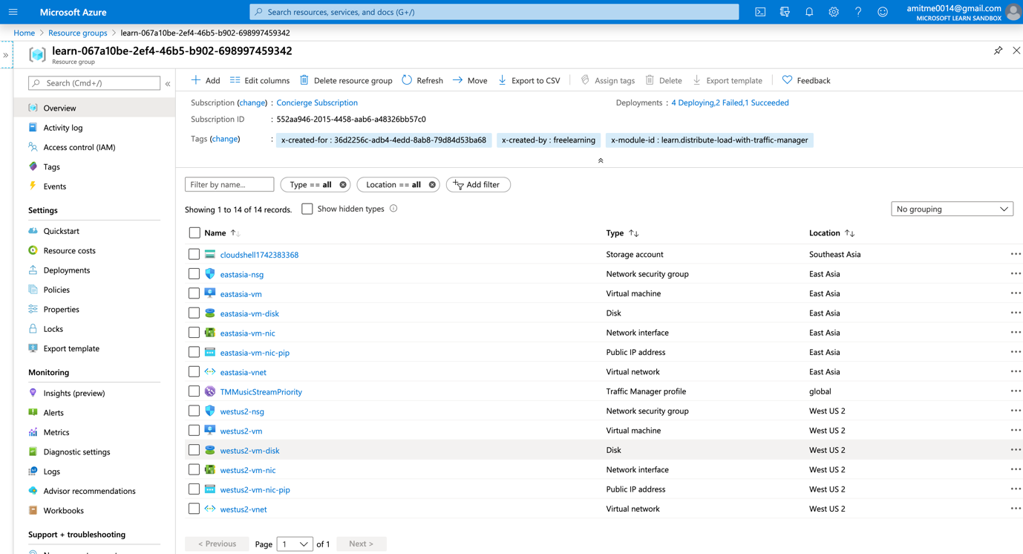

**Azure Load Balancer-Introduction**

Many apps need to be resilient to failure and scale easily when demand increases. You can address those needs by using Azure Load Balancer.

Suppose you work for a healthcare organization that's launching a new portal application in which patients can schedule appointments. The application has a patient portal and web application front end and a business tier database. The database is used by the front end to retrieve and save patient information.

The new portal needs to be available around the clock to handle failures. The portal must adjust to fluctuations in load by adding and removing resources to match the load. The organization needs a solution that distributes work to virtual machines across the system as virtual machines are added. The solution should detect failures and reroute jobs to virtual machines as needed. Improved resiliency and scalability helps ensure that patients can schedule appointments from any location.

By the end of this module, you will be able to use Azure Load Balancer to build a resilient and scalable app architecture.

* Improve application scalability and resiliency by using Azure Load Balancer

# Azure Load Balancer features and capabilities

* With Azure Load Balancer, you can spread user requests across multiple virtual machines or other services. That way, you can scale the app to larger sizes than a single virtual machine can support, and you ensure that users get service, even when a virtual machine fails.
* In your healthcare organization, you can expect large user demand. It's of vital importance to each user that they can book an appointment, even at times of peak demand or when virtual machines fail. If you use multiple virtual servers for your front end and a load balancer to distribute traffic between them, you achieve a high capacity because all the virtual servers collaborate to satisfy requests. You also improve resilience because the load balancer can automatically route traffic away when a virtual server fails.

Here, you will learn how the features of Load Balancer help you create robust app architectures.

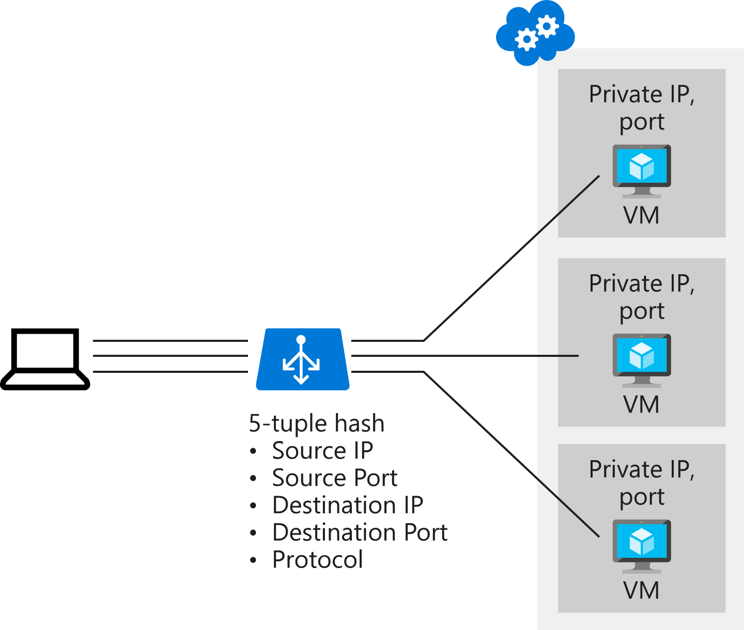

Load Balancer supports inbound and outbound scenarios, provides low latency and high throughput, and scales up to millions of flows for all TCP and UDP applications.

Load balancers aren't physical instances. Load balancer objects are used to express how Azure configures its infrastructure to meet your requirements.

To achieve high availability with Load Balancer, you can choose to use availability sets and availability zones to ensure that virtual machines are always available:

| **Configuration** | **Service level agreement (SLA)** | **Information** |
| --- | --- | --- |
| **Availability set** | 99.95% | Protection from hardware failures within datacenters |
| **Availability zone** | 99.99% | Protection from entire datacenter failure |
|  |  |  |

### **Availability sets**

An availability set is a logical grouping that you use to isolate virtual machine resources from each other when they're deployed. Azure ensures that the virtual machines you put in an availability set run across multiple physical servers, compute racks, storage units, and network switches. If there's a hardware or software failure, only a subset of your virtual machines is affected. Your overall solution stays operational. Availability sets are essential for building reliable cloud solutions.

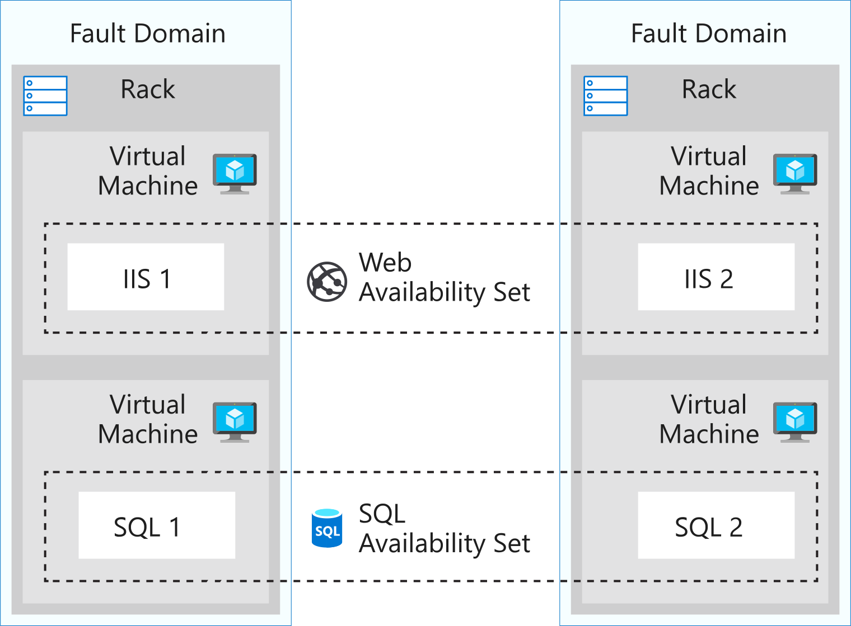

**Availability zones**

An availability zone offers groups of one or more datacenters that have independent power, cooling, and networking. The virtual machines in an availability zone are placed in different physical locations within the same region. Use this architecture when you want to ensure that, when an entire datacenter fails, you can continue to serve users.

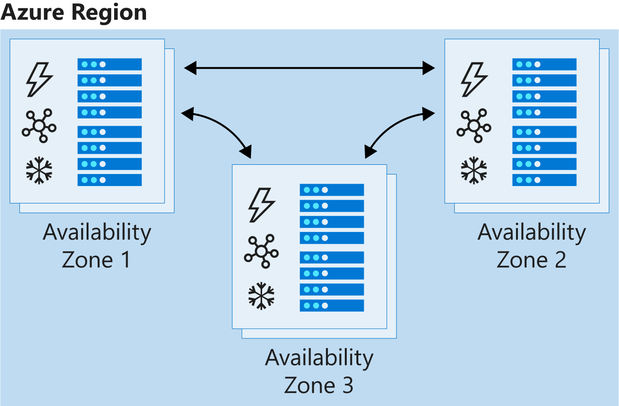

Availability zones don't support all virtual machine sizes and aren't available in all Azure regions. Check that they are supported in your region before you use them in your architecture.

**Select the right Load Balancer product**

Two products are available when you create a load balancer in Azure: basic load balancers and standard load balancers.

Basic load balancers allow:

* Port forwarding
* Automatic reconfiguration
* Health probes
* Outbound connections through source network address translation (SNAT)
* Diagnostics through Azure Log Analytics for public-facing load balancers

Basic load balancers can be used only with availability sets.

Standard load balancers support all of the basic features. They also allow:

* HTTPS health probes
* Availability zones
* Diagnostics through Azure Monitor, for multidimensional metrics
* High availability (HA) ports
* Outbound rules
* A guaranteed SLA (99.99% for two or more virtual machines)

## Internal and external load balancers

An external load balancer operates by distributing client traffic across multiple virtual machines. An external load balancer permits traffic from the internet. The traffic might come from browsers, module apps, or other sources. In a healthcare organization, the balancer distributes the load of all the browsers that run the client healthcare application.

An internal load balancer distributes a load from internal Azure resources to other Azure resources. For example, if you have front-end web servers that need to call business logic that's hosted on multiple middle-tier servers, you can distribute that load evenly by using an internal load balancer. No traffic is allowed from internet sources. In a healthcare organization, the load balancer distributes a load across the internal application tier.

# **Configure a public load balancer**

As the solution architect for the healthcare portal, you need to distribute the load from the client browsers over the virtual machines in your web farm. You need to set up a load balancer and configure the virtual machines to be balanced.

A public load balancer maps the public IP address and port number of incoming traffic to the private IP address and port number of a virtual machine in the back-end pool. The responses are then returned to the client. By applying load-balancing rules, you distribute specific types of traffic across multiple virtual machines or services.

## Distribution modes

By default, Azure Load Balancer distributes network traffic equally among virtual machine instances. The following distribution modes are also possible if a different behavior is required:

* **Five-tuple hash**. The default distribution mode for Load Balancer is a five-tuple hash. The tuple is composed of the source IP, source port, destination IP, destination port, and protocol type. Because the source port is included in the hash and the source port changes for each session, clients might be directed to a different virtual machine for each session.
* **Source IP affinity**. This distribution mode is also known as *session affinity* or *client IP affinity*. To map traffic to the available servers, the mode uses a two-tuple hash (from the source IP address and destination IP address) or three-tuple hash (from the source IP address, destination IP address, and protocol type). The hash ensures that requests from a specific client are always sent to the same virtual machine behind the load balancer.

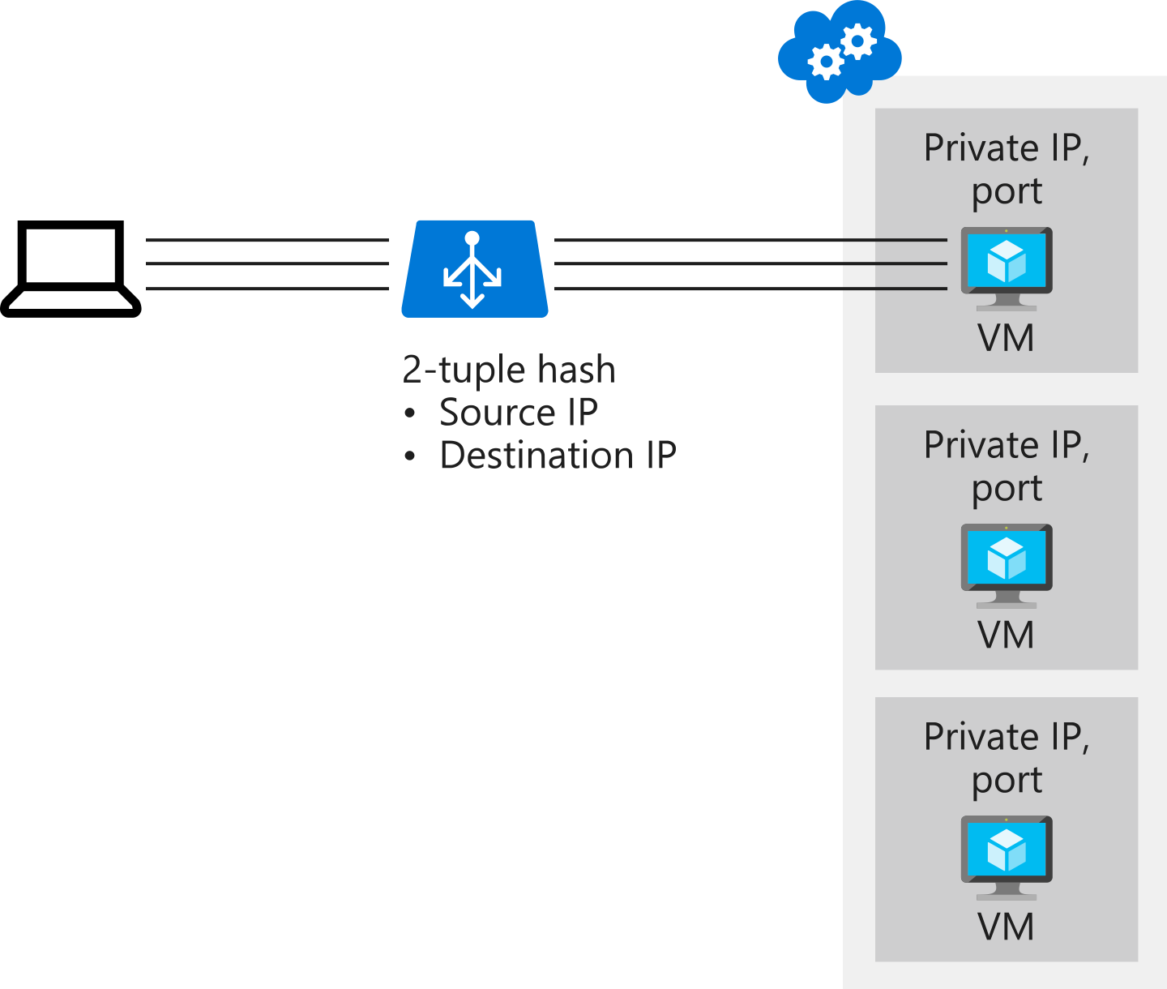

## Choose a distribution mode

In the healthcare portal example, imagine that a developer requirement of the presentation tier is to use in-memory sessions to store the logged user's profile as the user interacts with the portal.

In this scenario, the load balancer must provide source IP affinity to maintain a user's session. The profile is stored only on the virtual machine that the client first connects to because that IP address is directed to the same server. When you create the load balancer endpoint, you must specify the distribution mode by using the following PowerShell example:

To add session persistence through the Azure portal:

1. In the Azure portal, open the load balancer resource.
2. Edit the relevant line of the **Load-balancing rules**.
3. Change the value for **Session persistence** to **Client IP**.

Session persistence can be done by

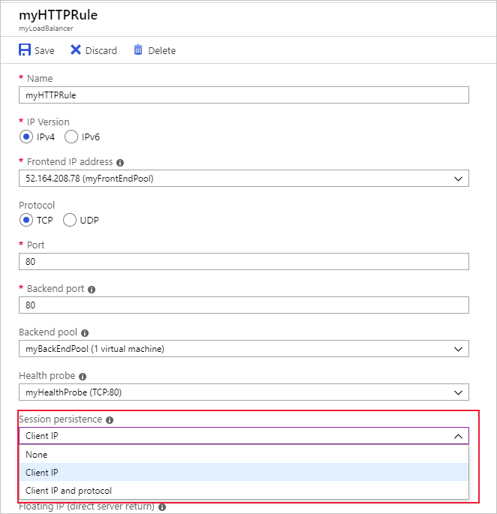

## Load Balancer and Remote Desktop Gateway

Remote Desktop Gateway is a Windows service that you can use to enable clients on the internet to make Remote Desktop Protocol (RDP) connections through firewalls to Remote Desktop servers on your private network. The default five-tuple hash in Load Balancer is incompatible with this service. If you want to use Load Balancer with your Remote Desktop servers, use source IP affinity.

## Load Balancer and media upload

Another use case for source IP affinity is media upload. In many implementations, a client initiates a session through a TCP protocol and connects to a destination IP address. This connection remains open throughout the upload to monitor progress, but the file is uploaded through a separate UDP protocol.

With the five-tuple hash, the load balancer likely will send the TCP and UDP connections to different destination IP addresses and the upload won't finish successfully. Use source IP affinity to resolve this issue.

# **Internal load balancer**

In addition to balancing requests from users to front-end servers, you can use Azure Load Balancer to distribute traffic from front-end servers evenly among back-end servers.

In your healthcare organization, front-end servers call business logic that's hosted on a middle tier. You want to ensure that the middle tier is as scalable and resilient as the front end. You want to use a load balancer to distribute requests from the front-end servers evenly among the middle-tier servers. This way, you'll scale out the middle-tier servers to achieve the highest capacity possible. You'll also ensure that the middle tier is resilient to failure. When a server fails, the load balancer automatically reroutes traffic.

Here, you'll learn how to use load balancers to distribute internal traffic.

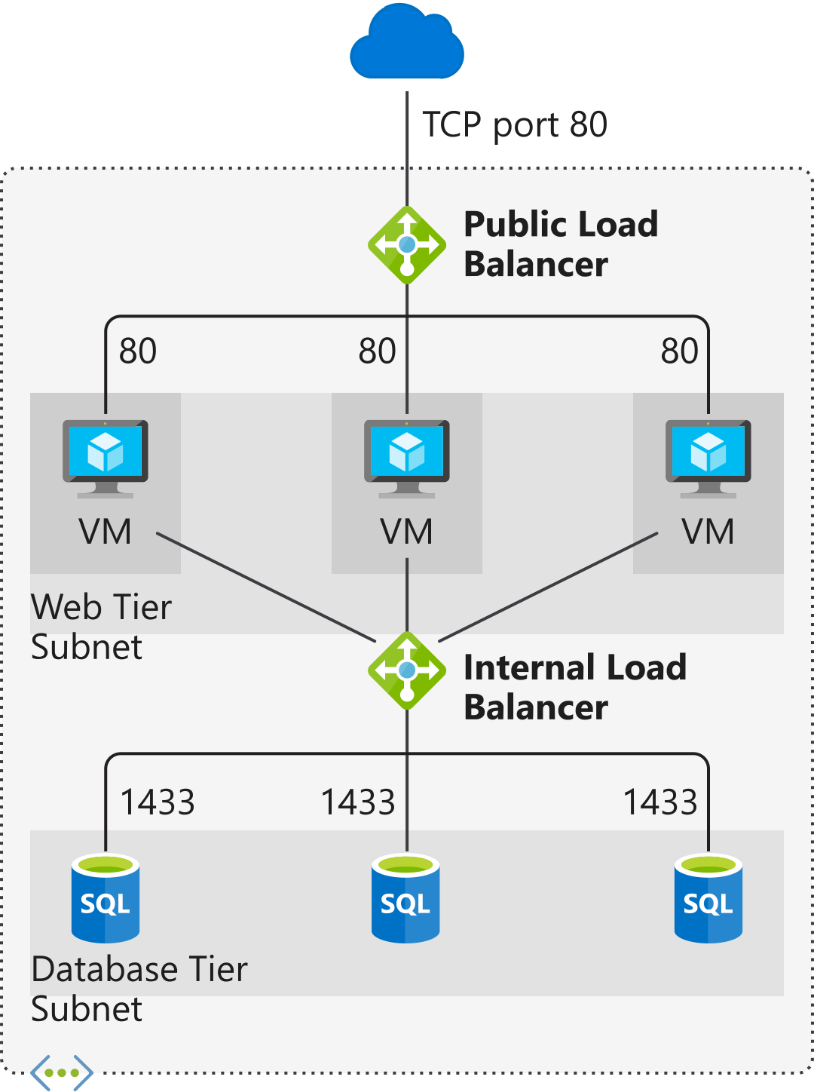

# **Load balance your web service traffic with Application Gateway**

Improve application resilience by distributing load across multiple servers and use path-based routing to direct web traffic.

In this module, you will:

* Identify the load balancing capabilities of Application Gateway
* Create an Application Gateway and configure load balancing
* Configure an Application Gateway to use URL path-based routing

# **Route traffic with Application Gateway**

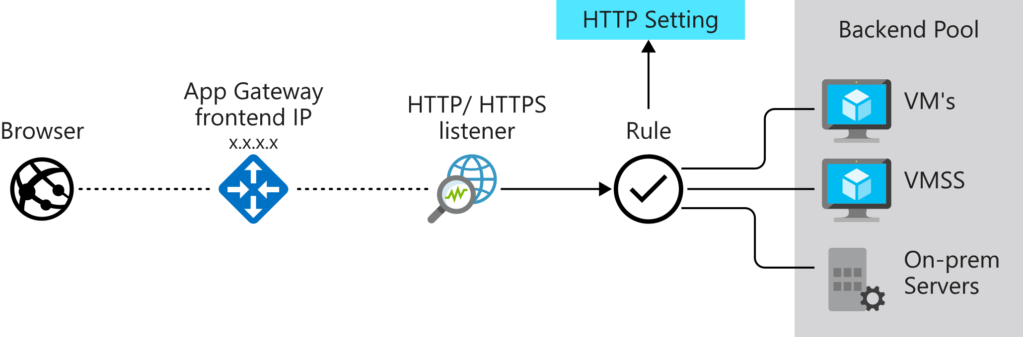

## How Application Gateway routes requests

Clients send requests to your web apps to the IP address or DNS name of the gateway. The gateway routes requests to a selected web server in the back-end pool, using a set of rules configured for the gateway to determine where the request should go.

There are two primary methods of routing traffic, path-based routing and multiple site hosting. Let's take a look at the capabilities for each.

### **Path-based routing**

Path-based routing enables you to send requests with different paths in the URL to a different pool of back-end servers. For example, you could direct requests with the path /video/* to a back-end pool containing servers that are optimized to handle video streaming, and direct /images/* requests to a pool of servers that handle image retrieval.

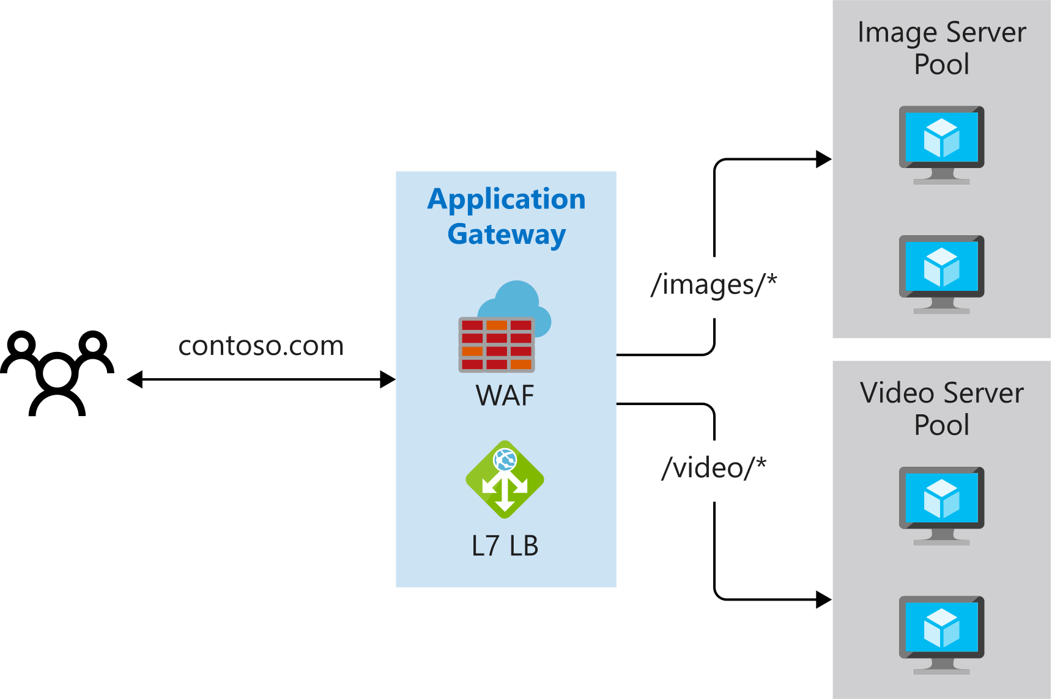

### **Multiple site hosting**

Multiple site hosting enables you to configure more than one web application on the same application gateway instance. In a multi-site configuration, you register multiple DNS names (CNAMEs) for the IP address of the Application Gateway, specifying the name of each site. Application Gateway uses separate listeners to wait for requests for each site. Each listener passes the request to a different rule, which can route the requests to servers in a different back-end pool. For example, you could configure Application Gateway to direct all requests for http://contoso.com to servers in one back-end pool, and requests for http://fabrikam.com to another back-end pool. The following diagram shows this configuration.

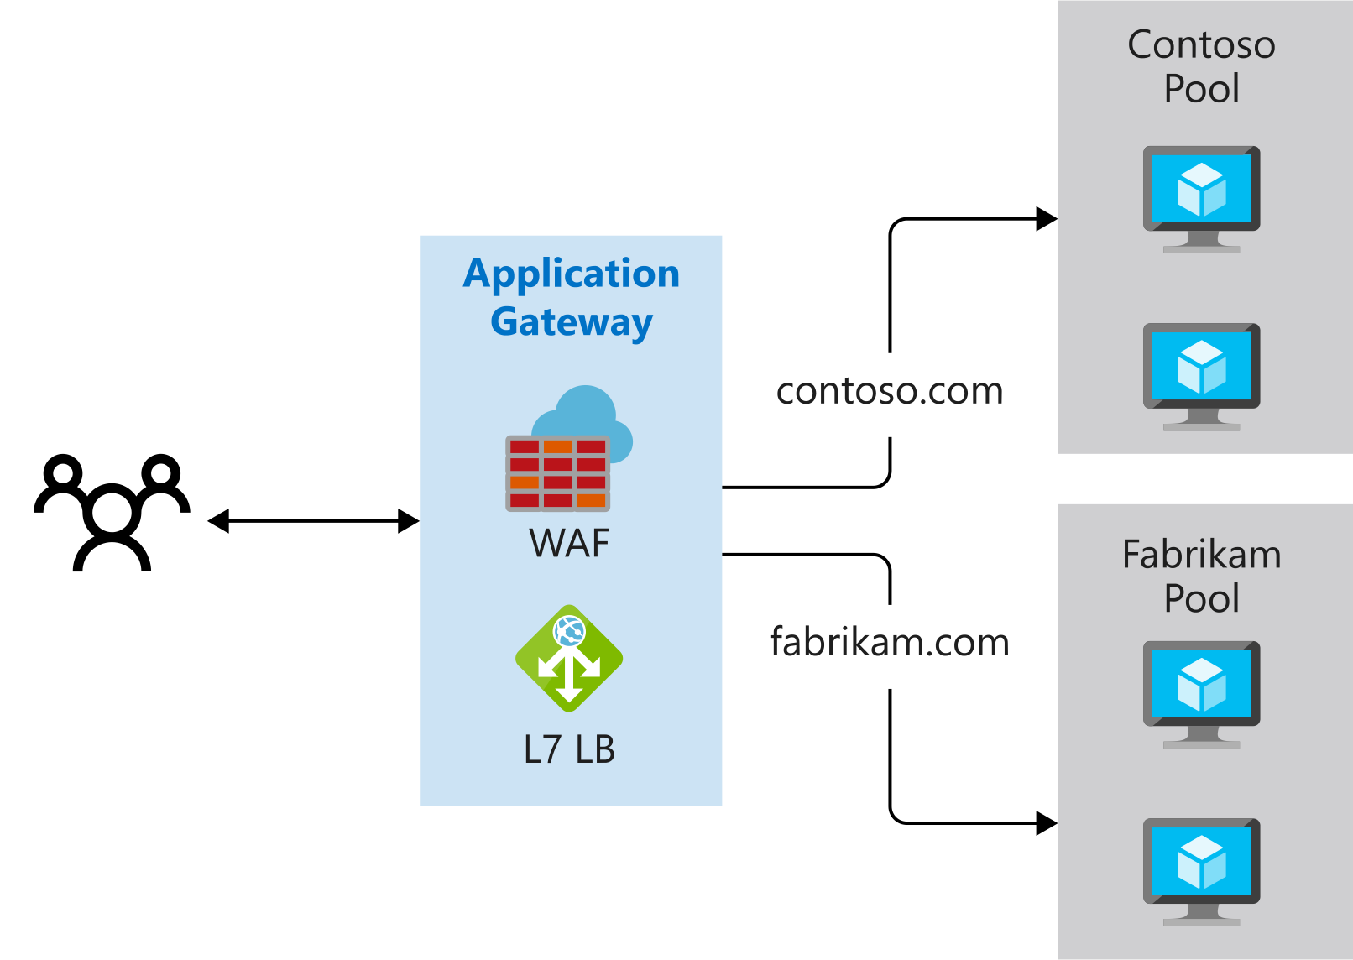

Multi-site configurations are useful for supporting multi-tenant applications, where each tenant has its own set of virtual machines or other resources hosting a web application.

**Other routing capabilities**

Along with path-based routing and multiple site hosting, there are a few additional capabilities when routing with Application Gateway.

* **Redirection** - Redirection can be used to another site, or from HTTP to HTTPS.
* **Rewrite HTTP headers** - HTTP headers allow the client and server to pass additional information with the request or the response.
* **Custom error pages** - Application Gateway allows you to create custom error pages instead of displaying default error pages. You can use your own branding and layout using a custom error page.

## Load balancing in Application Gateway

Application Gateway will automatically load balance requests sent to the servers in each back-end pool using a round-robin mechanism. However, you can configure session stickiness, if you need to ensure that all requests for a client in the same session are routed to the same server in a back-end pool.

Load-balancing works with the OSI Layer 7 routing implemented by Application Gateway routing, which means that it load balances requests based on the routing parameters (host names and paths) used by the Application Gateway rules. In comparison, other load balancers, such as Azure Load Balancer, function at the OSI Layer 4 level, and distribute traffic based on the IP address of the target of a request.

Operating at OSI Layer 7 enables load balancing to take advantage of the other features that Application Gateway provides. These features include:

* Support for the HTTP, HTTPS, HTTP/2 and WebSocket protocols.
* A web application firewall to protect against web application vulnerabilities.
* End-to-end request encryption.
* Autoscaling, to dynamically adjust capacity as your web traffic load changes.

# **Application Gateway creation and configuration**

Application Gateway comprises a series of components that combine to route requests to a pool of web servers and to check the health of these web servers. Let's take a look at how these components are related and what role they play in an Application Gateway.

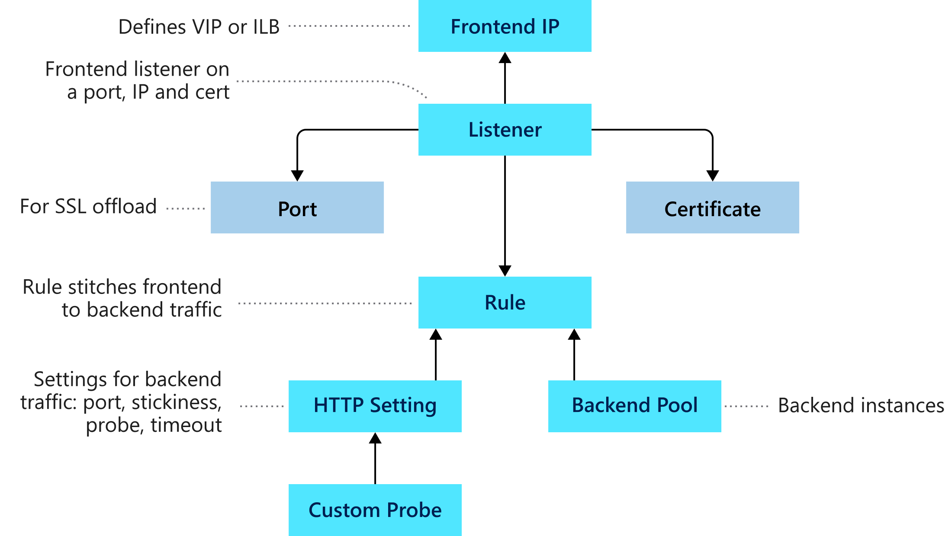

### **Front-end IP address**

Client requests are received through a front-end IP address. You can configure Application Gateway to have a public IP address, a private IP address, or both. Application Gateway can't have more than one public and one private IP address.

### **Listeners**

Application Gateway uses one or more listeners to receive incoming requests. A listener accepts traffic arriving on a specified combination of protocol, port, host, and IP address. Each listener routes requests to a back-end pool of servers following routing rules that you specify. A listener can be Basic or Multi-site. A Basic listener only routes a request based on the path in the URL. A Multi-site listener can also route requests using the hostname element of the URL.

Listeners also handle SSL certificates for securing your application between the user and Application Gateway.

### **Routing rules**

A routing rule binds a listener to the back-end pools. A rule specifies how to interpret the hostname and path elements in the URL of a request, and direct the request to the appropriate back-end pool. A routing rule also has an associated set of HTTP settings. These settings indicate whether (and how) traffic is encrypted between Application Gateway and the back-end servers, and other configuration information such as:

* Protocol (HTTP or HTTPS).
* Session stickiness, to pass all requests in a client session to the same web server rather than distributing them across servers with load balancing.
* Connection draining, to enable the graceful removal of servers from a back-end pool.
* Request timeout period, in seconds.
* Health probes, specifying a probe URL, time out periods, and other parameters used to determine whether a server in the back-end pool is available.

### **Back-end pools**

A back-end pool references a collection of web servers. You provide the IP address of each web server and the port on which it listens for requests when configuring the pool. Each pool can specify a fixed set of virtual machines, a virtual machine scale-set, an app hosted by Azure App Services, or a collection of on-premises servers. Each back-end pool has an associated load balancer that distributes work across the pool

### **Web application firewall**

The web application firewall (WAF) is an optional component that handles incoming requests before they reach a listener. The web application firewall checks each request for many common threats, based on the Open Web Application Security Project (OWASP). These include:

* SQL-injection
* Cross-site scripting
* Command injection
* HTTP request smuggling
* HTTP response splitting
* Remote file inclusion
* Bots, crawlers, and scanners
* HTTP protocol violations and anomalies

OWASP has defined a set of generic rules for detecting attacks. These rules are referred to as the Core Rule Set (CRS). The rule sets are under continuous review as attacks evolve in sophistication. WAF supports two rule sets, CRS 2.2.9 and CRS 3.0. CRS 3.0 is the default and more recent of these rule sets. If necessary, you can opt to select only specific rules in a rule set, targeting certain threats. Additionally, you can customize the firewall to specify which elements in a request to examine, and limit the size of messages to prevent massive uploads from overwhelming your servers.

WAF is enabled on your Application Gateway by selecting the WAF tier when you create a gateway.

### **Health probes**

Health probes are an important part in assisting the load balancer to determine which servers are available for load balancing in a back-end pool. Application Gateway uses a health probe to send a request to a server. If the server returns an HTTP response with a status code between 200 and 399, the server is deemed healthy.

If you don't configure a health probe, Application Gateway creates a default probe that waits for 30 seconds before deciding that a server is unavailable.

## Application Gateway network requirements

Application Gateway requires a virtual network in which to operate. You must create this virtual network and a dedicated subnet before setting up Application Gateway. Application Gateway uses a number of private addresses for internal use and for communicating with each instance if the gateway scales out. For example, If you plan on scaling out to four instances, create a /28 size subnet. If you're likely to scale to more instances, then create a bigger subnet.

You can expose the Application Gateway through a public IP address, or you can or keep it private by only giving it a private IP inside virtual network. This is useful if you have internal sites that you would like to use Application Gateway to provide load balancing.

## Application Gateway options

You can create an Application Gateway on the Standard tier or the WAF tier. You also have a choice of three sizes with varying performance, pricing, and scalability: Small, Medium, and Large.

The Standard and WAF tiers are available in two versions, V1 and V2. V2 supports Azure availability zones, but is currently in preview.

Application Gateway supports manual scaling and autoscaling. If you select autoscaling, Application Gateway will scale out and in automatically according to the application traffic. You can limit the maximum and minimum number of instances of Application Gateway.

# **Create and configure an Application Gateway**

Application Gateway listens on an endpoint for incoming requests, and forwards these requests to one of the web servers in its back-end pool. You provide the configuration that describes how Application Gateway directs traffic, and how to load balance requests across web servers.

In the motor vehicle department system, you need to configure Application Gateway to load balance incoming requests across the web servers hosting the vehicle registration web app. You also need to configure Application Gateway to detect when either of the web servers has failed, so it can redirect traffic to a working server. Additionally, you need to configure path-based routing to send requests for the vehicle registration and license renewal sites to the proper back-end web services.

In this exercise, you'll create an instance of Application Gateway with a back-end pool of web servers. You'll verify that Application Gateway is configured with the correct listener to handle incoming HTTP requests, and routes these requests to a functioning web server.

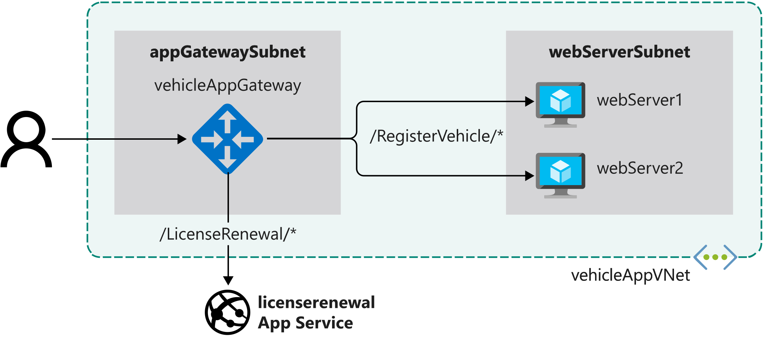

# **Manage and control traffic flow in your Azure deployment with routes**

Learn how to control Azure virtual network traffic by implementing custom routes.

In this module, you will:

* Identify the routing capabilities of an Azure virtual network
* Configure routing within a virtual network
* Deploy a basic network virtual appliance
* Configure routing to send traffic through a network virtual appliance

# **Introduction**

A virtual network lets you implement a security perimeter around your resources in the cloud. You can control the information that flows in and out of a virtual network. You can also restrict access to only the traffic that originates from trusted sources.

Suppose you're the solution architect for a retail organization. Also suppose your organization recently suffered a security incident that exposed customer information such as names, addresses, and credit cards. Malicious actors infiltrated vulnerabilities in the retailer's network infrastructure, which resulted in the loss of customers' confidential information.

As part of a remediation plan, the security team recommends adding network protections in the form of network virtual appliances. The cloud infrastructure team must ensure traffic is properly routed through the virtual appliances and is inspected for malicious activity.

You'll learn about Azure routing and you'll create custom routes to control the traffic flow. You'll also learn to redirect the traffic through the network virtual appliance so you can inspect the traffic before it's allowed through.

# **Identify routing capabilities of an Azure virtual network**

To control traffic flow within your virtual network, you must learn the purpose and benefits of custom routes. You must also learn how to configure the routes to direct traffic flow through a network virtual appliance (NVA).

## Azure routing

Network traffic in Azure is automatically routed across Azure subnets, virtual networks, and on-premises networks. This routing is controlled by system routes, which are assigned by default to each subnet in a virtual network. With these system routes, any Azure virtual machine that is deployed to a virtual network can communicate with all other Azure virtual machines in subnets in that network. These virtual machines are also potentially accessible from on-premises through a hybrid network or the internet.

You can't create or delete system routes. But you can override the system routes by adding custom routes to control traffic flow to the next hop.

Every subnet has the following default system routes:

| **Address prefix** | **Next hop type** |
| --- | --- |
| Unique to the virtual network | Virtual network |
| 0.0.0.0/0 | Internet |
| 10.0.0.0/8 | None |
| 172.16.0.0/12 | None |
| 192.168.0.0/16 | None |
| 100.64.0.0/10 | None |

The **Next hop type** column shows the network path taken by traffic sent to each address prefix. The path can be one of the following hop types:

* **Virtual network**: A route is created in the address prefix. The prefix represents each address range created at the virtual-network level. If multiple address ranges are specified, multiple routes are created for each address range.
* **Internet**: The default system route 0.0.0.0/0 routes any address range to the internet, unless you override Azure's default route with a custom route.
* **None**: Any traffic routed to this hop type is dropped and doesn't get routed outside the subnet. By default, the following IPv4 private-address prefixes are created: 10.0.0.0/8, 172.16.0.0/12, and 192.168.0.0/16. The prefix 100.64.0.0/10 for a shared address space is also added. None of these address ranges are globally routable.

The following diagram shows an overview of system routes and shows how traffic flows among subnets and the internet by default. You can see from the diagram that traffic flows freely among the two subnets and the internet.

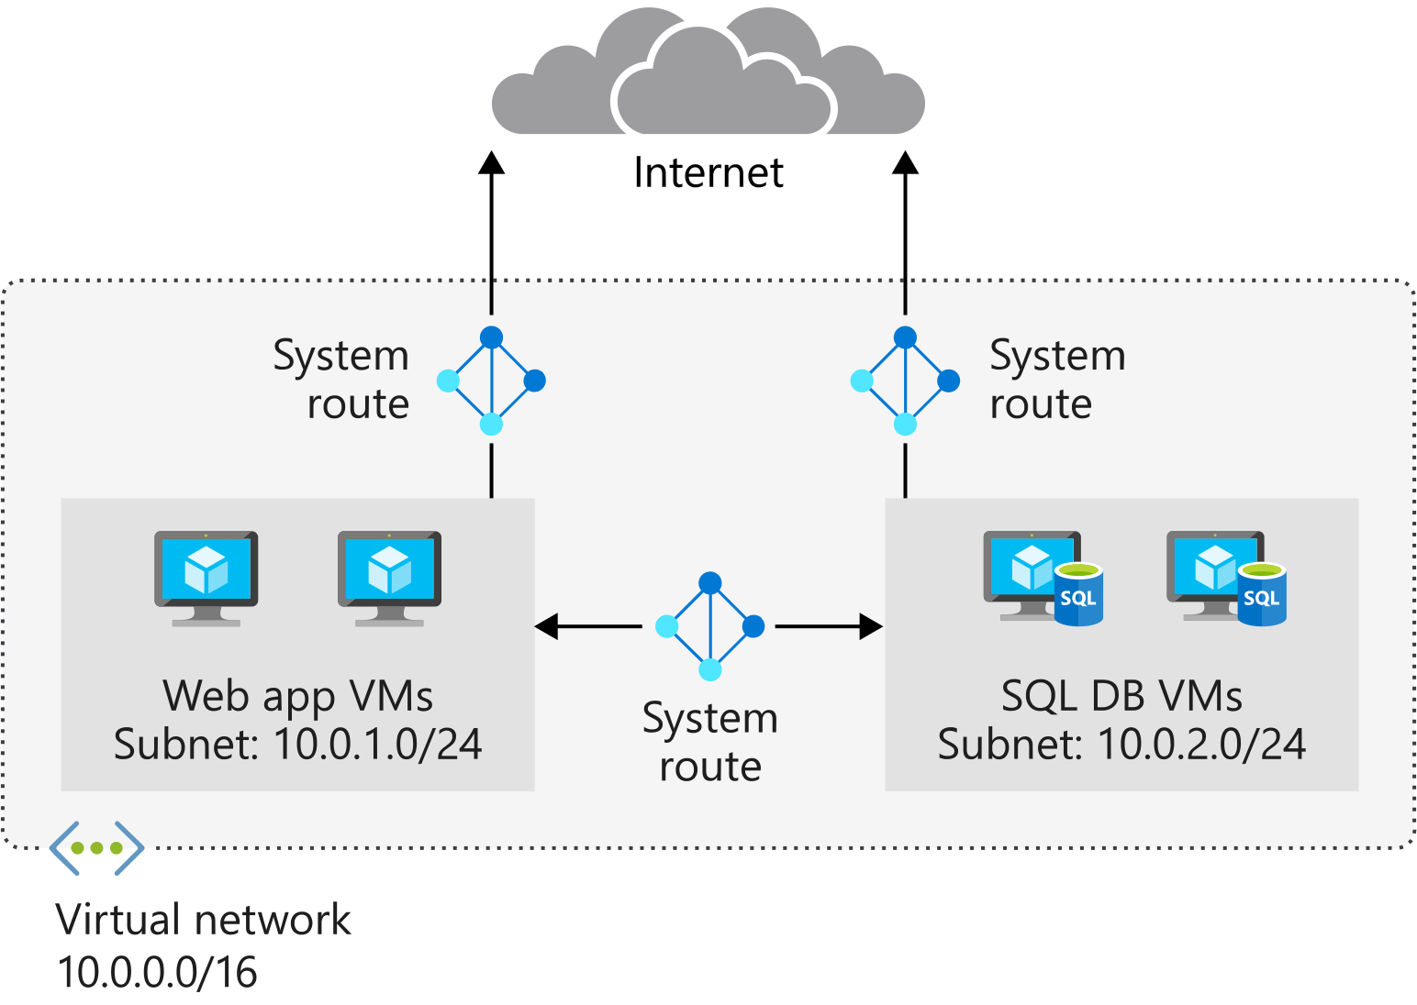

Within Azure, there are additional system routes. Azure will create these routes if the following capabilities are enabled:

* Virtual network peering
* Service chaining
* Virtual network gateway
* Virtual network service endpoint

### **Virtual network peering and service chaining**

Virtual network peering and service chaining let virtual networks within Azure be connected to one another. With this connection, virtual machines can communicate with each other within the same region or across regions. This communication in turn creates additional routes within the default route table. Service chaining lets you override these routes by creating user-defined routes between peered networks.

The following diagram shows two virtual networks with peering configured. The user-defined routes are configured to route traffic through an NVA or an Azure VPN gateway.

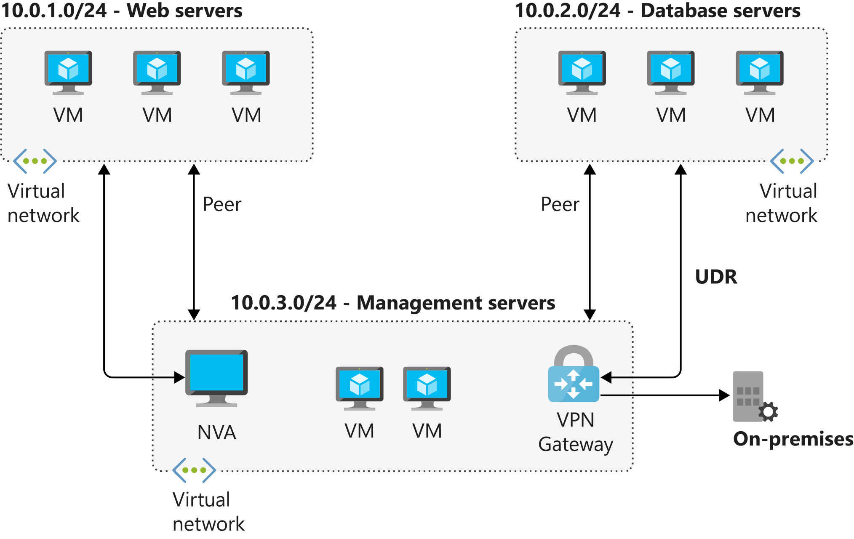

**Virtual network gateway**

Use a virtual network gateway to send encrypted traffic between Azure and on-premises over the internet and to send encrypted traffic between Azure networks. A virtual network gateway contains routing tables and gateway services.

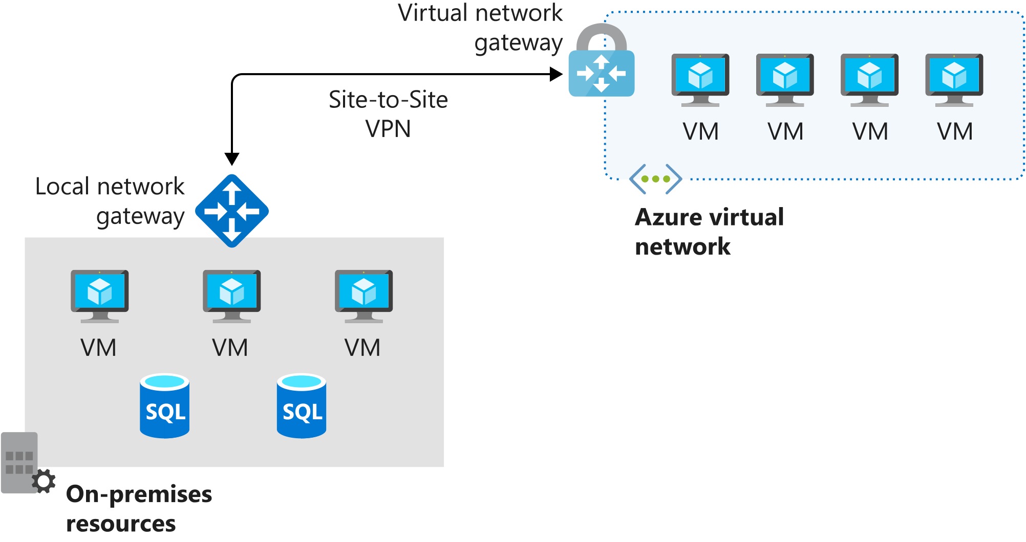

### **Virtual network service endpoint**

Virtual network endpoints extend your private address space in Azure by providing a direct connection to your Azure resources. This connection restricts the flow of traffic: your Azure virtual machines can access your storage account directly from the private address space and deny access from a public virtual machine. As you enable service endpoints, Azure creates routes in the route table to direct this traffic.

## Custom routes

System routes might make it easy for you to quickly get your environment up and running. But there are many scenarios in which you'll want to more closely control the traffic flow within your network. For example, you might want to route traffic through an NVA or through a firewall from partners and others. This control is possible with custom routes.

* You have two options for implementing custom routes: create a user-defined route or use Border Gateway Protocol (BGP) to exchange routes between Azure and on-premises networks.

### **User-defined routes**

You use a user-defined route to override the default system routes so that traffic can be routed through firewalls or NVAs.

For example, you might have a network with two subnets and want to add a virtual machine in the perimeter network to be used as a firewall. You create a user-defined route so that traffic passes through the firewall and doesn't go directly between the subnets.

When creating user-defined routes, you can specify these next hop types:

* **Virtual appliance**: A virtual appliance is typically a firewall device used to analyze or filter traffic that is entering or leaving your network. You can specify the private IP address of a NIC attached to a virtual machine so that IP forwarding can be enabled. Or you can provide the private IP address of an internal load balancer.
* **Virtual network gateway**: Use to indicate when you want routes for a specific address to be routed to a virtual network gateway. The virtual network gateway is specified as a VPN for the next hop type.
* **Virtual network**: Use to override the default system route within a virtual network.
* **Internet**: Use to route traffic to a specified address prefix that is routed to the internet.
* **None**: Use to drop traffic sent to a specified address prefix.

With user-defined routes, you can't specify the next hop type **VirtualNetworkServiceEndpoint**, which indicates virtual network peering.

### **Border gateway protocol**

A network gateway in your on-premises network can exchange routes with a virtual network gateway in Azure by using BGP. BGP is the standard routing protocol that is normally used to exchange routing and information among two or more networks. BGP is used to transfer data and information between different host gateways like on the internet or between autonomous systems.

You typically use BGP to advertise on-premises routes to Azure when you're connected to an Azure datacenter through Azure ExpressRoute. You can also configure BGP if you connect to an Azure virtual network by using a VPN site-to-site connection.

The following diagram shows a topology with paths that can pass data between Azure VPN Gateway and on-premises networks:

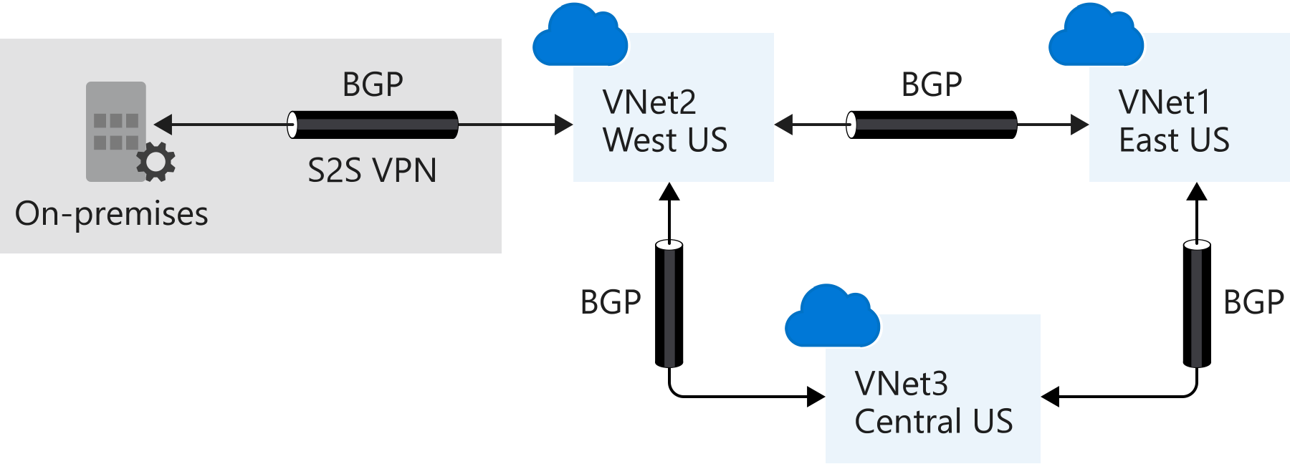

BGP offers network stability because routers can quickly change connections to send packets if a connection path goes down.

**Route selection and priority**

If multiple routes are available in a route table, Azure uses the route with the longest prefix match. For example, if a message is sent to the IP address 10.0.0.2, but two routes are available with the 10.0.0.0/16 and 10.0.0.0/24 prefixes, Azure selects the route with the 10.0.0.0/24 prefix because it's more specific.

The longer the route prefix, the shorter the list of IP addresses available through that prefix. By using longer prefixes, the routing algorithm can select the intended address more quickly.

You can't configure multiple user-defined routes with the same address prefix.

If multiple routes share the same address prefix, Azure selects the route based on its type in the following order of priority:

1. User-defined routes
2. BGP routes
3. System routes

# **Create custom routes-Exercise**

As you implement your security strategy, you want to control how network traffic is routed across your Azure infrastructure.

In the following exercise, you'll use a network virtual appliance (NVA) to help secure and monitor traffic. You'll want to ensure communication between front-end public servers and internal private servers is always routed through the appliance.

You'll configure the network so that all traffic flowing from a public subnet to a private subnet will be routed through the NVA. To make this flow happen, you'll create a custom route for the public subnet to route this traffic to a perimeter-network subnet. Later, you'll deploy an NVA to the perimeter-network subnet.

# **What is an NVA?**

A network virtual appliance (NVA) is a virtual appliance that consists of various layers like:

* a firewall
* a WAN optimizer
* application-delivery controllers
* routers
* load balancers
* IDS/IPS
* proxies

You can deploy NVAs chosen from providers in Azure Marketplace. Such providers include Check Point, Barracuda, Sophos, WatchGuard, and SonicWall. You can use an NVA to filter traffic inbound to a virtual network, to block malicious requests, and to block requests made from unexpected resources.

In the retail-organization example scenario, you must work with the security and network teams. You want to implement a secure environment that scrutinizes all incoming traffic and blocks unauthorized traffic from passing on to the internal network. You also want to secure both virtual-machine networking and Azure-services networking as part of your company's network-security strategy.

Your goal is to prevent unwanted or unsecured network traffic from reaching key systems.

As part of the network-security strategy, you must control the flow of traffic within your virtual network. You also must learn the role of an NVA and the benefit of using an NVA to control traffic flow through an Azure network.

## Network virtual appliance

Network virtual appliances or NVAs are virtual machines that control the flow of network traffic by controlling routing. You typically use them to manage traffic flowing from a perimeter-network environment to other networks or subnets.

An NVA often includes various protection layers like:

* a firewall
* a WAN optimizer
* application-delivery controllers
* routers
* load balancers
* proxies
* an SD-WAN edge
* You can deploy firewall appliances into a virtual network in different configurations. You can put a firewall appliance in a perimeter-network subnet in the virtual network. Or if you want more control of security, implement a microsegmentation approach.
* With the microsegmentation approach, you can create dedicated subnets for the firewall and then deploy web applications and other services in other subnets. All traffic is routed through the firewall and inspected by the NVAs. You enable forwarding on the virtual-appliance network interfaces to pass traffic that is accepted by the appropriate subnet.
* Microsegmentation lets the firewall inspect all packets at OSI Layer 4 and, for application-aware appliances, Layer 7. When you deploy an NVA to Azure, it acts as a router that forwards requests between subnets on the virtual network.
* Some NVAs require multiple network interfaces. One network interface is usually dedicated to the management network for the appliance. Additional network interfaces manage and control the traffic processing. After you’ve deployed the NVA, you can then configure the appliance to route the traffic through the proper interface.

# **Create an NVA and virtual machines**

In the next stage of your security implementation, you'll deploy a network virtual appliance (NVA) to secure and monitor traffic between your front-end public servers and internal private servers.

You'll configure the appliance to forward IP traffic. If IP forwarding isn't enabled, traffic that is routed through your appliance will never be received by its intended destination servers.

In this exercise, you'll deploy the **nva** network appliance to the **dmzsubnet** subnet. You'll then enable IP forwarding so that traffic from **publicsubnet** and traffic that uses the custom route is sent to the **privatesubnet** subnet.

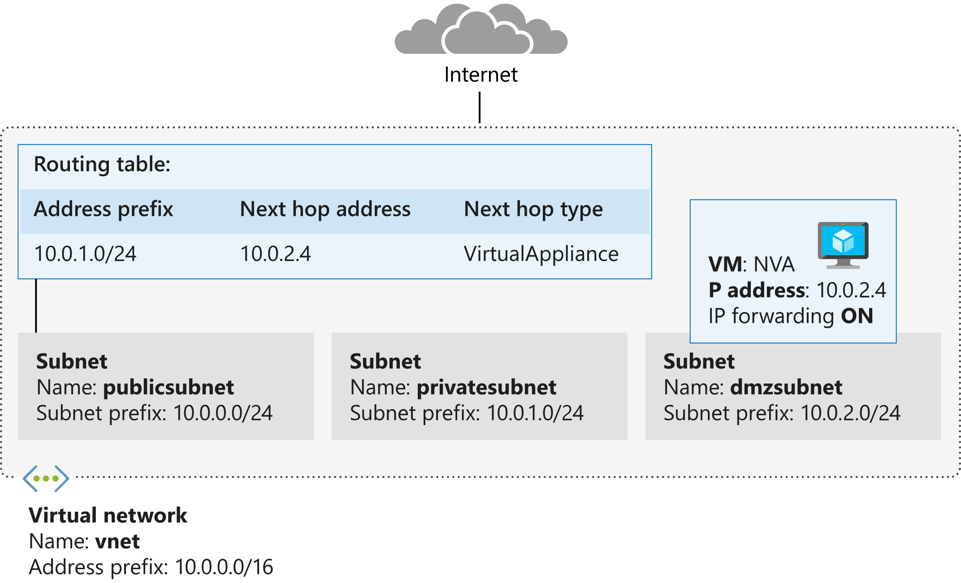

In the following steps, you'll deploy an NVA. You'll then update the Azure virtual NIC and the network settings within the appliance to enable IP forwarding.

## Test traffic routing through the network virtual appliance

The final steps use the Linux traceroute utility to show how traffic is routed. You'll use the ssh command to run traceroute on each virtual machine. The first test will show the route taken by ICMP packets sent from the **public** virtual machine to the **private** virtual machine. The second test will show the route taken by ICMP packets sent from the **private** virtual machine to the **public** virtual machine.

1. Run the following command to trace the route from **public** to **private**. When prompted, enter the password for the **azureuser** account that you specified earlier.

* ssh -t -o StrictHostKeyChecking=no azureuser@$PUBLICIP 'traceroute private --type=icmp; exit'

traceroute to private.kzffavtrkpeulburui2lgywxwg.gx.internal.cloudapp.net (10.0.1.4), 64 hops max

1 10.0.2.4 0.710ms 0.410ms 0.536ms

2 10.0.1.4 0.966ms 0.981ms 1.268ms

Connection to 52.165.151.216 closed.

Notice that the first hop is to 10.0.2.4. This address is the private IP address of **nva**. The second hop is to 10.0.1.4, the address of **private**. In the first exercise, you added this route to the route table and linked the table to the **publicsubnet** subnet. So now all traffic from **public** to **private** is routed through the network virtual appliance.

Run the following command to trace the route from **private** to **public**. When prompted, enter the password for the **azureuser** account.

ssh -t -o StrictHostKeyChecking=no azureuser@$PRIVATEIP 'traceroute public --type=icmp; exit'

traceroute to public.kzffavtrkpeulburui2lgywxwg.gx.internal.cloudapp.net (10.0.0.4), 64 hops max

1 10.0.0.4 1.095ms 1.610ms 0.812ms

Connection to 52.173.21.188 closed.

The **private** virtual machine is using default routes, and traffic is routed directly between the subnets.

* You've now configured routing between subnets to direct traffic from the public internet through the **dmzsubnet** subnet before it reaches the private subnet. In the **dmzsubnet** subnet, you added a virtual machine that acts as an NVA. You can configure this NVA to detect potentially malicious requests and block them before they reach their intended targets.

* **Design an IP addressing schema for your Azure deployment**

# **Introduction**

Imagine you're the solution architect for a manufacturing company. Your company is beginning a project to move many services out of its existing datacenter and into the Azure cloud. The company wants to integrate the existing network with Azure. You need to plan the public and private IP addresses for the network carefully, so you don’t run out of addresses and will have capacity for future growth. A good IP addressing scheme provides flexibility, room for growth, and integration with on-premises networks.

In this module, you'll learn about the public and private IP addressing capabilities of Azure virtual networks. You'll learn how to gather the necessary requirements for planning an IP address scheme. This module covers the on-premises integration methods of point-to-site and site-to-site, and also virtual network-to-virtual network peering. You'll also design and implement virtual networks, and configure and verify virtual network peering. By the end of this module, you'll understand how to plan IP addressing for an Azure network and how to integrate Azure with an on-premises network.

**Learning objectives**

In this module, you will:

* Identify the private IP addressing capabilities of Azure virtual networks.
* Identify the public IP addressing capabilities of Azure.
* Identify the requirements for IP addressing when integrating with on-premises networks.

# **Network IP addressing and integration**

* 8 minutes

To integrate resources in an Azure virtual network with resources in your on-premises network, you must understand how you can connect those resources and how to configure IP addresses.

Your manufacturing company wants to migrate a business-critical database to Azure. Client applications on desktop computers, laptops, and mobile devices need constant access to the database as if the database remained in the on-premises network. You want to move the database server without affecting users.

In this unit, you will look at a typical on-premises network design and compare it to a typical Azure network design. You also will learn about requirements for IP addressing when integrating an Azure network with on-premises networks.

**On-premises IP addressing**

A typical on-premises network design includes these components:

* Routers
* Firewalls
* Switches
* Network segmentation

The diagram shows a simplified version of a typical on-premises network. On the routers facing the internet service provider (ISP), you have public IP addresses that are used by your outbound internet traffic as their source. These addresses also are used for inbound traffic across the internet. The ISP might assign you a block of IP addresses to assign to your devices, or you might have your own block of public IP addresses that your organization owns and controls. These addresses can be assigned to systems that you would like to make accessible from the internet, such as web servers.

The perimeter network and internal zone have private IP addresses. In the perimeter network and internal zone, the IP addresses that are assigned to these devices aren't accessible over the internet. The administrator has full control over the IP address assignment, name resolution, security settings, and security rules. There are three ranges of non-routable IP addresses that are designed for internal networks that won't be sent over internet routers:

* 10.0.0.0 to 10.255.255.255
* 172.16.0.0 to 172.31.255.255
* 192.168.0.1 to 192.168.255.255

The administrator can add or remove on-premises subnets to accommodate network devices and services. The number of subnets and IP addresses you can have in your on-premises network depends on the Classless Inter-Domain Routing (CIDR) for the IP address block.

## Azure IP addressing

Azure virtual networks use private IP addresses. The ranges of private IP addresses are the same as for on-premises IP addressing. Like on-premises networks, the administrator has full control over the IP address assignment, name resolution, security settings, and security rules in an Azure virtual network. The administrator can add or remove subnets depending on the CIDR for the IP address block.

In a typical Azure network design, we usually have these components:

* Virtual networks
* Subnets
* Network security groups
* Firewalls
* Load balancers
* In Azure, the network design has features and functions that are similar to an on-premises network, but the structure of the network is different. The Azure network does not follow the typical on-premises hierarchical network design. The Azure network provides the ability to scale up and scale down infrastructure based on demand. Provisioning in the Azure network happens in a matter of seconds. There are no hardware devices, like routers or switches. The entire infrastructure is virtual and you slice it into chunks that suit your requirements.
* In Azure, you typically would implement a network security group and a firewall. You use subnets to isolate front-end services, including web servers and DNS, and back-end services like databases and storage systems. Network security groups filter internal and external traffic at the network layer. A firewall has more extensive capabilities for network layer filtering and application layer filtering. By deploying both network security groups and a firewall, you get improved isolation of resources for a secure network architecture.

## Basic properties of Azure virtual networks

A virtual network is your network in the cloud. You can divide your virtual network into multiple subnets. Each subnet has a portion of the IP address space that is assigned to your virtual network. You can add, remove, expand, or shrink a subnet if there are no VMs or services deployed in it.

By default, all subnets in an Azure virtual network can communicate with each other. However, you can use a network security group to deny communication between subnets. The smallest subnet that is supported uses a /29 subnet mask. The largest supported subnet uses a /8 subnet mask.

## Integrate Azure with on-premises networks

Before you start integrating Azure with on-premises networks, it's important to identify the current private IP address scheme used in the on-premises network. There can be no IP address overlap for interconnected networks.

For example, you can't use 192.168.0.0/16 on your on-premises network and use 192.168.10.0/24 on your Azure virtual network. These ranges both contain the same IP addresses and won't be able to route traffic between each other.

You can, however, have the same class range for multiple networks. For example, you can use the 10.10.0.0/16 address space for your on-premises network and the 10.20.0.0/16 address space for your Azure network because they don't overlap.

It is vital to check for overlaps when you're planning an IP address scheme. If there's an overlap of IP addresses, you can't integrate your on-premises network with your Azure network.

**A dedicated subnet assigns an IP address to devices connected through the tunnel. You must have a dedicated subnet named GatewaySubnet for the VPN gateway.**

# **Public and private IP addressing in Azure**

In your manufacturing company, you are moving resources into Azure, starting with a database server. You want to ensure that the database server is accessible for clients in your on-premises network. Public resources like web servers must be accessible from the internet. You want to ensure that you plan IP addresses that support these requirements.

## Public IP addresses

Use a public IP address for public-facing services. A public address can be either static or dynamic. A public IP address can be assigned to a VM, an internet-facing load balancer, a VPN gateway, or an application gateway.

Basic public IPs can be assigned to any Azure resource that can be assigned a public IP address, such as network interfaces, VPN gateways, application gateways, and internet-facing load balancers. They do not support availability zone scenarios. You must use a Standard SKU public IP for an availability zone scenario.

#### **Standard**

Standard SKU public IP addresses always use the static allocation method. They have an adjustable inbound originated flow idle timeout of 4-30 minutes, with a default of 4 minutes, and a fixed outbound originated flow idle timeout of 4 minutes.

Standard IPs are secure by default and closed to inbound traffic. You must explicitly allow inbound traffic by using a network security group.

Standard IPs can be assigned to network interfaces, Standard public load balancers, application gateways, or VPN gateways. For more information about Standard load balancers, see [Azure Standard Load Balancer overview](https://docs.microsoft.com/azure/load-balancer/load-balancer-standard-overview). Standard IPs are zone-redundant by default and optionally zonal (they can be created zonal and guaranteed in a specific availability zone).

## Private IP addresses

Private IP addresses are used for communication within a virtual network. Private IP addresses are used within Azure Virtual Network virtual networks and your on-premises networks. They can be set to dynamic (DHCP lease) or static (DHCP reservation).

**Dynamic private IP addresses** are assigned through a DHCP lease and can change over the lifespan of the Azure resource.

**Static private IP addresses** are assigned through a DHCP reservation and do not change throughout the lifespan of the Azure resource. Static private IP addresses persist if a resource is stopped or deallocated.

# **Plan IP addressing for your networks**

In your manufacturing company, you have asked the operations and engineering teams about their requirements for the number of virtual machines in Azure. You've also asked them about their plans for expansion. Based on the results of this survey, you want to plan an IP addressing scheme that you won't have to change in the foreseeable future.

In this unit, you'll explore the requirements for a network IP address scheme. You'll learn about classless inter-domain routing (CIDR) and how you use it to slice an IP block to meet your addressing needs. At the end of the module, there's an exercise that shows how to plan IP addressing for Azure virtual networks.

## Gather your requirements

Before planning your network IP address scheme, you must gather the requirements for your infrastructure. These requirements also will help you prepare for future growth by reserving extra IP addresses and subnets.

Here are two of the questions you might ask to discover the requirements:

* How many devices do you have on the network?
* How many devices are you planning to add to the network in the future?

When your network expands, you don't want to redesign the IP address scheme. Here are some other questions you could ask:

* Based on the services running on the infrastructure, what devices do you need to separate?
* How many subnets do you need?
* How many devices per subnet will you have?
* How many devices are you planning to add to the subnets in future?
* Are all subnets going to be the same size?
* How many subnets do you want or plan to add in future?

You'll need to isolate some services. Isolation of services provides an additional layer of security, but also requires good planning. For example, your front-end servers can be accessed by public devices, but the back-end servers need to be isolated. Subnets help isolate the network in Azure. However, by default, all subnets within a virtual network can communicate with each other in Azure. To provide further isolation, you can use a network security group. You might isolate services depending on the data and its security requirements. For example, you might choose to isolate HR data and the company's financial data from customer databases.

When you know the requirements, you'll have a greater understanding of the total number of devices on the network per subnet and how many subnets you'll need. CIDR allows more flexible allocation of IP addresses than was possible with the original system of IP address classes. Depending on your requirements, you'll slice the IP block into the required subnets and hosts.

Remember that Azure uses the first three addresses on each subnet. The first and last IP addresses of the subnets also are reserved for protocol conformance. Therefore, the number of possible addresses on an Azure subnet is **2^n-5**, where **n** represents the number of host bits.

# **Design-a-hybrid-network-architecture**

# **Introduction**

* **5 minutes**

You work for a global enterprise that is planning a migration to Azure. You need to integrate resources in Azure with your on-premises networks, but you're unsure which technology is best suited for your needs.

Your company has a central datacenter and several remote offices that need connectivity to Azure. After completing your research, you'll understand the pros and cons of your connectivity options, and you'll know how and when to select the various technologies for hybrid connectivity.

In this module, you explore the hybrid networking capabilities in Azure. The module looks at services for on-premises integration, using tools such as Azure ExpressRoute. It covers the scenarios that apply to the design of your company's hybrid architecture.

## Traffic routing on an Azure virtual network

Outbound traffic from a subnet is routed based on the destination IP address. A routing table defines how the traffic routes and what happens next. A destination IP address can exist across multiple routing table prefix definitions (for example, 10.0.0.0/16 and 10.0.0.0/24). The router uses a sophisticated algorithm to find the longest prefix match. Traffic that's heading for a 10.0.0.6 address would resolve to the 10.0.0.0/24 prefix and be routed accordingly.

| **Resource** | **Default or maximum number** |
| --- | --- |
| Virtual networks | 1,000 |
| Subnets per virtual network | 3,000 |
| Virtual network peerings per virtual network | 500 |
| Private IP addresses per virtual network | 65,536 |

**Limits:**

Much like the system routing table, custom routing tables also have a next hop type. But the custom routing tables offer a few more options:

* **Virtual appliance**: This option is usually a virtual machine that runs a specific network application, such as a firewall.
* **Virtual network gateway**: Use this option when you want to send traffic to a virtual network gateway. A virtual network gateway type must be VPN. The type can't be Azure ExpressRoute, which requires setting a Border Gateway Protocol (BGP) routing process.
* **None**: This option drops the traffic rather than forwarding it.
* **Virtual network**: This option lets you override a default system routing.
* **Internet**: This option lets you specify that any prefix forwards traffic to the internet.

## Connect Azure virtual networks

You can connect your virtual networks in any of several ways. You can use Azure VPN Gateway or ExpressRoute, or you can use the peering method directly.

### Azure VPN Gateway

When you're working toward integrating your on-premises network with Azure, there needs to be a bridge between them. VPN Gateway is an Azure service that provides this functionality. A VPN gateway can send encrypted traffic between the two networks. VPN gateways support multiple connections, which enable them to route VPN tunnels that use any available bandwidth. A virtual network can have only one gateway assigned. VPN gateways make connections possible from virtual network to virtual network in Azure.

Implementing a VPN gateway requires two or more virtual machines to be deployed to the subnet that you create when you set up the virtual network. In this instance, the subnet is also known as the gateway subnet. Each virtual machine is assigned a default configuration for routing and gateway services, explicit to the provisioned gateway. You can configure these virtual machines directly.

When you create a gateway, several topologies are available. These topologies, also known as gateway types, determine what's configured and the expected connection type.

#### **Site-to-site**

You use a site-to-site connection for cross-premises and hybrid-network configurations. This connection topology requires an on-premises VPN device to have a publicly accessible IP address, and must not be behind a NAT. The connection uses a secret ASCII string of up to 128 characters, to authenticate between the gateway and the VPN device.

#### **Multisite**

A multisite connection is similar to a site-to-site connection, but with a slight variation. Multisite supports multiple VPN connections to your on-premises VPN devices. This connection topology requires a RouteBased VPN known as a dynamic gateway. It's important to note that, with a multisite configuration, all connections route through and share all available bandwidth.

#### **Point-to-site**

A point-to-site connection is suited to a remote individual client device that connects to your network. You must authenticate the client device either through Azure Active Directory or by using Azure certificate authentication. This model suits home working scenarios.

#### **Network-to-network**

You use a network-to-network connection to create connections between multiple Azure virtual networks. This connection topology, unlike the others, doesn't require a public IP or VPN device. It can also be used in a multisite configuration to establish combined cross-premises connections with inter-virtual network connectivity.

### **ExpressRoute**

ExpressRoute creates a direct connection between your on-premises network and the Azure virtual network that doesn't use the internet. You use ExpressRoute to seamlessly extend your local network across to the Azure virtual network space. The ExpressRoute service is offered by many third-party connectivity providers. There are three different ExpressRoute connection types:

* CloudExchange colocation
* Point-to-point Ethernet connection
* Any-to-any (IPVPN) connection

### **Peering**

Virtual networks can peer across subscriptions and Azure regions. After the virtual networks are peered, resources in these networks communicate with each other as if they're in the same network. The traffic is routed between resources in a peered virtual network by using only private IP addresses. Routing is achieved by routing traffic through the Azure network and keeping the connection private as part of the Azure backbone network. The backbone network provides low latency and high-bandwidth network connections.

## Site-to-site VPN gateway reference architecture

Although many reference architectures are available when you design a hybrid network, one popular architecture is the site-to-site configuration. The simplified reference architecture shown in the following diagram illustrates how you would connect an on-premises network to the Azure platform. The internet connection uses an IPsec VPN tunnel.

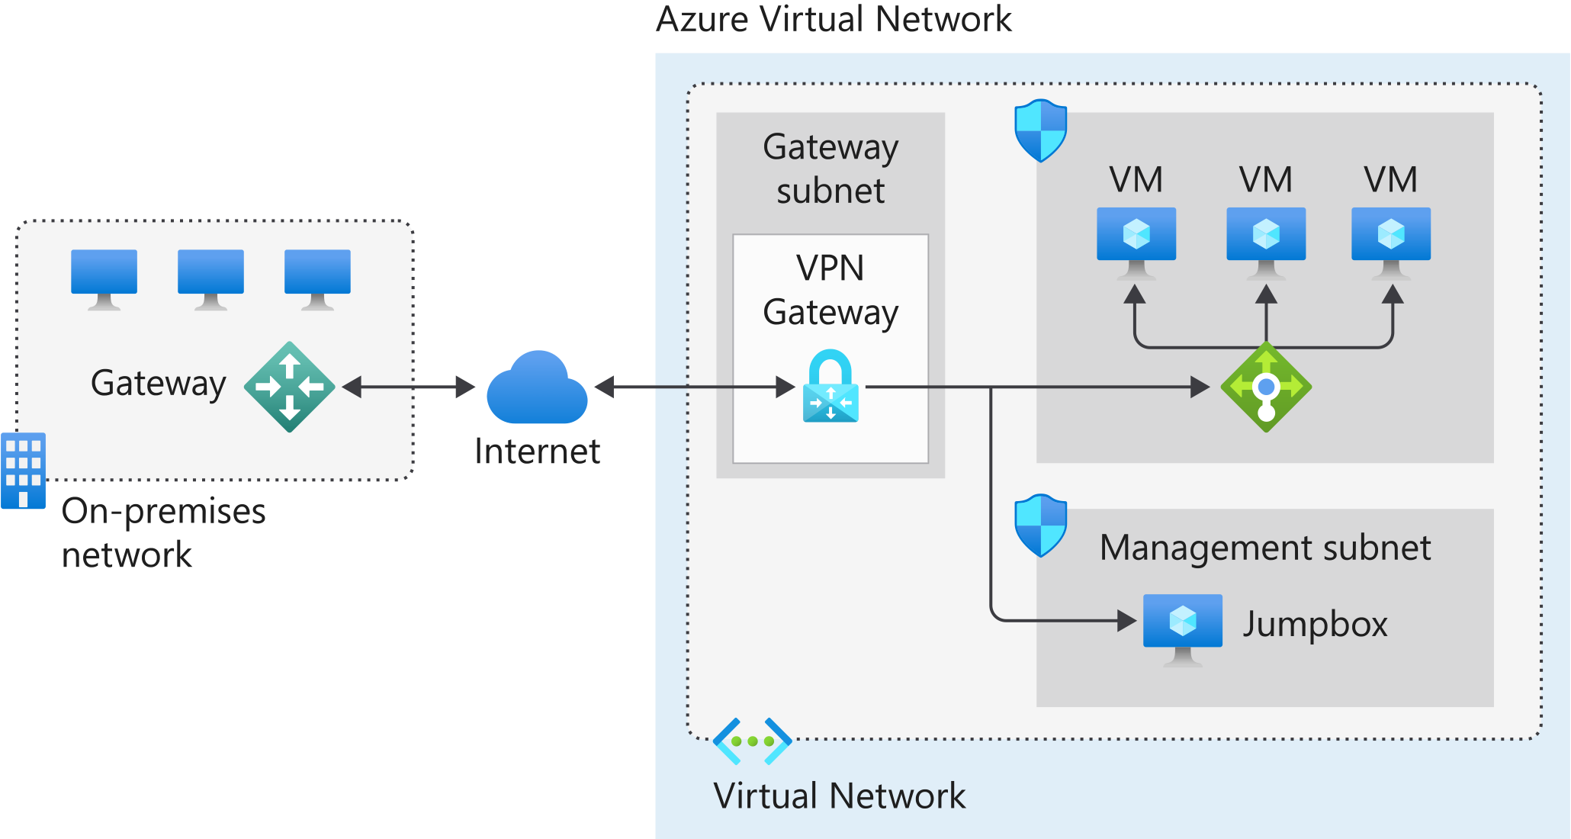

the architecture features several components:

* The **on-premises network** represents your on-premises Active Directory and any data or resources.
* The **gateway** is responsible for sending encrypted traffic to a virtual IP address when it uses a public connection.
* The **Azure virtual network** holds all your cloud applications and any Azure VPN gateway components.
* An **Azure VPN gateway** provides the encrypted link between the Azure virtual network and your on-premises network. An Azure VPN gateway is made up of these elements:
  + Virtual network gateway
  + Local network gateway
  + Connection
  + Gateway subnet
* **Cloud applications** are the ones you've made available through Azure.
* An **internal load balancer**, located in the front end, routes cloud traffic to the correct cloud-based application or resource.

Using this architecture offers several benefits, including:

* Configuration and maintenance are simplified.
* Having a VPN gateway helps ensure that all data and traffic are encrypted between the on-premises gateway and the Azure gateway.
* The architecture can be scaled and extended to meet your organization's networking needs.

This architecture isn't applicable in all situations, because it uses an existing internet connection as the link between the two gateway points. Bandwidth constraints can cause latency issues that result from reuse of the existing infrastructure.

Notes:

* **Point-to-site connections get established from a client machine, such as a desktop computer connecting to the VPN.**
* **The VPN gateway is a bridge between on-premises or local to the cloud, not where the connection is established.**
* **Storing the credentials for an administrator account in a VPN is not a secure or supported method for site-to-site VPN connections.**
* **Service principals are used for authentication, but not in site-to-site VPN connections.**
* A VPN Tunnel such as IPsec, is the method for connecting between on-premises and Azure
* All Azure VPN connections get encrypted automatically. There is no requirement to enable encryption.
* When we connect to Azure by using a VPN, we use VPN Gateway connection method.
* **CloudExchange**: With the CloudExchange method, you cross-connect to Azure by using the Ethernet exchange that's provided by your colocation facility.
* **Any-to-any**: With the any-to-any network method, you integrate your WAN with Azure by using an IP virtual private network (VPN) provider. This connection type offers links between branch offices and datacenters. When it's enabled, the connection to Azure is similar to any other branch office that's connected via the WAN.

**Point-to-point**: With the point-to-point Ethernet network method, you connect on-premises datacenters and offices to Azure through a point-to-point Ethernet link.

Whatever your motivations for adding cloud services to your infrastructure, there are several architectures to consider. We covered ExpressRoute in the preceding unit. The other architectures are:

* Azure VPN Gateway
* ExpressRoute with VPN failover
* Hub-spoke network topology

## Azure VPN Gateway

Azure VPN Gateway, a virtual network gateway service, allows site-to-site and point-to-site VPN connectivity between your on-premises network and Azure.

A VPN or virtual private network is a well-established, well-understood network architecture.

**VPN Gateway uses your existing connection to the internet. However, all communication is encrypted using the Internet Key Exchange (IKE) and Internet Protocol Security (IPsec) protocols. You can have only one virtual network gateway per virtual network.**

When you set up a virtual network gateway, you must specify whether it's a VPN gateway or an ExpressRoute gateway.

The VPN type depends on the type of connection topology you need. For example, if you want to create a point-to-site (P2S) or a point-to-point (P2P) gateway, you use a *RouteBased* type. There are two VPN types:

* **PolicyBased**: Uses an IPsec tunnel to encrypt data packets. Configuration of the policy uses address prefixes that are drawn from your Azure virtual network and your on-premises network.
* **RouteBased**: Uses the routing or IP forwarding tables to route data packets to the correct tunnel. Each tunnel encrypts and decrypts all packets.
* After you've specified the *VPN type* for the virtual network gateway, it can't be altered. If you have to make a change, you need to delete the virtual network gateway and create it again.

### **Site-to-site**

All site-to-site gateway connections use an IPsec/IKE VPN tunnel to create a connection between Azure and your on-premises network. For a site-to-site connection to work, you'll need an on-premises VPN device with a publicly accessible IP address.

### **Point-to-site**

A point-to-site gateway connection creates a secured connection between an individual device and your Azure virtual network. This gateway type is suited to remote workers; for example, users attending a conference or working from home. A point-to-site connection doesn't require a dedicated on-premises VPN device.

### **Benefits**

Here are some of the benefits of using a VPN connection:

* It's a well-known technology, easy to configure and maintain.
* All data traffic is encrypted.
* It's better suited to lighter data-traffic loads.

**Considerations**

When you're evaluating the use of this hybrid architecture, consider the following points:

* A VPN connection uses the internet.
* Potential latency issues might exist, depending on bandwidth size and usage.
* Azure supports a maximum bandwidth of 1.25 Gbps.
* For site-to-site connections, you need a local VPN device.

## ExpressRoute with VPN failover

One of the guarantees of using ExpressRoute is that it provides a high level of availability. Each ExpressRoute circuit comes with dual ExpressRoute gateways. However, even with this level of resiliency built into the Azure side of the network, connectivity might be interrupted. One way to remedy this situation, and maintain connectivity, is to provide a VPN failover service.

The merging of the VPN connection and ExpressRoute improves the resiliency of your network connection. When it operates under normal conditions, ExpressRoute behaves precisely like a regular ExpressRoute architecture, with the VPN connection remaining dormant. If the ExpressRoute circuit fails or goes offline, the VPN connection takes over. This action ensures network availability under all circumstances. When the ExpressRoute circuit is restored, all traffic reverts to using the ExpressRoute connection.

### **Reference architecture for ExpressRoute with VPN failover**

The following diagram illustrates how to connect your on-premises network to Azure by using ExpressRoute with a VPN failover. The chosen topology in this solution is a VPN-based, site-to-site connection with high traffic flow.

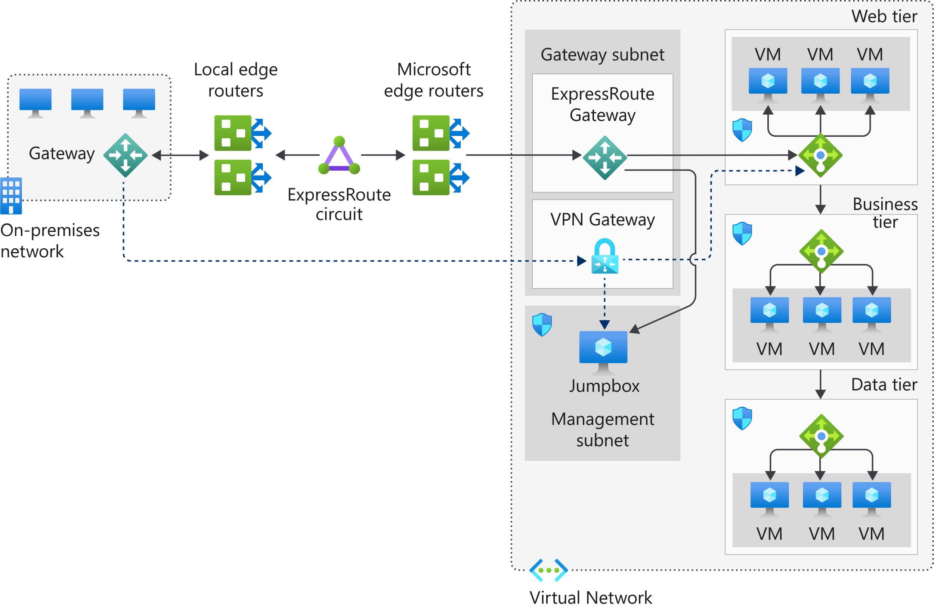

In this model, all network traffic routes through the ExpressRoute private connection. When connectivity is lost on the ExpressRoute circuit, the gateway subnet automatically fails over to the site-to-site VPN gateway circuit. This scenario is indicated by the dotted line from the gateway to the VPN gateway in the Azure virtual network.

When the ExpressRoute circuit is restored, traffic automatically switches back from the VPN gateway.

Implementation requires a redundant VPN gateway and local VPN hardware.

**Note**

A redundant VPN gateway incurs payment charges, even when it's not being used.

**Hub-spoke network topology**

The hub-spoke network topology allows you to structure the workloads that are carried out by your servers. It uses a single virtual network as the hub, which is also connected to your on-premises network through either VPN or ExpressRoute. The spokes are other virtual networks that are peered with the hub. Each spoke can be assigned specific workloads, and the hub is used for shared services.

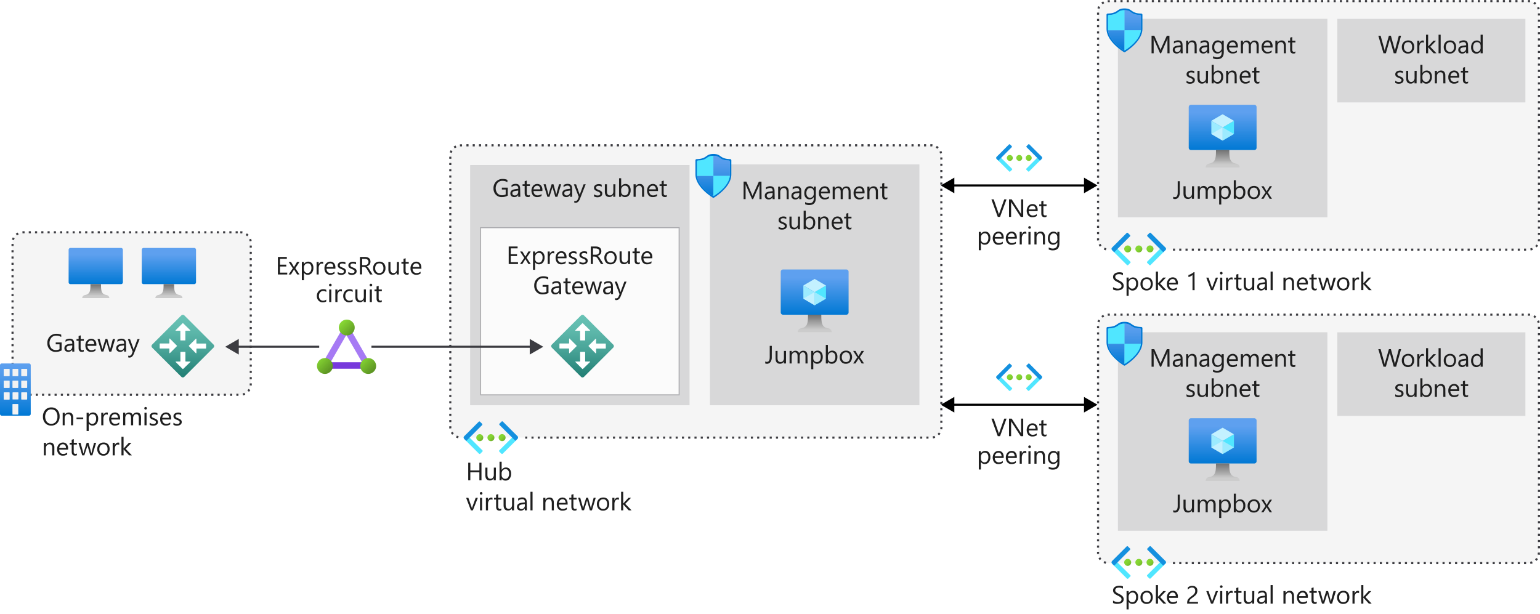

You can implement the hub and each spoke in separate subscriptions or resource groups and then peer them together.

This model uses one of the three previously discussed approaches: VPN, ExpressRoute, and ExpressRoute with VPN failover. The associated benefits and challenges are discussed in the following sections.

### **Benefits**

Implementing a hub-spoke architecture has the following benefits:

* The use of sharing and centralized services on the hub might reduce the need for duplication on the spokes, which can reduce costs.
* Subscription limits are overcome by peering virtual networks.
* The hub-spoke model allows for the separation of organizational work areas into dedicated spokes, such as SecOps, InfraOps, and DevOps.

### Considerations

When you're evaluating the use of this hybrid architecture, consider the following point:

* Look at the services that are shared on the hub and what remains on the spokes.

# **Choose a hybrid network architecture on Azure**

* **10 minutes**

Your organization is almost ready to migrate resources to Azure. This migration uses a hub-spoke architecture, but there remains an open question about the best method to use to connect the on-premises datacenter with the Azure network.

You've already provided a high-level design for this migration. However, your project manager has requested extra information about the choice between Azure ExpressRoute and Azure VPN Gateway. You also need to put together a capability matrix, so that non-technical staff members understand the features of each service.

In this unit, you'll assess two hybrid networking scenarios: Azure ExpressRoute and Azure VPN Gateway.

## Azure ExpressRoute

As the solution architect, you understand the need to provide a robust and reliable network connection between your on-premises datacenters and Azure. The requirements demand low latency and a high level of availability. From your investigations, you know there are two possibilities: VPN or ExpressRoute.

Both solutions provide a secure connection between the on-premises network and the Azure virtual network.

The VPN solution uses known and established technologies. However, a VPN isn't designed to handle high data volumes, and the core infrastructure backbone still uses the internet. Using a VPN might be a cost-effective solution in the short term. You know that in the long term a VPN is unlikely to provide the performance, scalability, and resilience your organization requires.

The ExpressRoute option uses a dedicated private connectivity partner to provide a direct connection between your on-premises datacenters and Azure. Microsoft requires the connectivity provider to maintain two discrete connections to the Azure network for each ExpressRoute circuit, which helps ensure a high level of resilience. ExpressRoute also provides a connection bandwidth that's almost 10 times faster than a VPN.

ExpressRoute requires a close working partnership with the connectivity provider, it's a more complex configuration, and it can be more expensive than a regular VPN network.

However, based on what you've learned so far, you decide that ExpressRoute is better suited to meet your organization's primary needs.

## Azure VPN Gateway

Your organization's presence covers a wide geographical location. Although your datacenter and HQ are all in the same building, many satellite branches also need a connection to the Azure network.

You've established ExpressRoute as your preferred connection to Azure. Now you'll consider your second requirement: connecting regional satellite offices to the Azure network.

Unlike your HQ, which has thousands of employees and an on-premises datacenter, each satellite office has between 20 and 50 employees. There's no requirement for a fast, low-latency connection.

This secondary requirement has different needs. ExpressRoute, although ideal for high speeds and resilience, doesn't suit smaller satellite offices that have a lower connectivity requirement. Also, each office would need a dedicated private connection to be maintained and run by the connectivity provider.

In this instance, using a VPN would provide a better overall solution. A VPN is based on existing and understood technology, which means it can be managed in-house. The lower-speed bandwidth is within an acceptable tolerance for day-to-day usage.

## Hybrid networking capability matrix

To show what you've learned in this unit and to help you choose between the two connectivity types, we've built a capability matrix. The following table lists the key features for each method, the supported bandwidths, the resiliency model, typical use cases, and associated SLAs.

| **Capability** | **VPN Gateway** | **ExpressRoute** |
| --- | --- | --- |
| **Azure services support** | Azure Cloud Services and Azure Virtual Machines | Microsoft Cloud Platform |
| **Bandwidth** | < 1.25 Gbps | < 10 Gbps or 100 Gbps (direct) |
| **Protocol** | SSTP or IPsec | Direct over VLAN or MPLS |
| **Routing** | Static or dynamic | Border Gateway Protocol (BGP) |
| **Connection resiliency** | Active-passive or active-active | Active-passive or active-active(PREFERRED) |
| **Use case** | Prototyping, dev, test, labs, RDC, and small production workloads | Access to all Azure services, enterprise-grade, supporting critical large-scale workloads |
| **SLA** | 99.95-99.99% | 99.95% |

**ExpressRoute is the recommended service for mission-critical, large-scale workloads.**

**VPN Gateway is less expensive than ExpressRoute and is better suited to smaller traffic volumes.**

## Connect your on-premises network

When working towards integrating your on-premises network with Azure, you need to bridge between the two networks. Azure VPN Gateway provides this functionality. A VPN gateway sends encrypted traffic between the two networks over the internet. Gateways support multiple connections that route the VPN tunnels through the available bandwidth, although a virtual network can only have one gateway assigned. You can also use a VPN gateway for network-to-network connections in Azure.

Azure ExpressRoute is another option to consider for bridging. ExpressRoute allows you to extend your on-premises networks over a private connection to Azure. This connection is facilitated by a connectivity or cloud exchange provider. ExpressRoute extends wider than just Azure resources, and allows you to establish connections to other Microsoft cloud services like Office 365.

Implementation of ExpressRoute does take some time. You have to work through a connectivity provider, and might require a physical network device implementation. To provide connectivity while this implementation is ongoing, you can use site-to-site VPN to add a connection between your on-premises resources and your Azure virtual networks. You then migrate to your new ExpressRoute connection when the service provider confirms that the setup is complete.

## Use ExpressRoute in a hub-spoke topology

Using ExpressRoute in a hub and spoke topology is no different than other architectural patterns. ExpressRoute, which underpins the connectivity between the hub and the on-premises network, works best when there's high data ingress and egress.

You use circuits to manage and route traffic. Link ExpressRoute into a virtual network in Azure. The circuits to be connected to the virtual network might be in different regions or subscriptions. There are limits to the number of virtual networks per ExpressRoute circuit. For the standard tier, the limit is currently 10 networks. If you use the premium add-on, the limit is increased based on the circuit size. The lowest number is 20 virtual networks on a 50-Mbps circuit, up to 100 for circuits that are 10-Gbps or bigger.

## Base components of Azure security for hub-spoke topologies

You want to ensure that your resources are protected from unauthorized access, or attack, by controlling your network traffic. In the hub and spoke model, there are several components you need to implement:

**Network security group**

Each subnet within the topology has a network security group configured. The network security groups implement security rules to allow or deny network traffic to and from each resource in the topology.

**Perimeter network**

Configure a perimeter network in its own subnet in the hub virtual network for routing external traffic. The perimeter network is designed to host network virtual appliances to provide security functionality, such as firewalls and packet inspection. You can route the outbound traffic from the perimeter network through virtual appliances, so the traffic is monitored, secured, and audited.

**Network virtual appliance**

Network virtual appliances (NVAs) provide a secure network boundary by checking all inbound and outbound network traffic. Then the NVA passes only the traffic that meets network security rules, essentially acting as a firewall.

Azure Firewall can replace some components discussed in this article, to control access to Azure network resources. For more details, see the following section, "Azure Firewall."

**Azure ExpressRoute**

ExpressRoute creates a dedicated private WAN link between on-premises resources and an Azure gateway subnet in the hub virtual network. You add a network security appliance between the on-premises network and the ExpressRoute provider edge routers. This restricts the flow of unauthorized traffic from the virtual network.

## Azure Firewall